NBA and Pega Decisioning both are the same only. Pega decisioning and Pega marketing are both combinations in decision Hub.

NBA is a framework that allows businesses to convert customer interaction into an opportunity and maximize customer value by providing the next best offer.

Ex- if you are interested in a personal loan and visited a bank website and it came to know that you are interested and it will show things related to personal loan based on the comments and content you visited

**NBA means providing the right offer to the right customer at the right time**

**Pega’s decision woris generatingte the offer not to deliver the offer.**

Delivering the customer with the offer by mail and phone is not done by the decisioning. It is done by Pega marketing.

So this is the primary difference between Pega decisioning and Pega marketing.

As part of generating we use strategies and predictive and adaptive models, we create data sets and data flows

To deliver this to the customer we need to use the channels to deliver which is done through marketing.

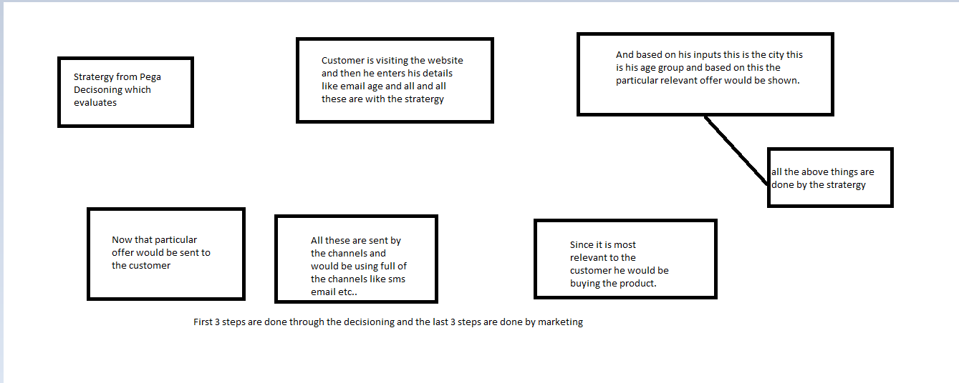

|  |  |
| --- | --- |
| Decisioning | Marketing |
| Decisioning involves mainly the logic creation that will decide the next best action | Marketing involves mainly the effective means of delivering the NBA to the customer. |
| It contains mainly strategies, models, and datasets for logic creation to generate NBA | Marketing contains campaigns, actions, and containers to reach the customer with NBA(Next Best Action) |
| NBA we call Propositions in Decisioning | NBA we call Actions in marketing |
| Uses CDH portal | Uses Marketing Portal(We use CDH but call it a Marketing Portal |
| By default roles, we have the following roles Default  CDHAdmin  CDH Analyst  CDH Managers | By default roles, we are having the following rules  Market Admins  Market Analyst  Market Managers |

Inbound and Outbound Marketing

|  |  |
| --- | --- |
| Inbound | Outbound |
| Customer is contacting the business to take some product/ services/ offers. | Business contacts customer inorder to promote their products/servoces/offers. |
| Supported channels are website, retail, inbound calls | Supported channels are Email,SMS, Push Notification |
| Used on customer service portal | Used on customer service portal. |
| Less marketing efforts are involved | More marketing efforts are involved |  |
| Business cannot provide personalized offers. | Business can provide personalized offers. |

Why do we call propositions?

So NBA means it can be like offer or discount or personal loan service or home loan service etc….

So what we propose is called NBA. And whatever we propose we call it ahe Propositions in decisioning.

Now in marketing, we call the same things which we send to customers as marketing.

Admin and analyst difference

We have to be CSSA certified to be decisioning certified

We will only do 70% of the work in the decisioning/ marketing the remaining 30% would be DT / Activity etc.

CDH Admin has access to the Dev studio as well as the customer Decision Hub.

But CDH Analyst does not have access to the dev studio

Generally, projects would hire CDH Admin/Marketing Admins because they are capable of both Pega work and decision work

The same marketing admin will have dev access.

But marketing analysts won’t have access to the dev studio.

If we are marketing managers then the access group would be marketing managers

The Decisioning manager would have access to group as CDH Manager

Pega decisioning and Pega marketing are part of customer service

If a business has purchased customer service they would get both frameworks additionally.

Pega can support only some channels in Pega Marketing.

Website

Email

Mobile

Push notification

Call center

From 8.1 we have a single portal called Customer Decision Hub

The portal will differentiate based on the access groups

And In both, some are restricted.

Before Pega 8 we have a marketing consultant and a decisioning consultant but after Pega 8 we have only single certification called PCDC

Before Pega 8 we used traditional customer engagement and then we used to give offers to the customer and out of 1000 if 200 accepted we would leave the remaining customers that were before pega 8

In pega 8 we have One to One customer engagement in which every customer is made sure that he would be receiving one offer for one customer that is one to one engagement

How strategy gives you NBA

The marketing features like channels actions are not there in personal edition for that we can use the cloud version.

The CDH portal looks like this

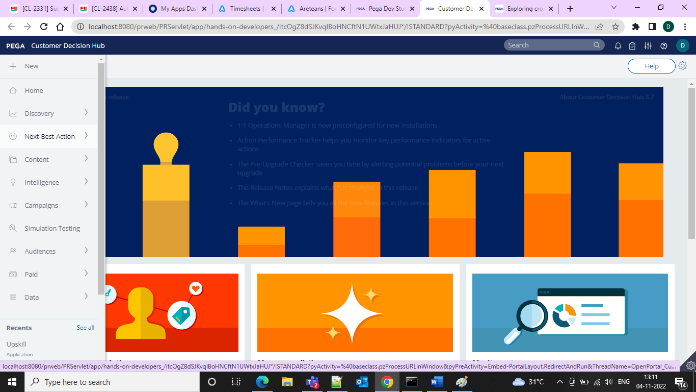

For pega decisioning and pega marketing we use the same portal

But when logged in through the main marketing people

As I logged in through CDH administrator we d not have access to the campaign

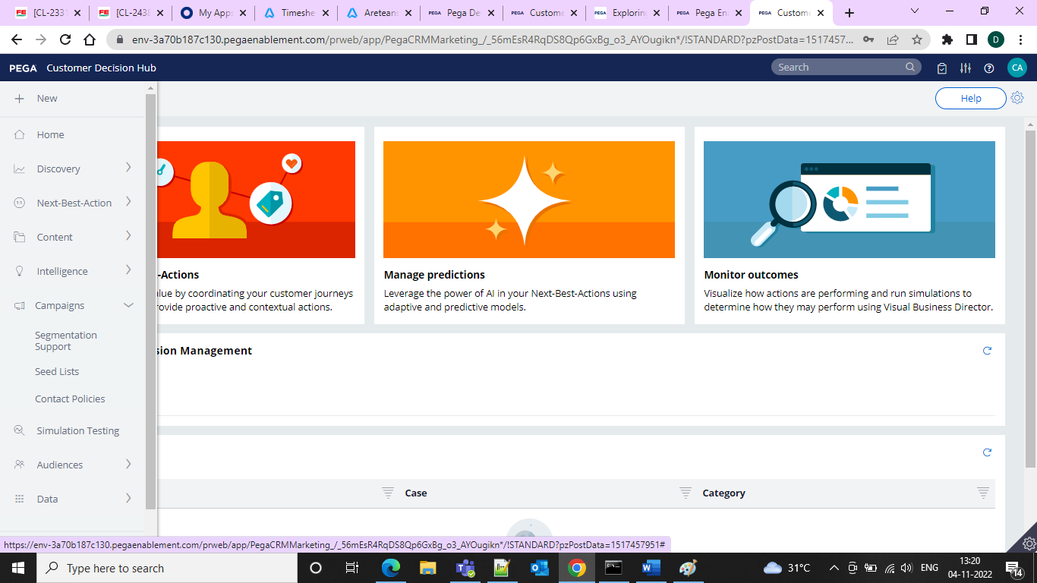

But when logged in as analyst we can see the campaign also for analyst

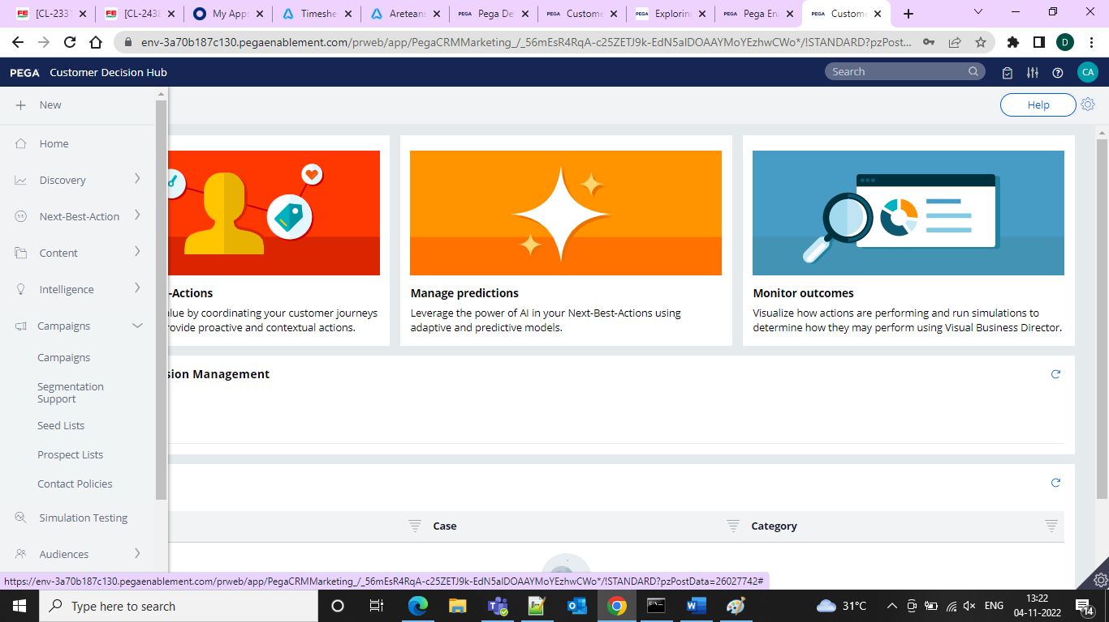

So same portal but different member so no access for it

Pega uses AI and business rules to drive real time decisions that improve customer engagement and optimize processes.

|  |  |
| --- | --- |
| One to One customer Engagement | It optimizes every customer interaction across all channels |
| Process AI | It can automatically predict and avoid SLA breaches, and route work more efficiently |
| Next Best Action | It helps in providing proactive service experiences |

Pega AI and decisioning Capabilities

Manage business decisions

Real time learning and Re Decisioning

Ethics/Bias Checks

Champion/Challenger

Business User Friendly

It can also do the following things

Make Better Decisions Consistently in real time

Create and maintain work flows and decisions in one place

Reduce manual errors involved in decision making

Ext Best Action Designer user interface allows us to easily define, manage, and moitor next best actions.

There are components to define next best actions

**Taxonomy**- it will define business structure for your organization.

**Constraints-** To implement channel limits and constraints

**Engagement policy-** to define rules that control which actions are offered to which customers.

**Arbitration-** to configure when and where the best actions initiate

The decision strategies are a combination of business rules and AI models that form core of Pega Customer Decision Hub

Business groups organize customer actions into categories.

Use constraints to specify actions or group of actions

In constraints tab you can create contact policy rules in the library.

And we use engagement policies to define when specific actions or groups of actions are appropriate for customers.

There are 4 types of engagement policies in

Eligibility

Applicability

Suitability

Contact policies

Propensity is like if a customer is responding positively for an action. Business value enables you to assign a financial value to an action and prioritize high value actions over low value actions. It is nothing but the highest probability of acceptance of an offer by a customer.

Basically, we have 2 things customer needs and business objectives

* Relevant Sales
* Timely Service
* Contextual Retail
* Consistent Reduce Risk

All these actions move through one final stage before being presented to customers

|  |  |
| --- | --- |
| 200 | All available actions |
| 80 | Eligible Actions |
| 50 | Applicable actions |
| 10 | Suitable actions |
| 3 | Actions prioritized by Arbitration |

Arbitration aims to balance customer relevance with business priorities. The factors weighed are Propensity, Context, Weighting, Business Value, Business Levers.

Business Levers allow business to assert some level of control over prioritization of actions

And the monitoring tab provides an overview of model’s performance.

Video(LMS)

Enterprises need different solutions to personalize customer experience but every solution has different tactics brains etc… sometimes giving solutions won’t help all the customers so which leads to losing of customer and the loyalty So to avoid this we are using the CDH strategies to provide instant outcomes and actions based on customer interest.

We are solving this problem for

1. Marketing leaders
2. Customer experience leaders
3. Customer retention leaders
4. Data and analytics leaders

CDH delivers next best action recommendations in real time, whenever someone interacts with your band. When any customer touches one of the channel and it calls into the Pega – which analyzes situation and provides next best action.

**Propositions in Pega**

A proposition represents proposed course of action for the customer. We use this in any decisioning enabled Pega Application.

In Pega we refer to the proposed course of action as an Offer.

An offer consists of 2 parts.

First part is set of attributes, offer attributes. Which is same as attributes of propositions the second part is the offer flow. The flow represents customer engagement steps.

When we design a strategy you only import the proposition part of the o

ffer.

When you design strategy executes, it results in zero or more propositions per customer. In marketing we call it as offers. But actually they are only propositions.   
For every customer, the campaign launches the offer flow that corresponds to the proposition.

Pega has the capability to connect with the machine learning as service. We can build our own cloud in amazon etc… that is prediction studio

|  |  |  |  |
| --- | --- | --- | --- |
| Component | | Description | |
| Adaptive decision manager | | Our machine learning engine, which tests and learns In real time.(Adaptive model is kept aside for learning from responses) | |
| Prediction studio | | It is the factory for the to build and integrate models. We can also build our own model in Pega. It can be exported in PMML format.(Predictive model markup lang) | |
| Scenario Planner | | For monitoring and forecasting performance | |
| Text Analytics | | Our natural language processing NLP to integrate text data | |
| 1:1 Operations Manager | | Our change management for creating the next best action context.The BAU changes can be done through this where for example we want to change the type and framing of the text for a message. It actusally triggers a case management and performs routing operations through different business units. | |
| Real time containers | |  | |
| Event Strategy | | It is always listening the events through it’s always listening Brains and will detect complex behaviour pattern | |
| Next best action designer | | To design and integrate faster with the best practices. | |
| Always On Outbound | | Continuous push notification SMS blaster etc.. can be done through this outbound | |
| Next Best Action Advisor | | If we are using the customer service this will come as an built In with the framework. other than this can use API to bring offers. | |
| Paid Media Manager | | To post an AD on a website like facebook OLX etc.. can be done through the PMM. It is separate license. | |
| Retail Advisor | Next best action into retail client experience. | |

**CDH Practice**

|  |  |  |
| --- | --- | --- |
| Sno | Pega Personal Edition | Pega Cloud Edition |
| 1 | Lot of memory is consumed 4.5GB and CDH 1.5 gb | No memory consumed |
|  | Installation and proper config is required | No installation and config is required |
|  | Practice anytime | Take regular Backups every 3 days to save work |
|  | More effective way of practice | Less effective way of practice |

The main business challenges we support are

1. Increasing Customer Lifetime Value
2. Providing personalized customer experience
3. Increasing customer Upsell and Cross-Sell
4. increasing customer retention and reducing Churn
5. increasing customer acquisitions rates

Common Use Cases

Website personalization

Agent intelligence

Outbound marketing

Mobile marketing

Connected devices

Streaming data

Paid Media Migration

Decisioning Consultant

Value of big data and analytics are fully realized when every customer conversation delivers the exact offer decision strategies combine both predictive and adaptive analysis with traditional business rules to maximize the value.

Pega Omni channel delivers right actions . it makes an offer, initiate a retention plan, predict a problem before it happens.

Every decision generates next best action for your customer, and your business.  
pega uses strategy to look across all the potential actions you may take with the customer.

Pega connects through different mobile locations and network events to detect and form a pattern and deliver the next best action.

In order to be able to provide the right offer at right time to each and every customer to increase the customer’s value this is called as One to One customer engagement.

A one to one customer engagement enables you to have consistent, contextual, and relevant conversations with individual customers across any channel touch point.

one piece of intelligence that acts as a single decision authority across your application ecosystem

data from every customer engagement across the enterprise is connected by brain to make prediction and decisions about every interaction.

Creating Strategy in Pega

By using the CDH framework we can create strategy from the portal and then we can use the proposition data to use it from the available data and we can use the data to connect with the set property

**Steps under the flow action**

**Import > Proposition data**

**Enrichment > set property**

**Arbitration > Prioritize**

A propensity is **a natural tendency to behave in a certain way**.

And in the apply to class of Pega-CRM-Data-Customer must be used because we have access to customer-related properties such as Age,Income,Address,Name etc…

**Scorecard**

A scorecard is a mathematical model that determines score values based on a set of conditions and a combiner function like sum average minimum max

The output of the scorecard is the raw score and a segment, which is obtained by defining a set of the cut-off values that create a set of score ranges.

The value of the scorecard is stored in the PxSegment property.

Application pre required to be configured before you go for the application creation.

These are the CDH services we need to activate before doing the installation

ADM(Adaptive Decision manager)(To learn adaptive and predictive models)

DDS(Decision Data Store)(heart of pega decisioning)(Information of the customer)(It is connected to the Cassandra Database) It is storing the DDS information

Stream

RTDG(Real Time Data Grid)

Real Time

Background Processing

Node is nothing but the server/machine PRPC is installed. One may have multiple nodes; if there are multiple nodes, it is called a Cluster.

We can classify the nodes by going to Admin Studio

For a decisioning application to work we need minimum of 3 nodes. In the practicd cloud instsance since data is reset we have only one node but oin real time project we have 3 nodes is minimum.

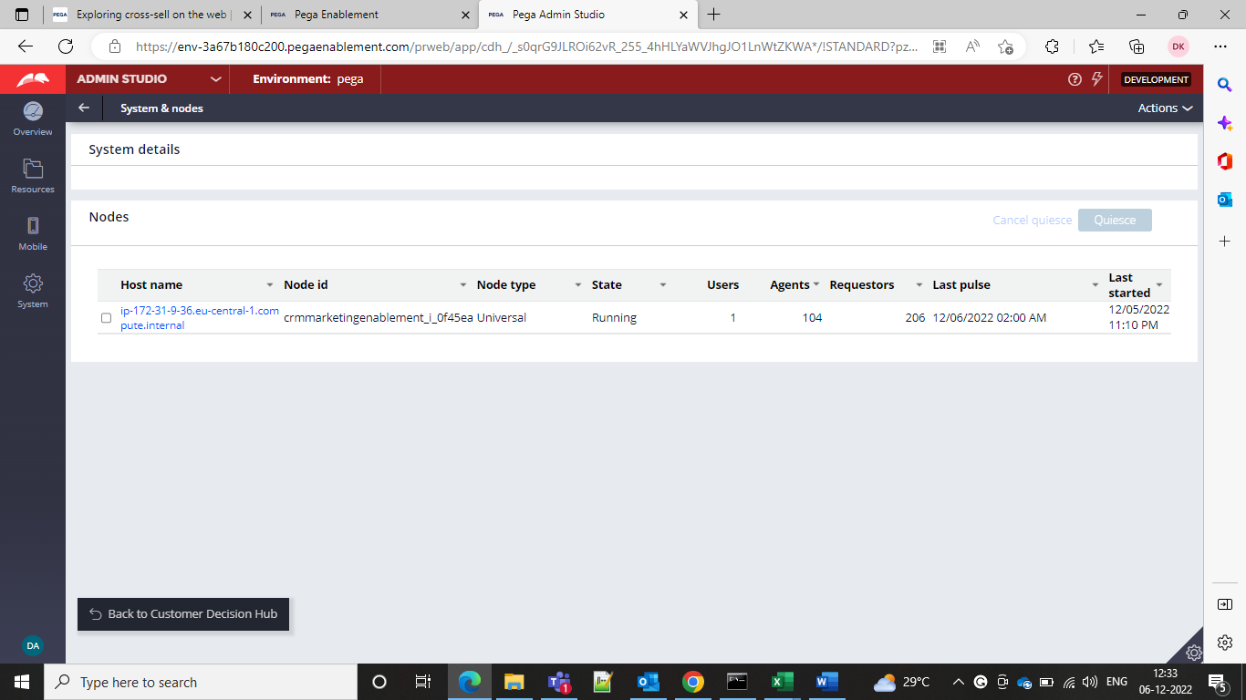

In order to classify the nodes we need to go for the prpc folder instlalaed folder and then we need to go for the bin folder and then we need to go for the setenv.bat file and then we need to set the D-NodeType as below

set JAVA_OPTS=%JAVA_OPTS% -DNodeType=Stream,BackgroundProcessing,WebUser,Search,Stream,ADM,DDS,RTDG

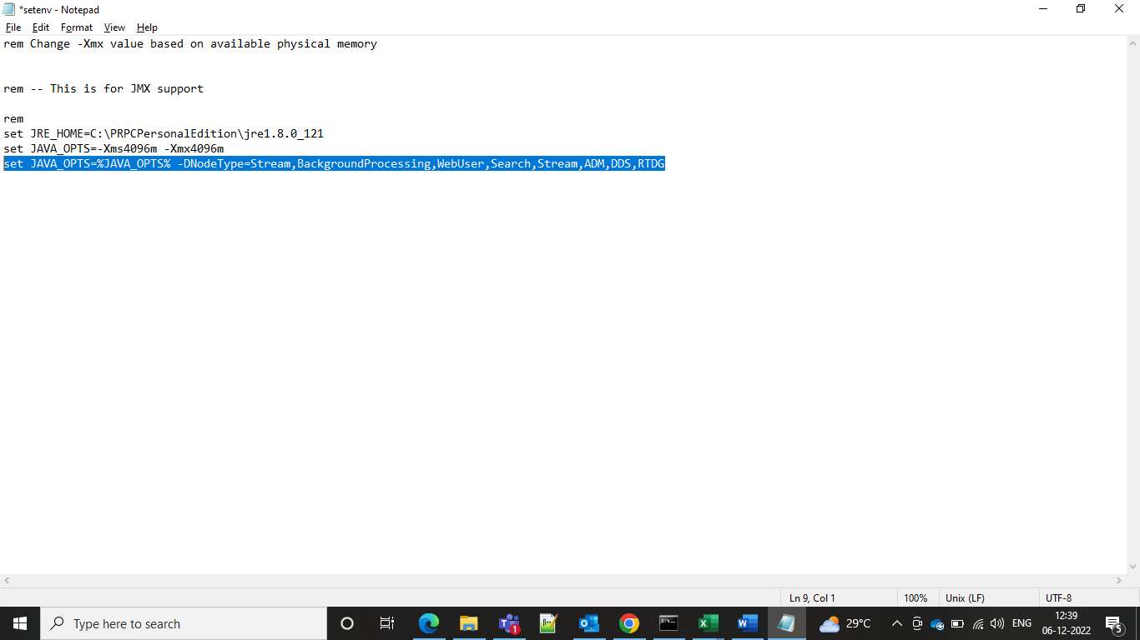

Node classification is done by updating the parameters in the tomcat folder bin folder in the PRPC folder and in that setenv bat file and change the nodes and then restart the server and go to the admin studio and click on nodes check whether service is displayed or not.

Generally stream is the real service and then the WebUser means like the browser where the operators login and we need to have the WebUser along with the decisioning Services.

After doing the node thing what we can do is we can go to the decisioning > decisions > infrastructure > services

Then all the decisioning services status will be set to normal and mapped to the Node ID

That means now all are setup and running and for the CDH we can see under the decision data store and all would be set to normal

We have an database called as the Cassandra Database which contains information about the customer and customer products which is very important and if we lose it it will become a big problem while implementation. That is the reason pega cponnected to Cassandra database.

By using Postgres if we send offers to the 5 million customers the database will surely crash.

It will be genera lly distribute in multiple nodes and copy the data to all the nodes and then it will able to retrieve the data when one is down.

Pega has internal Cassandra database for storing the decisioning data.

It also has database as the “EXTERNALMKTDATA” to store marketing information like segments, actions, treatments etc..and it is present in postgres database which is popular for storing marketing rules.

Before creating an application we need to be aware of the critical data that is needed to facilitate decisioning and marketing.

We need to identify root audience that is the customer base then you need to create the context dictionaries.

We need to identify them uniquely so we need a key to identify so we cannot call it as CustID so we go for the generically and give it as the subject ID and targeted user is called SUBJECT and where the records are stored are called as SUBJECTTYPE

Segments means group of customers whom we want to target and it is must and should that we create segments for each and every type of customer like example loan eligibility and card eligibility customers we need to create separate segments.

We need to have the information from one source and we need to map it to the class and then only we can map it and then target the customer.

If we select the Cassandra database when creating an application and then pega will create an internal Cassandra database. Otherwise, decision data will be in the Postgres database.

And in the frameworks in CDH creations

Pega decisioning implementation

Application framework

Pega framework – marketing

Base – Pega- UiKit

This is the structure for CDH

And for our core Pega also we have the same but we have core Pega implementation instead of the Pega decisioning implementation.

This Is the structure we need to follow

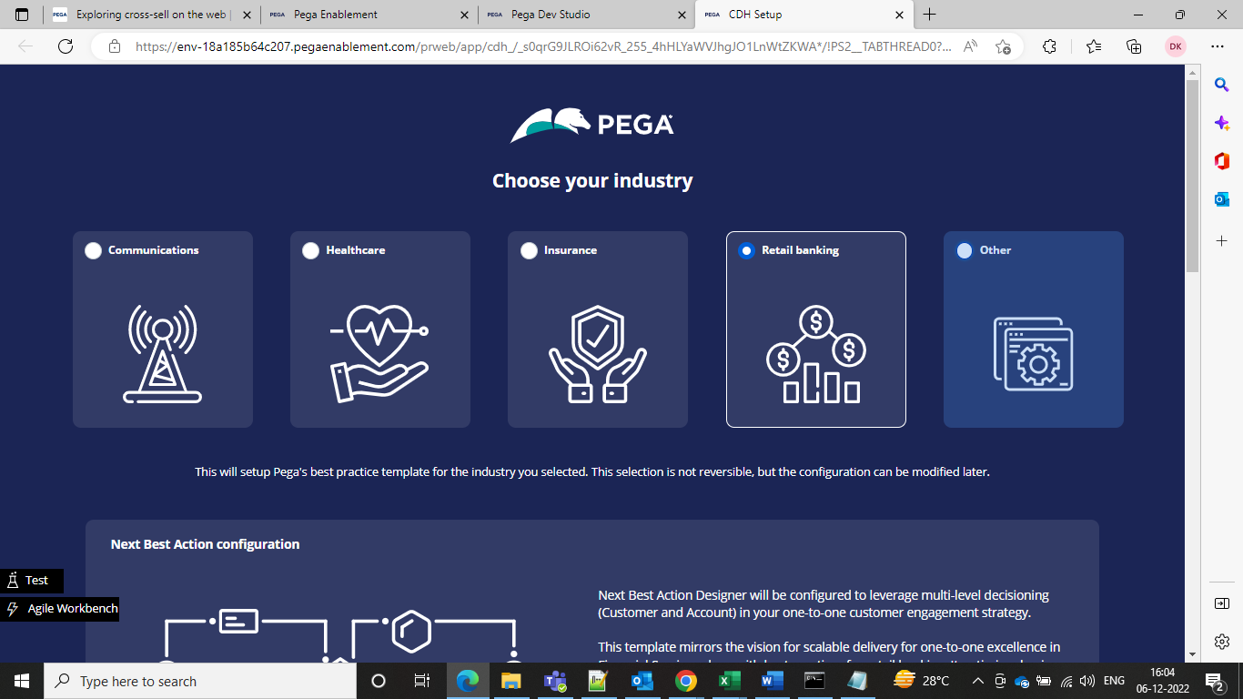

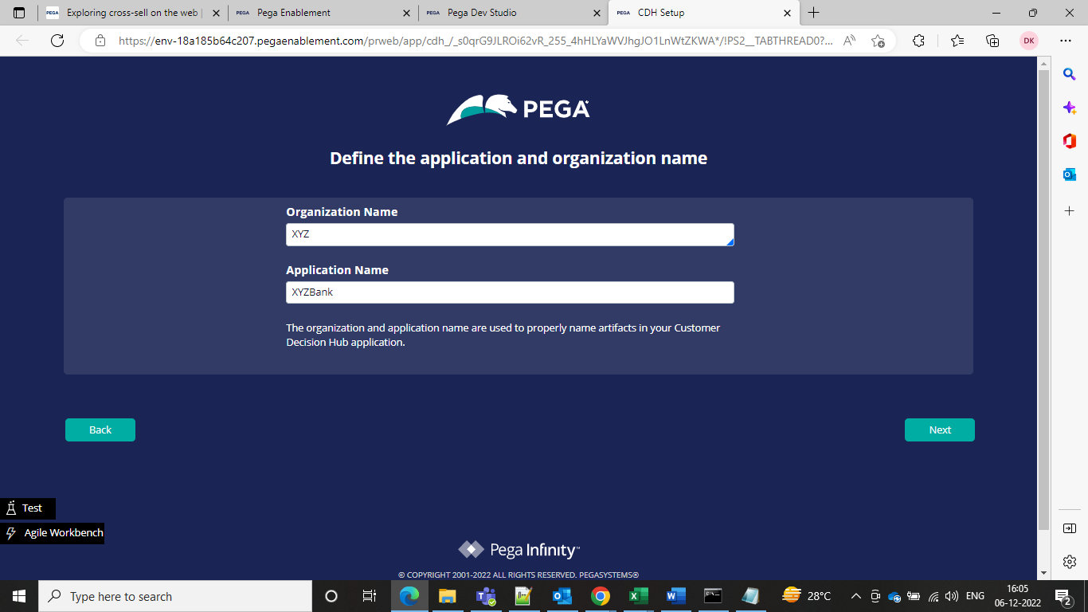

And the application starts created

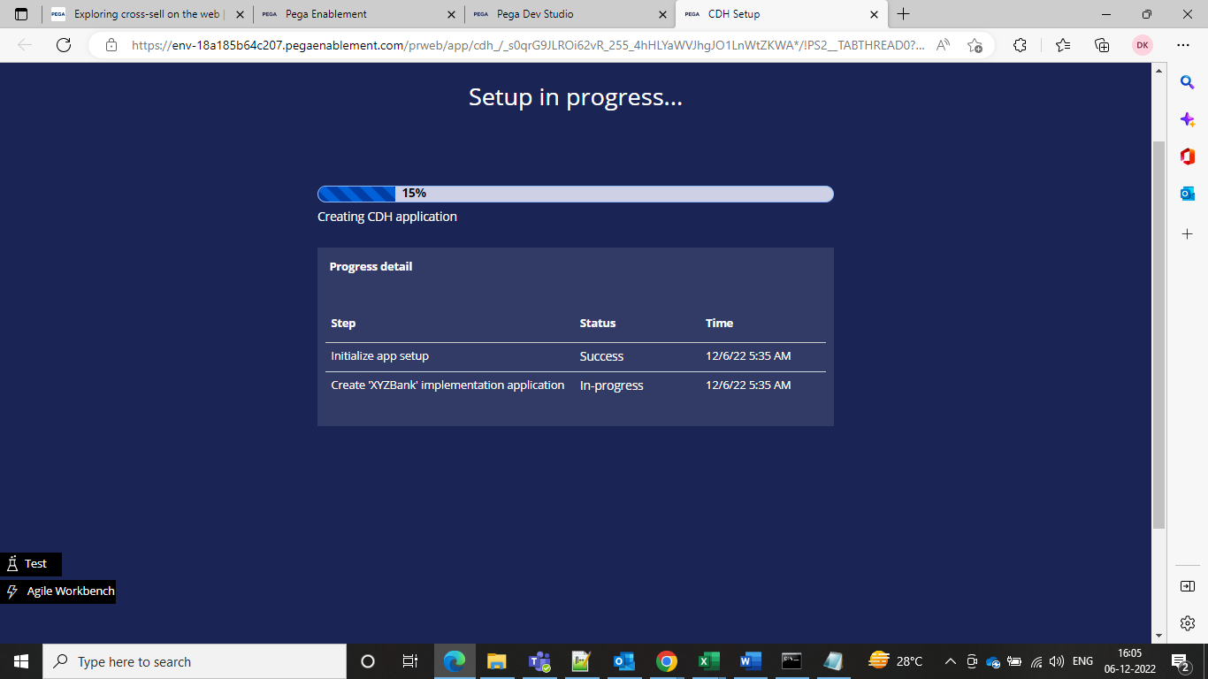

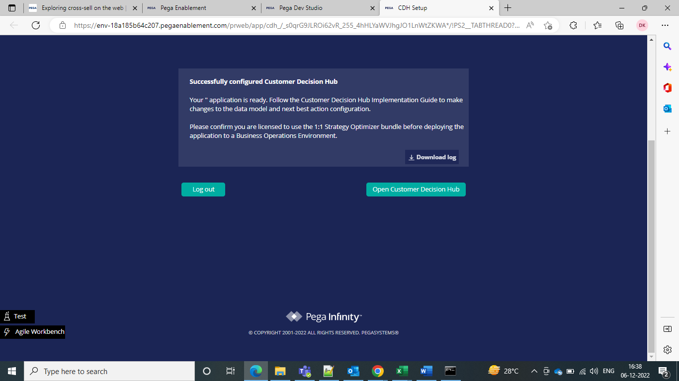

And a successful screen comes when application is created.

Where a context dictionary is created and saving the dictionaries.

There are 2 additional rulesets created apart from the by default application and organizational rulesets.

One is artifacts ruleset and another is the NBADTests ruleset.

The artifacts ruleset is like the production ruleset for Pega decisioning.

Any runtime rules you can keep it in the Artifacts ruleset and if we want to edit in the production we need to keep it in the artifacts and should always be open.

If we want to deploy anything we create the product rules and thee product rules are saved in the artifacts ruleset

TransformSROutput is the main DT to link CDH t customerService Framework

If we want to do any kind of POC we can do in the Artifacts ruleset.

And the NBADTests ruleset is kind of a testing ruleset. In normal BPM we create a ruleset but in decisioning the test cases will be stored in the NBAD tests ruleset and will not be promoted to other rulesets.

NBAD-Next Best Action Designer tests ruleset

And how can we see the Cassandra database information in CDH

Go to configure > decisioning > Infrastructure > Services

And then go to the edift settings where we will find Cassandra CQL part, Cassandra user ID Cassandra password

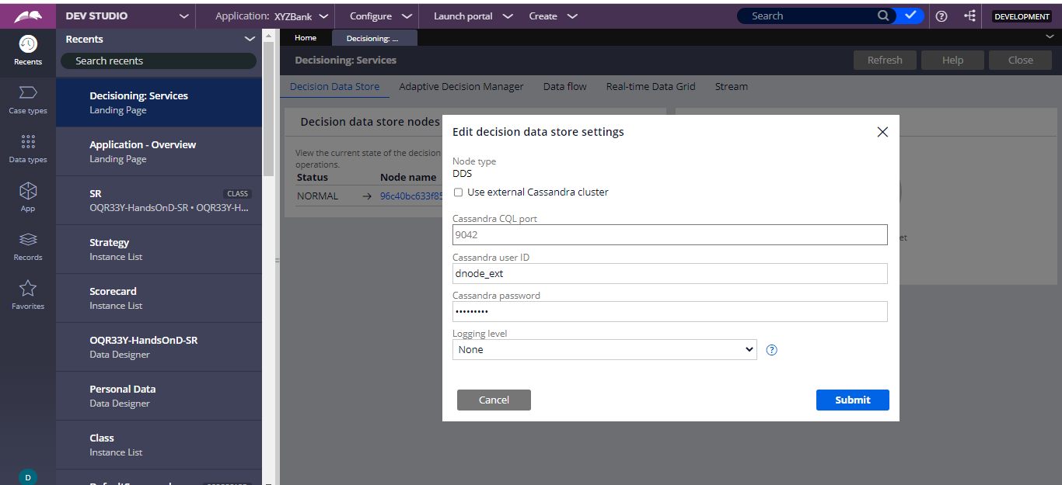

So this is going to Cassandra database

There is a separate rule type Cassandra which we need to create if we want to create external Cassandra

We have decision Data Store Data Set to see the data which is in Cassandra and we would create a DDS and see the data otherwise it would be in BLOB but not exactly but we cannot see the data.

If want to see the data we need to create the DDS dataset

If we have single node set it to universal but if we have multiple nodes set it to the D_nodetype

Set it to the stream, background processing, Batch, DDS, ADM, WebUser.

Generally we create eeverything in rules ruleset only.

Because artificats will store only products and updates and all that.

We have to proceed with context dictionary and as part of context dictionary context means an audience.

If you want to promote to audience you need to create two types of context

Primary context

Secondary context

Associated context

Cassandra database is for scalability and availability

Scalability means we can keep on increasing customers without affecting performance.

Availability means data can be available even after the crash of the system.

All auto-generated rules go to this Artifacts ruleset

It can be used for any POC and technical config.

And all the important rules and major decisioning rules go to this ruleset

And al the general rules like data transform decision table when rule flow action etc… go to the rules ruleset.

Taxonomy in CDH

It means that it contains 3 components are

* Business issue
* Business Group
* Proposition

After you configure the context dictionary you configure the taxonomy

As part of taxonomy there are 3 components

* Issue
* Group
* proposition

Business issue means the reason for promotion. The reason for promoting the offers is called as the issue.

Ex- bank want to promote in order to increase the sales or bank wants to promote in order to acquire customers. It wants to promote in order to retain the existing customers. SALES, ACQUISITION, RETENTION.

Business Group- it means category of the promotion.

Ex- debit card, credit card, personal Loan etc…..

Proposition means the promotion itself.

Proposition can be service/ discount/ notification/ product

Anything you propose to the customer is called as proposition.

The business issue can be created in the decisioning>decisions>propositions management> 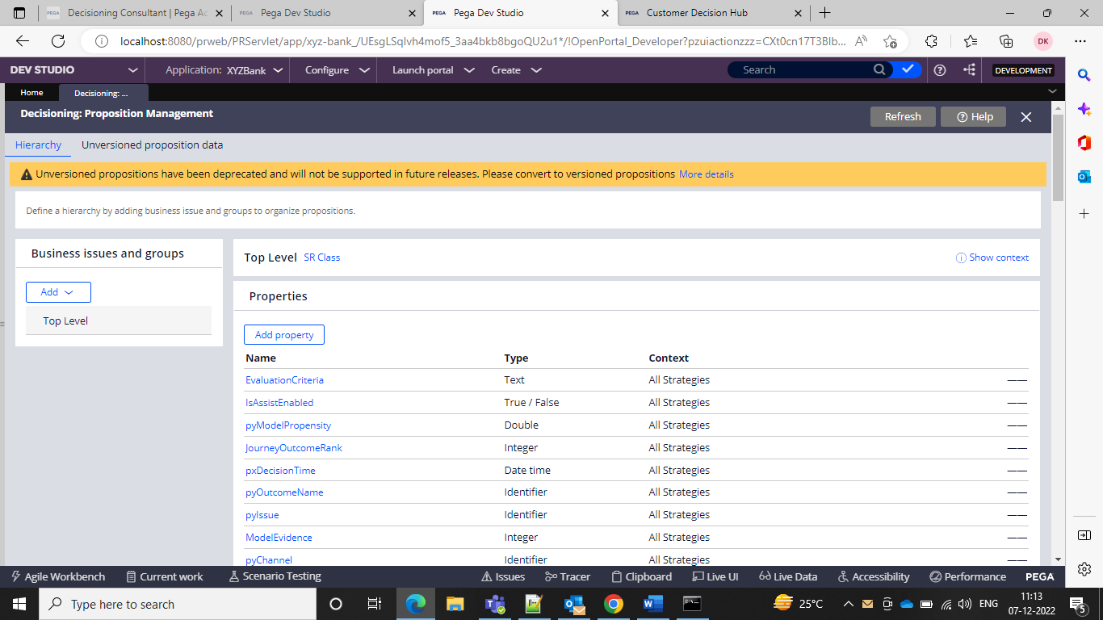

And here you can add your business issue

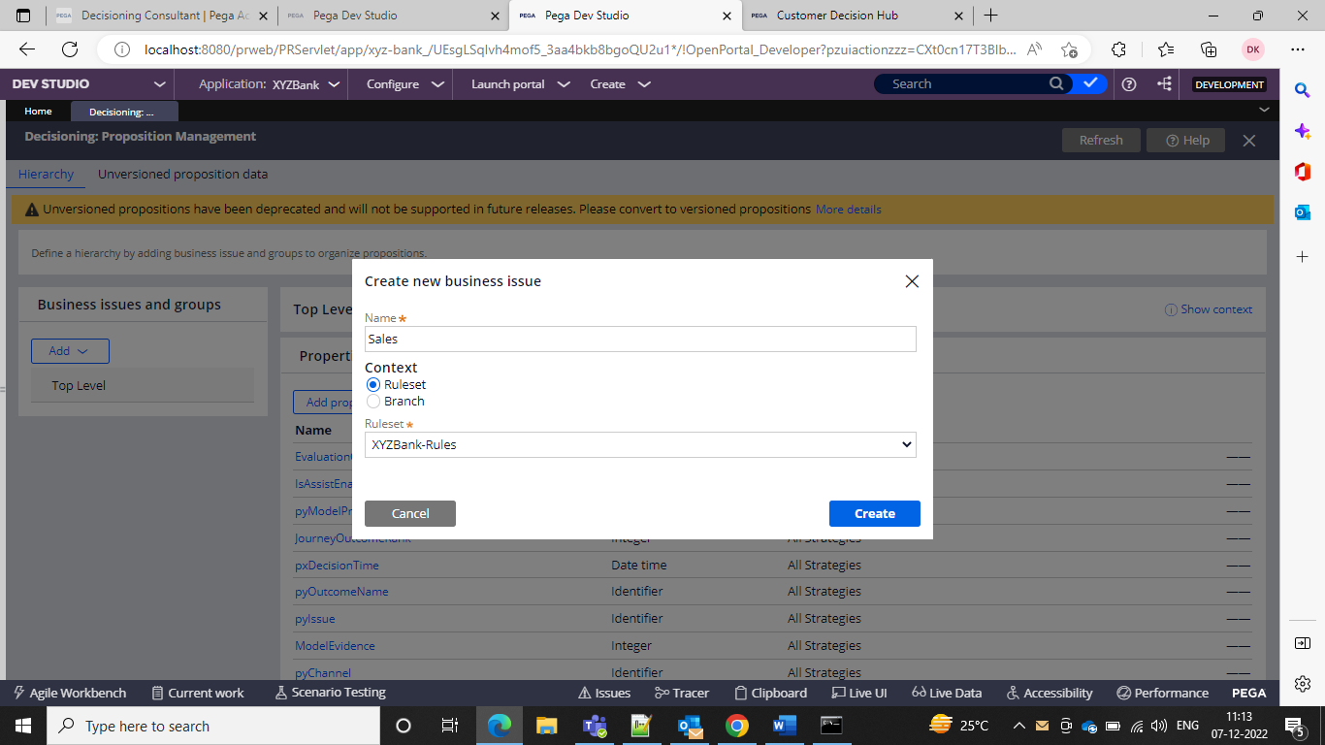



And now we can add the business group

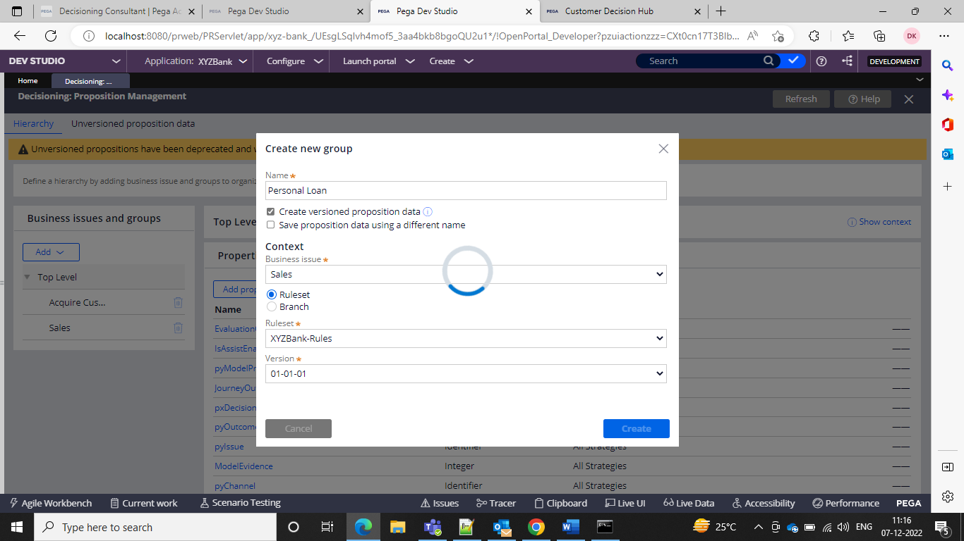

This we can create under the sales.

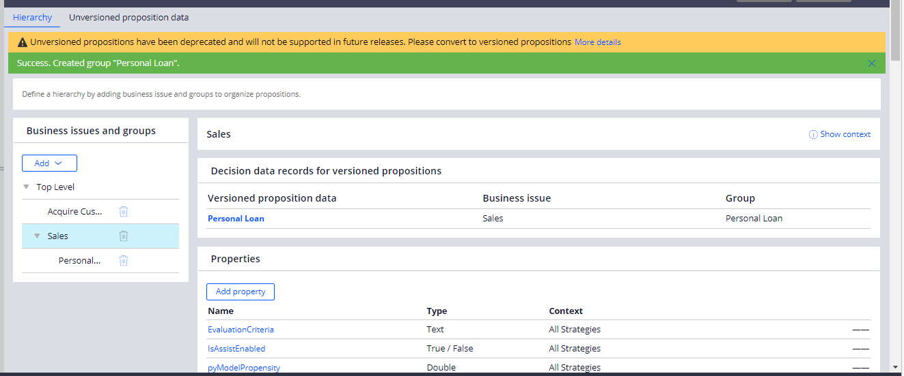

Now let us create Proposition in Personal Loan now

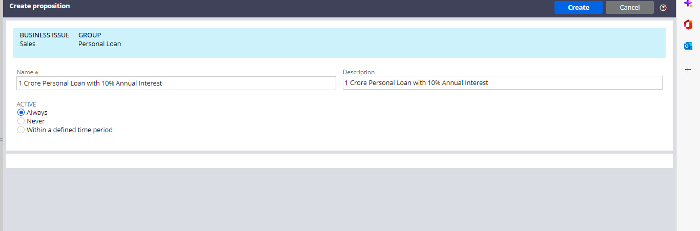

We want to create the offer of interest on 1 crore loan so AI created my proposition I such a way

We would be creating one class called as SR class which is strategy result class same as work class in PRPC

It will contain output of the strategy.

The eligible offers will be present in the strategy result class.

It will be created automatically when you have at least one business issues.

The class will be creatred in the format of the

APPLICATIONID-SR-BUSINESSISSUE-BUSINESS-GROUPS

If there is a property custID if this common to all the groups you will create at SR level

Properties means characteristics of your propositions.

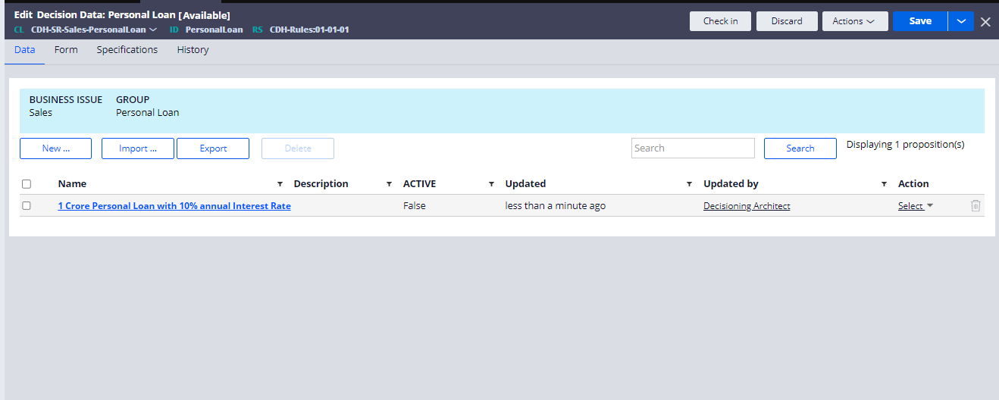

We can add our attributes/properties same like PRPC

We navigate to the group navigate to the form tab

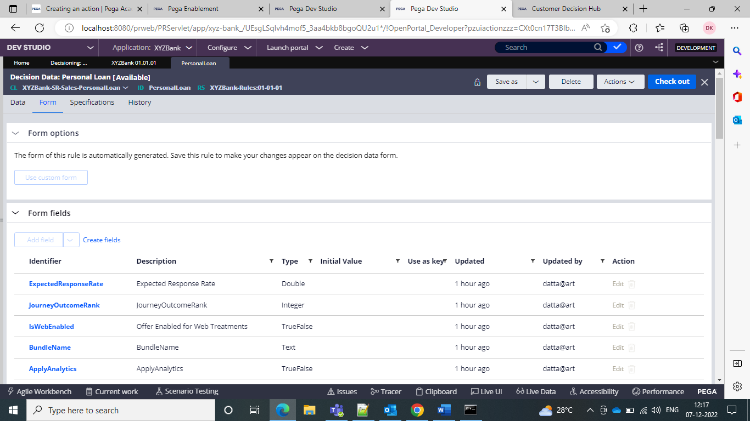

And add the fields. Since this is personal Loan group

I added monthly EMI and Loan Tenure and then we can now save and go to the offer and we can be able to add them to the fields in the offer.

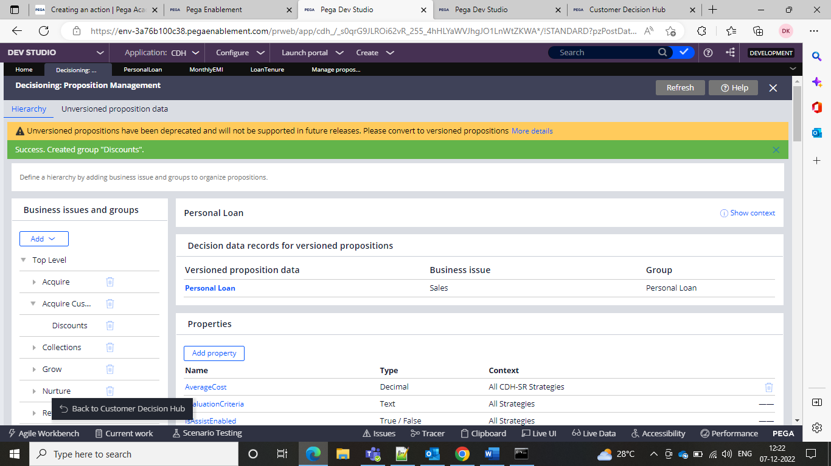

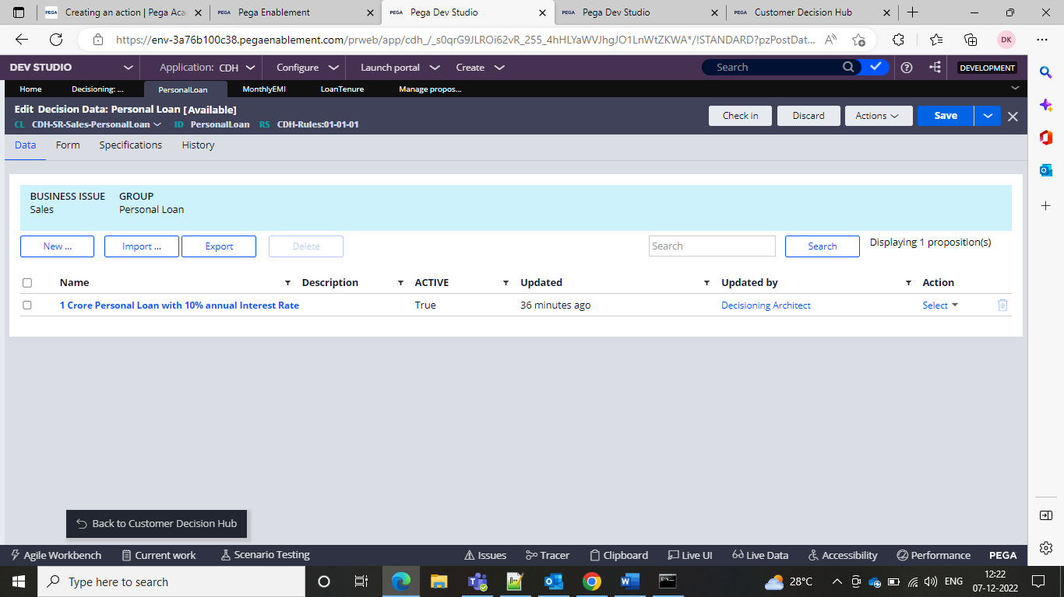

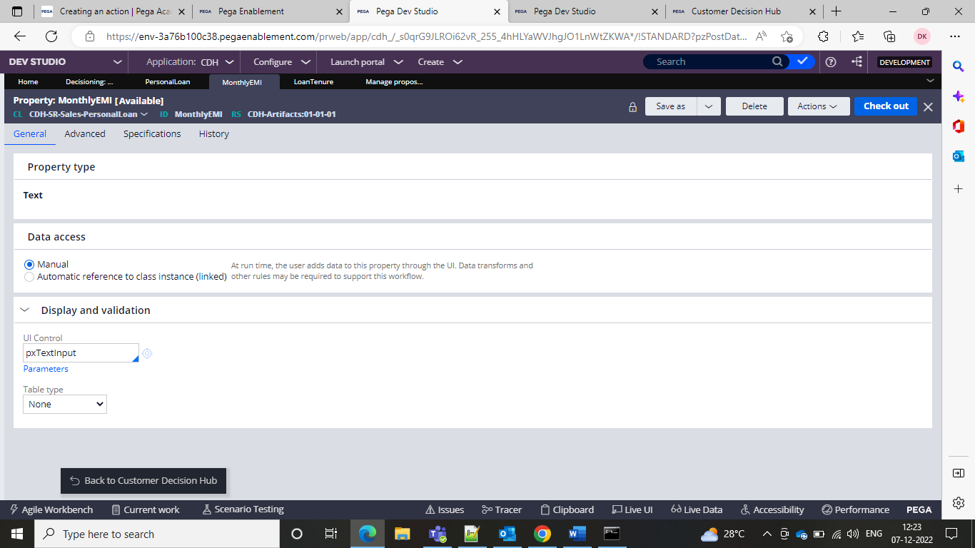

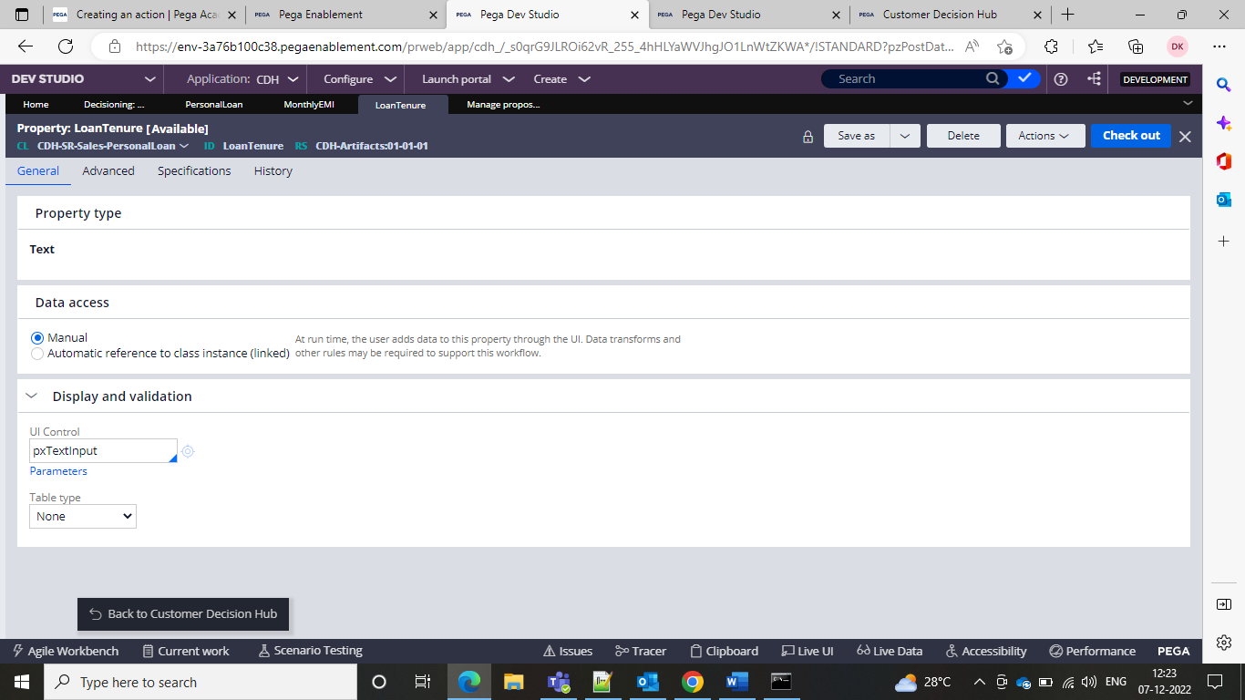

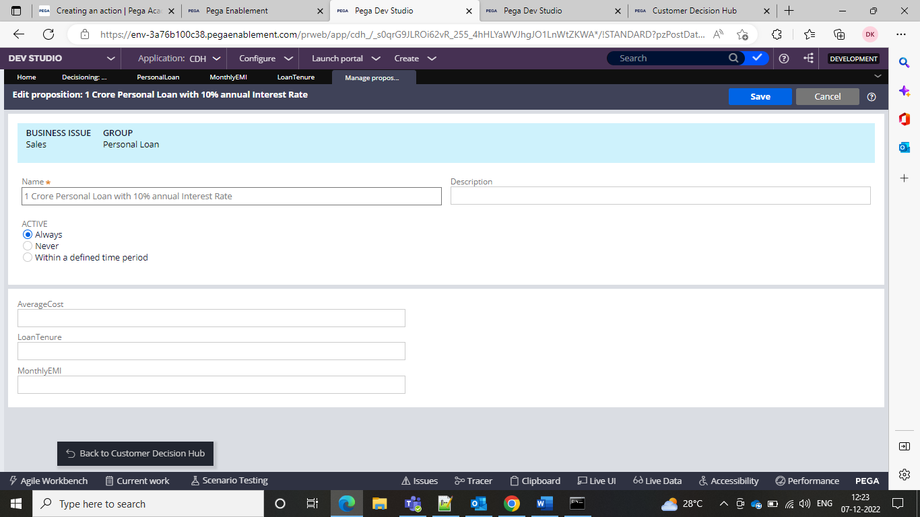

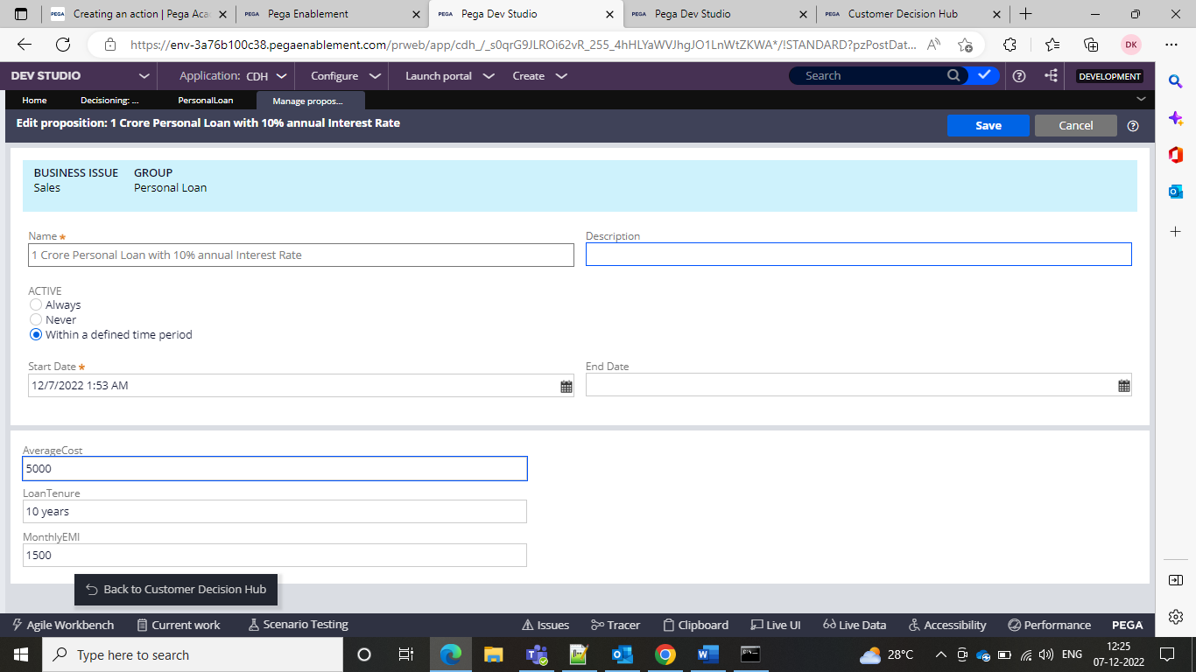

So this is how we give attributes to the propositions.

So basically what is the reason what are the categories and within the categories what you want to promote is called as the taxonomy.

In the real time we won’t be adding the properties like this we will export them and then remove the unwanted OOTB properties and add the offers and send them to the business.

The business issue is mapped to the property called as the pyIssue.

Business group is pyGroup

Proposition means it is present in pyName.

Propositions are updated and csn be updated in the csv file which we export. After the export and we can do the import by adding the offers

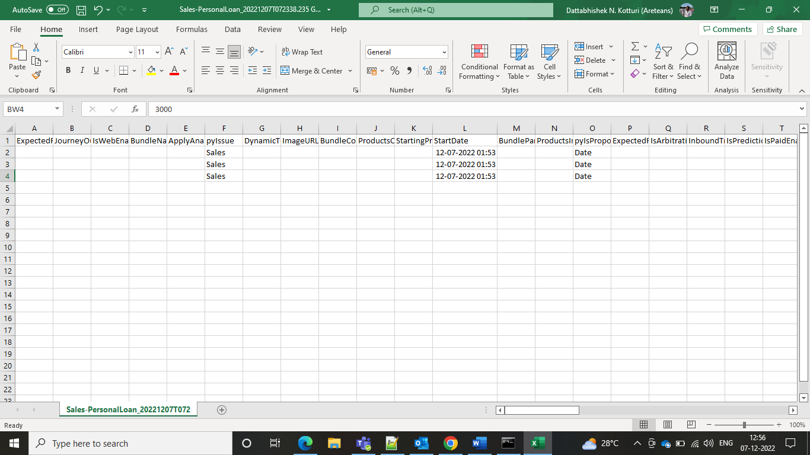

Now added the records and can check after the import

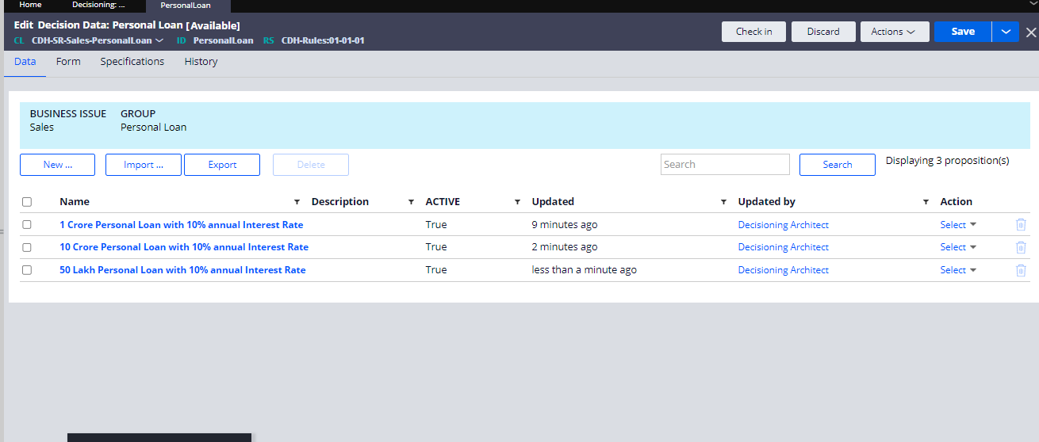

and now the 3 offers are added and we can present them.

If we want to select the offer for certain time period we can select and keep it in excel and import

And the status will be set to true only during that time period

So if it is not the time period the offer will be set to false

And we also have segments which means you are sending to a target list of customers.

Pega does not have any feature to separate the target list of customers. It can be done only with decisioning framework.

Scorecard model means like valuating on the basis of the cibil score or credit score those can be done.

Paid Media means like you have to connect with some advertising sites and get insights and connect withnfacebook campaign and YouTube campaigns. To know the results if you want to know the outcome of the campaign you can use the paid media which is not there in PRPC.

Tactics means you will come to know what is the effective strategy you can use out of the results that you got from advertising through the Decisioning which is not there in Core Pega.

From Pega you can do the advertising and no need to go to facebook or youtube

The context dictionary has primary context and secondary context and in the primary context the first set of audience whom we want to target and in the secondary context they are the next target.

Associated context means associated info on the customer

**ACADEMY NOTES PRACTICES CHALLENGES**

**Creating an action**

Go to the content and create one action and can show it through the portal.

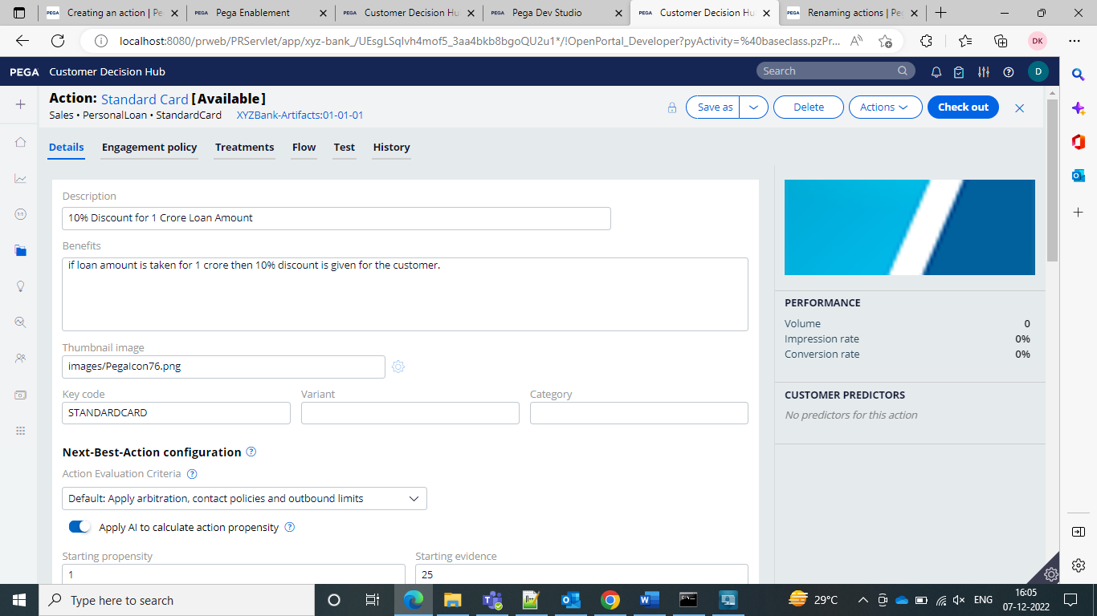

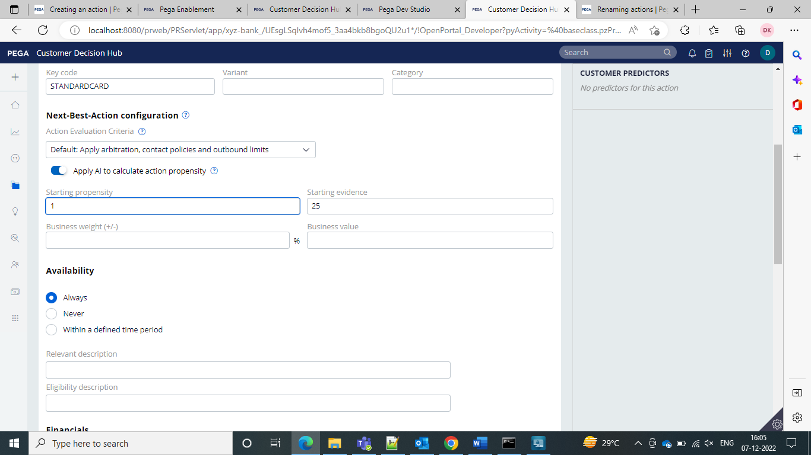

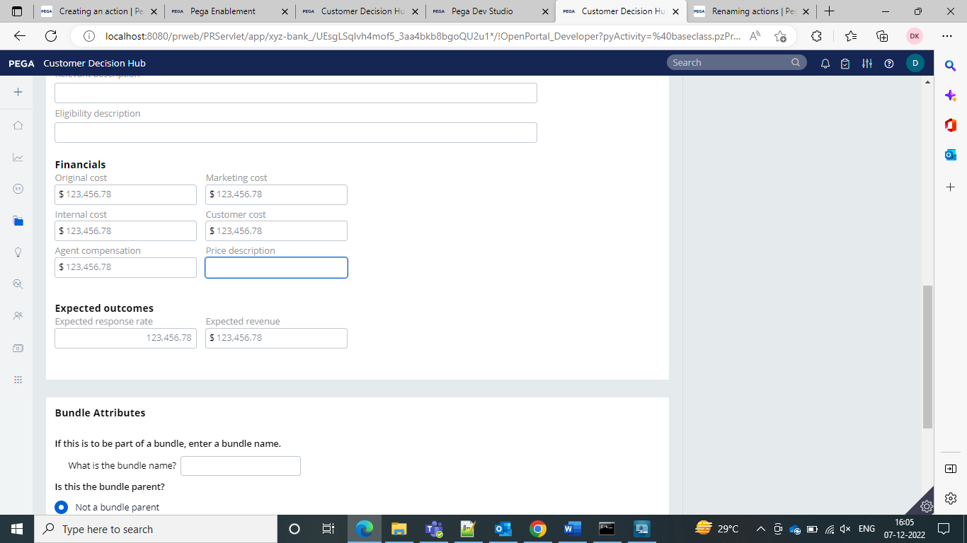

And then we can see the action in the Actions tab.

So after the creation, you can see the action in the action’s landing page.

And then go to the designer and then select on ething I selected Taxonomy and inside and then go for the edit and then you can edit

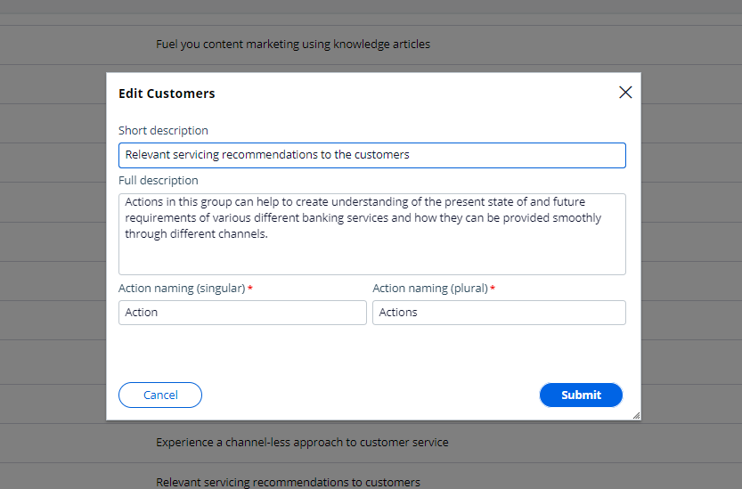

And then go for the edit and save and you can save the actions and groups.

**Creating a real time container**

Go to content> real time Artifacts

And then go for the creation of the container

After the creation it will look like this

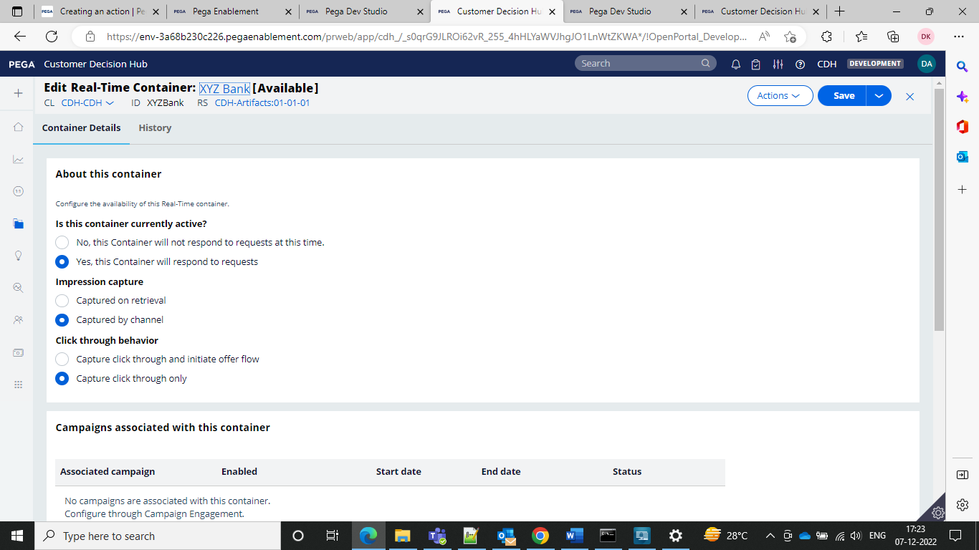

Where you can configure that channel will be responding to the requests from an external website and then the impression to capture and control how the CDH records impressions.

Captured on Retrieval means that CDH records an impression in the interaction history immediately after sending the action details to the external channel.

Captured by channel means that CDH does not immediately record an impression.

Instead the extrernal channel can explicitly request CDH to record at a later point in time.

To record a click in the interaction history without initiating the action flow for the customer, keep the default value.

This option is suitable for the options that do not have a defined flow.

And then navigate to the container tab to see the new containers.

**Presenting a single offer on the Web**

If a customer logs into the website then he must see cashback offers and then when he clicks on it he should see the more offers when clicked on the learn more

To implement this we need to go to the next best action designer

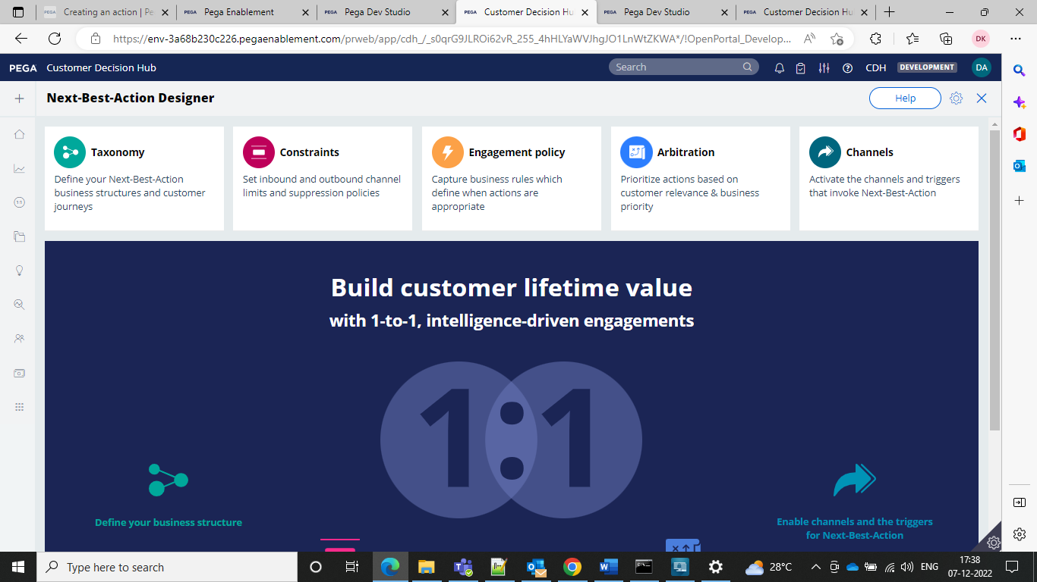

By using the engagement policy we can configure the business rules to define when specific actions or groups of actions are appropriate for the customers.

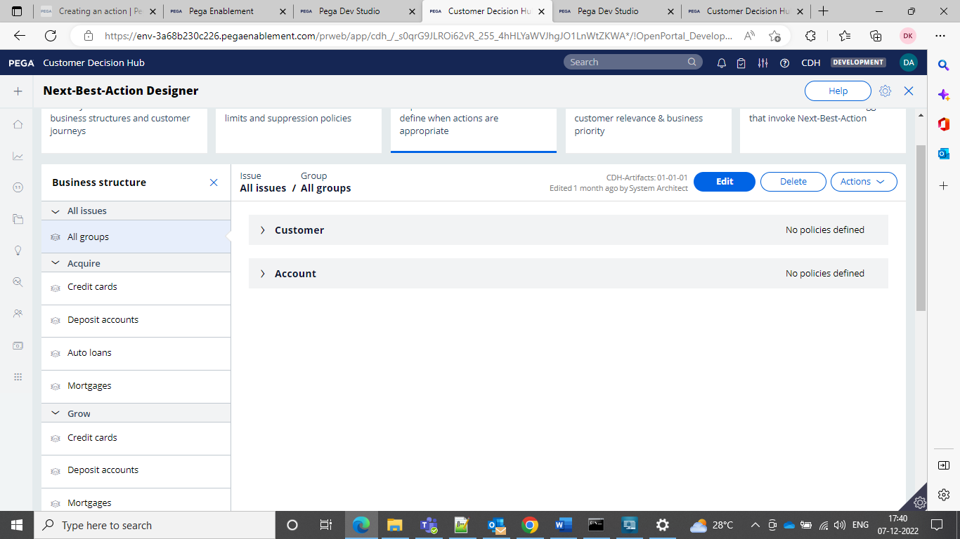

And we can configure the actions and in order to display an offer we need to have a treatment

That is specific to the channel.

To show on website select as the Web and can create one thing we can go for the content URL as how it should show and configure as below

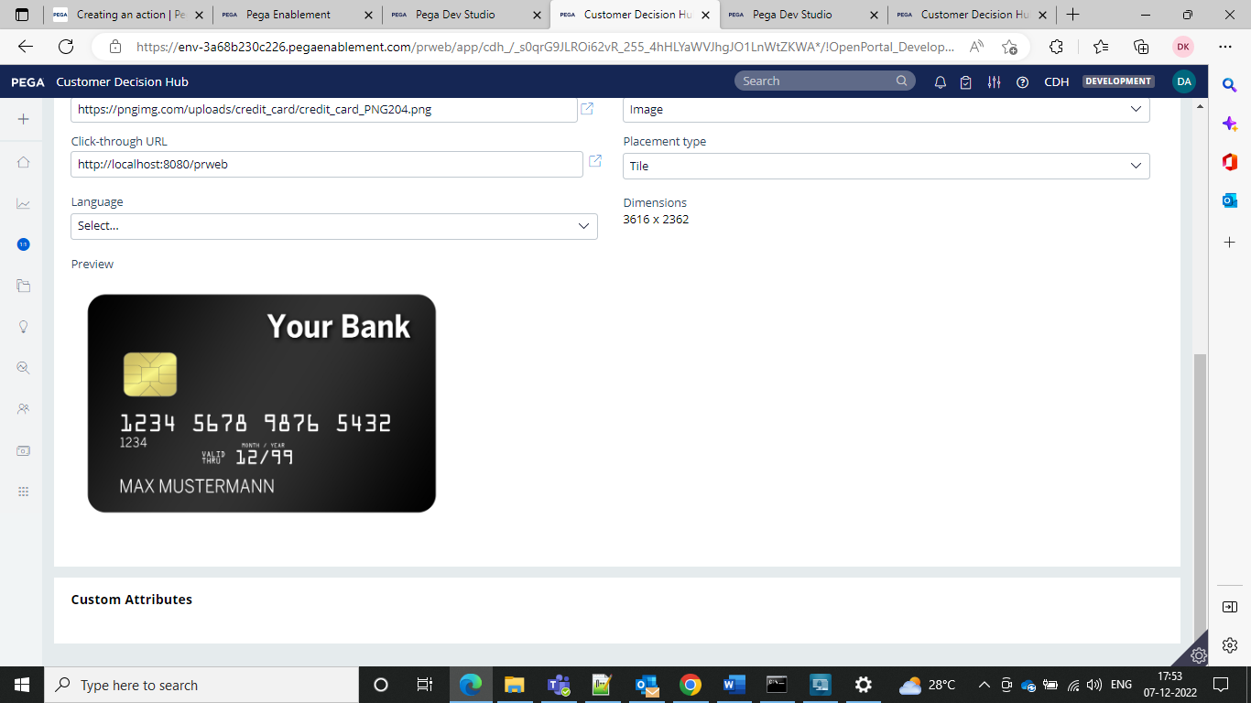

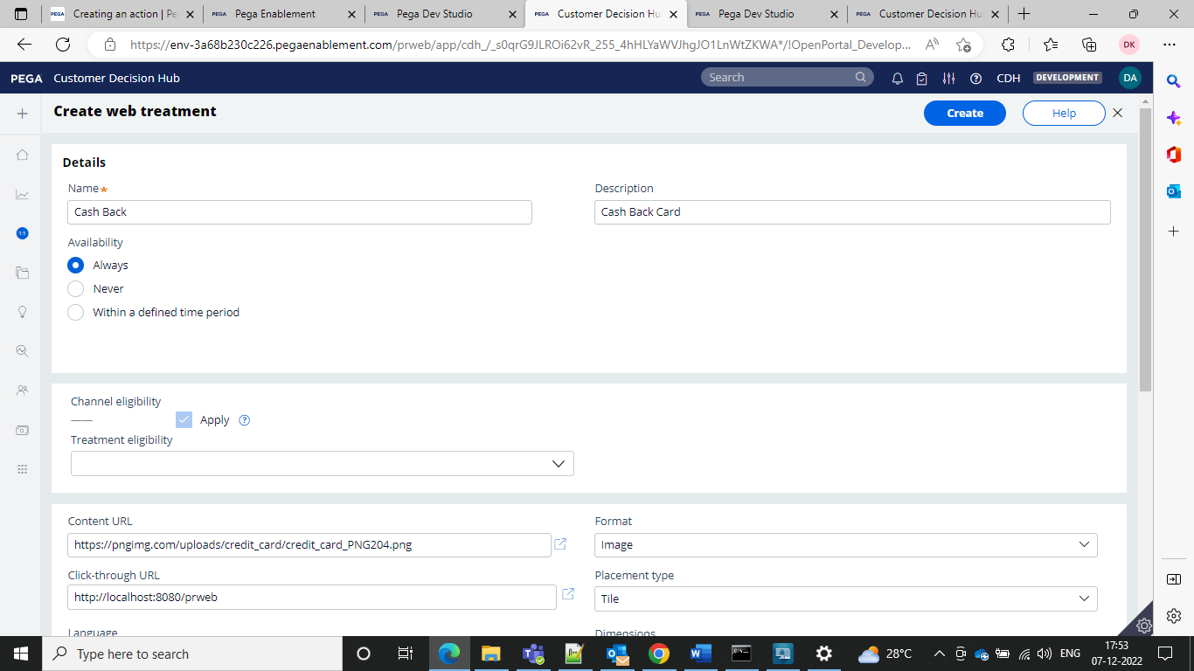

And then provide the URL to which it should go when they click on the action

Type of appearance we can select in the placement type

Specify the language if required

And then add the web treatment in the wizard

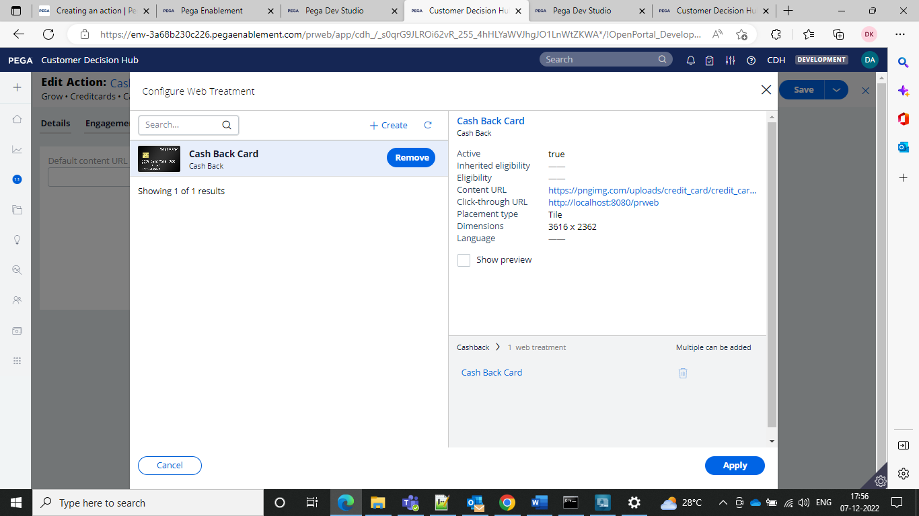

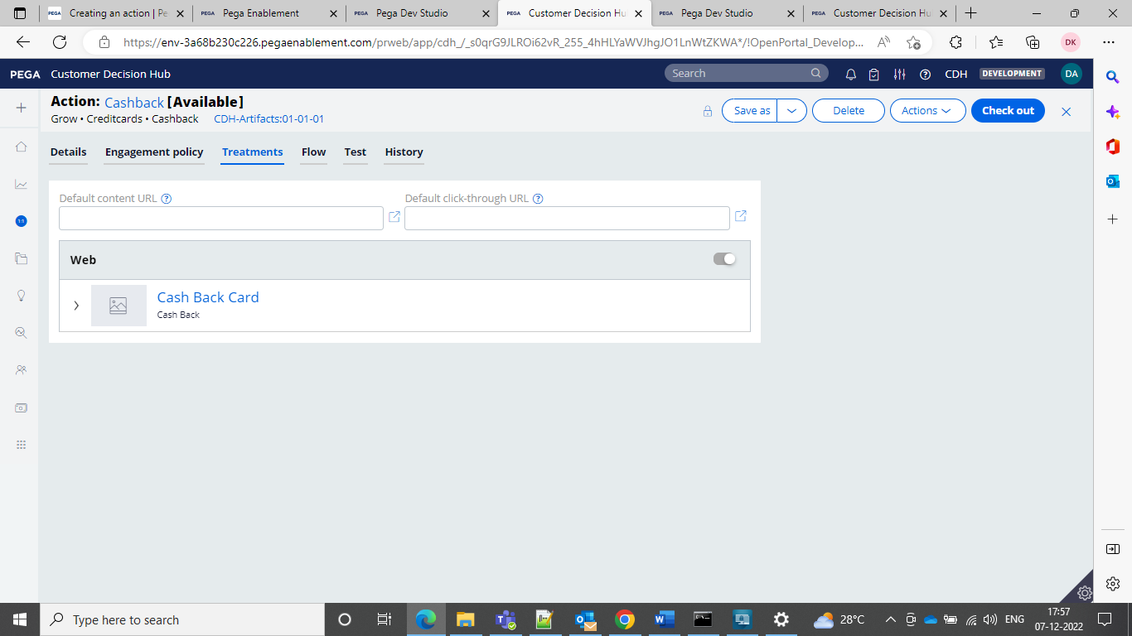

And then go for the save and see the action

And in the channels tab we can enable what will enable the actions.

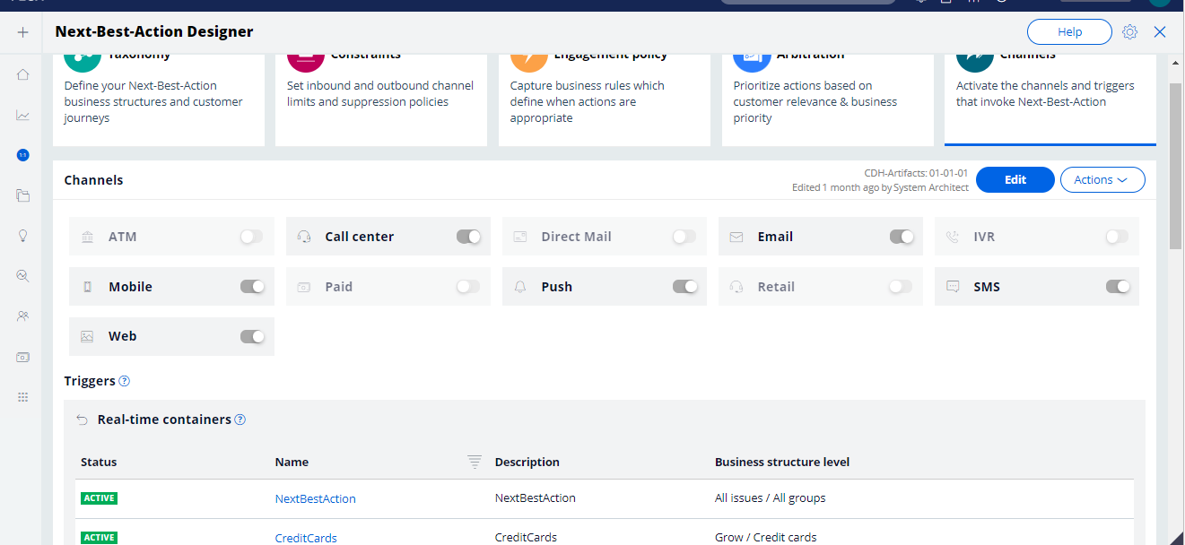

**Customer Engagement policies**

Customer engagement policies are nothing but which soecify the condition under which an action or group of actions is available for a customer.

Engagement policies are defined in the next best action designer. Under this we can use edit and then we can configure the engagement policies.

Under best practice engagement policies should be defined under eligibility, applicability and suitability which represent true nature of associated conditions.

Under best practice engagement policies should be defined under eligibility, applicability and suitability which represent true nature of associated conditions.

First define the eligibility condition to ensure that only current customers are eligible for the action.

Then in the applicability condition so that new customers who currently do not have a credit card, qualify for the actions.

These are also defined at group level.

At last define the suitability condition for each should be defined at the action level.

Creating a test case for the single or multiple groups

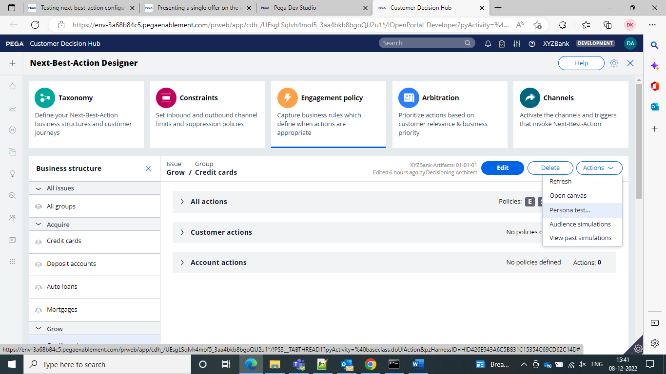

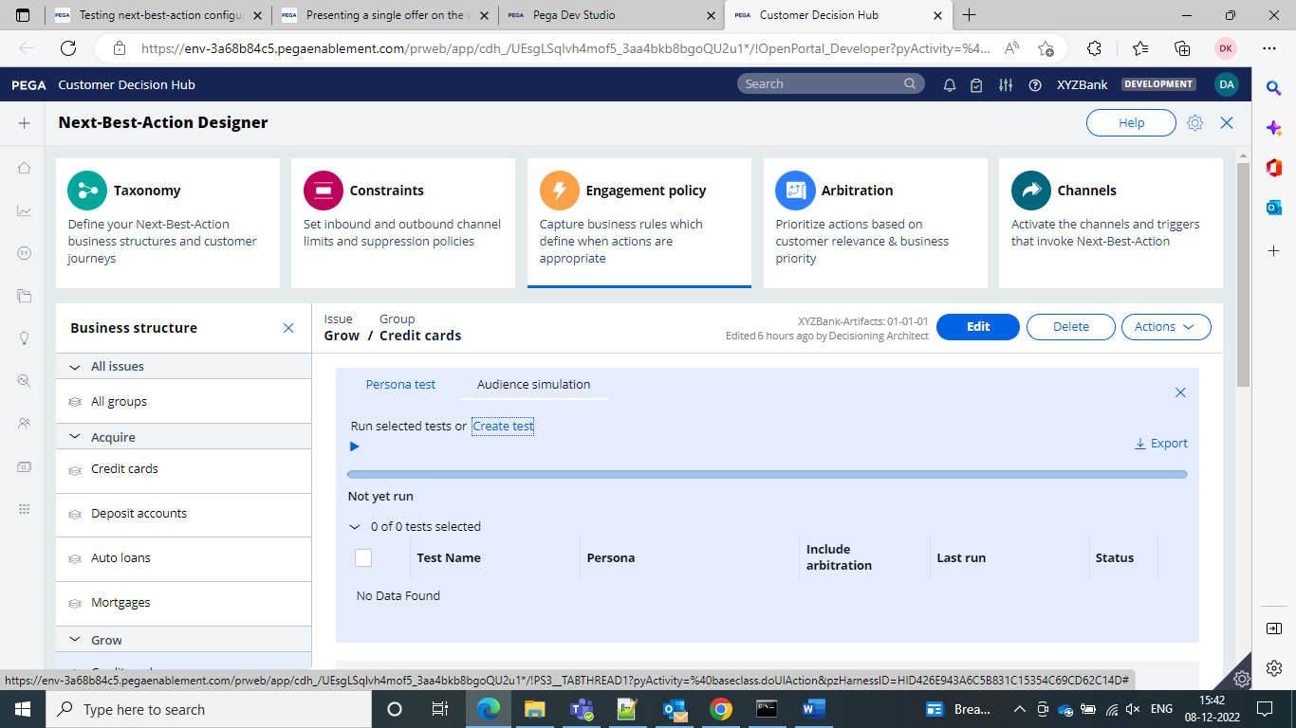

We can load actions and treatments from a file

Navigate to the content > Treatment and then go for the export of the treatment

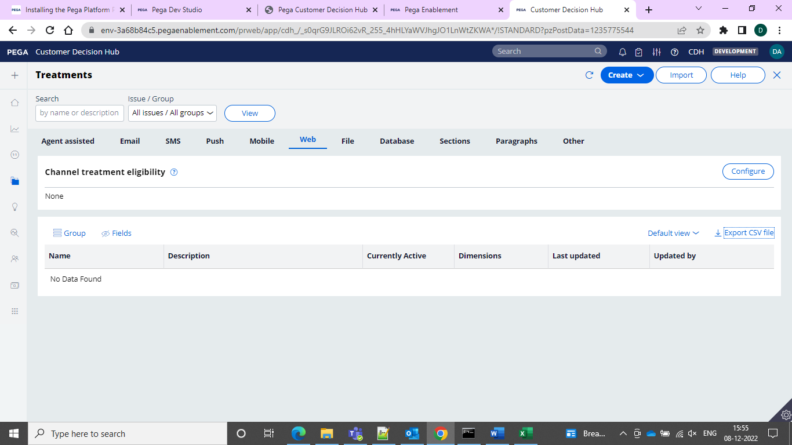

And then open the file and then click on the import

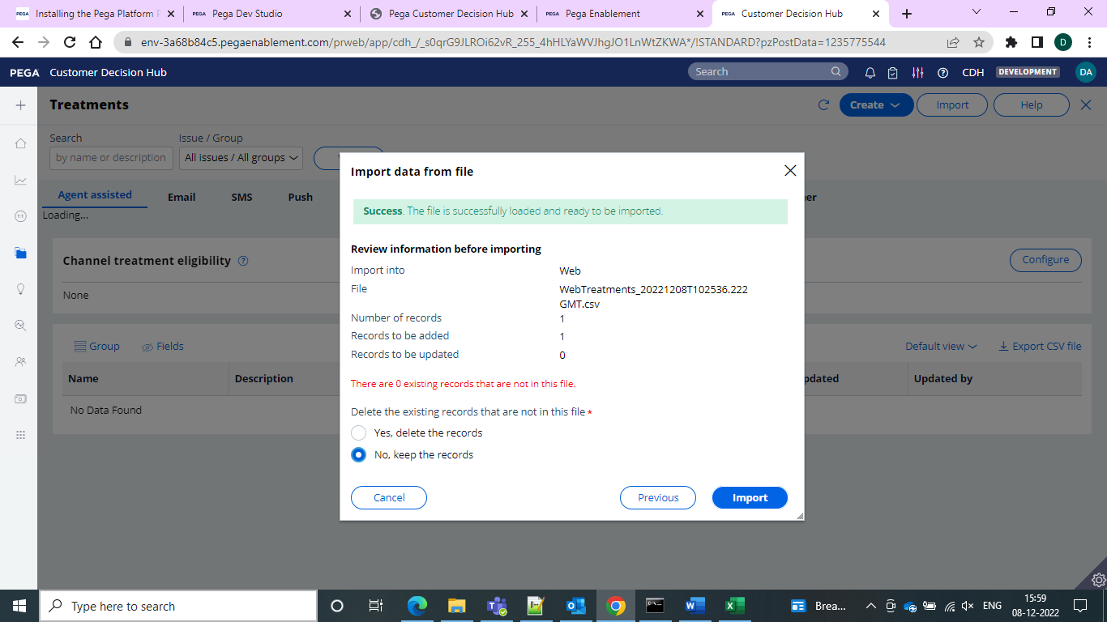

and then go for the addition of the file and in the actions now try to upload from the file and 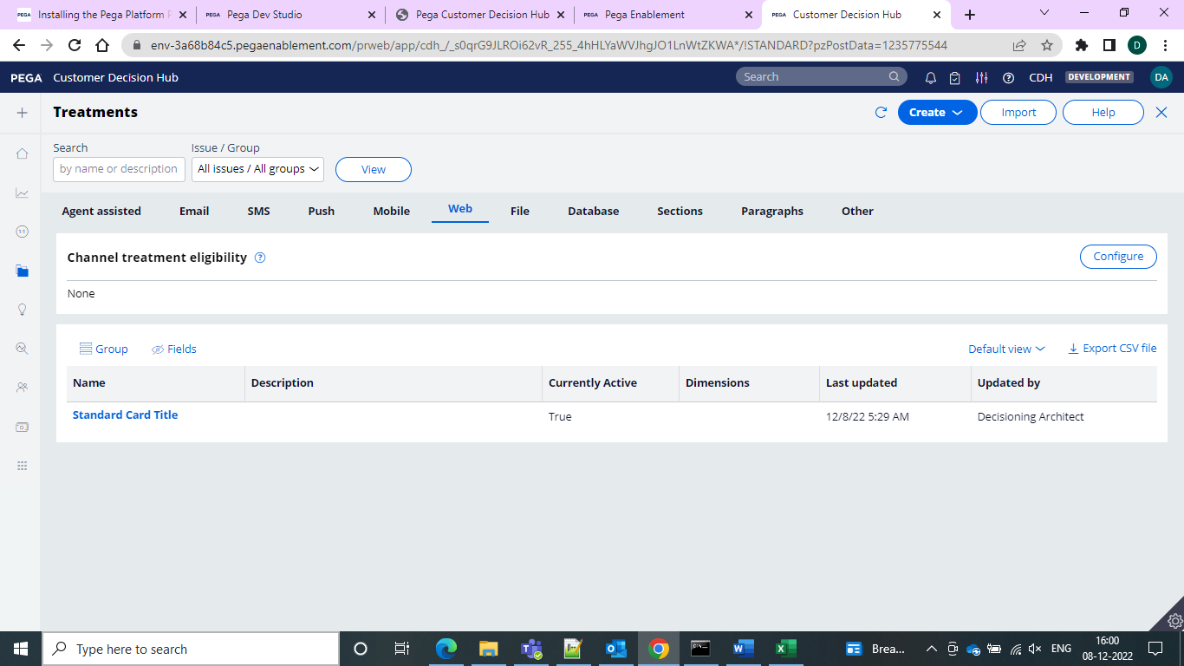

actions from the file from the actions and then go for the selection from the actions

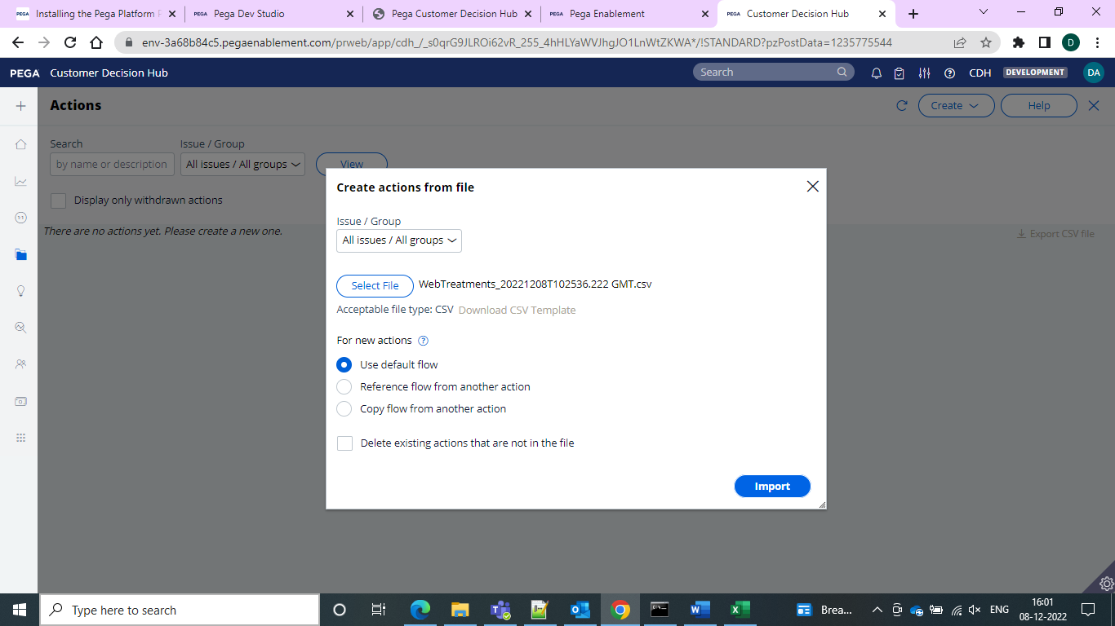

And select an issue or business

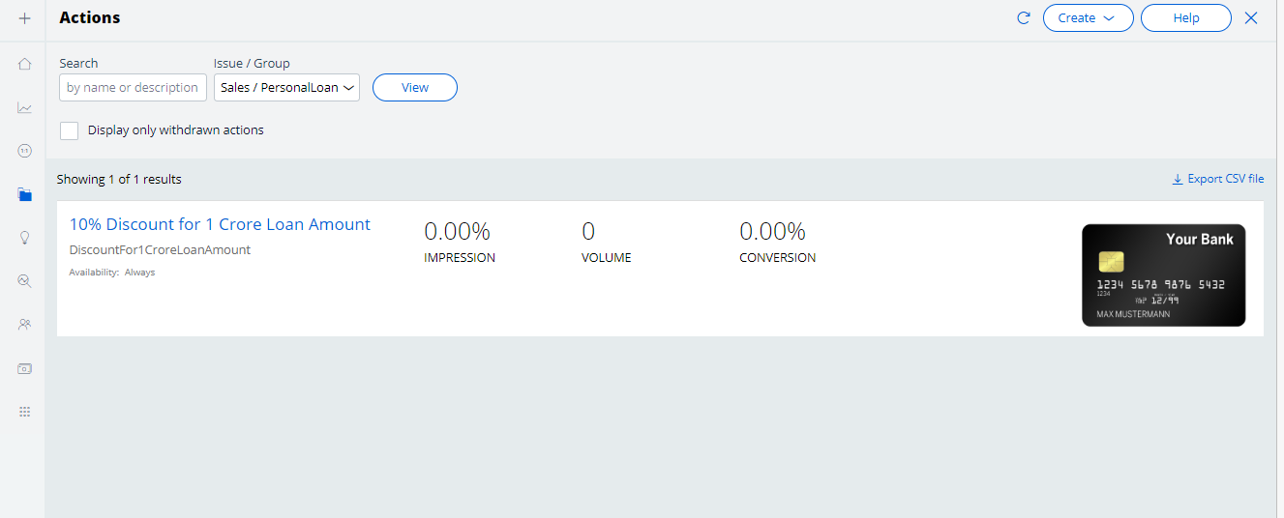

And load the file and refresh and you can see the action.

Defining of the customer engagement policies.

We can navigate to the next best action designer we can go for the engagement policies and then go for the action and then set the engagement policy

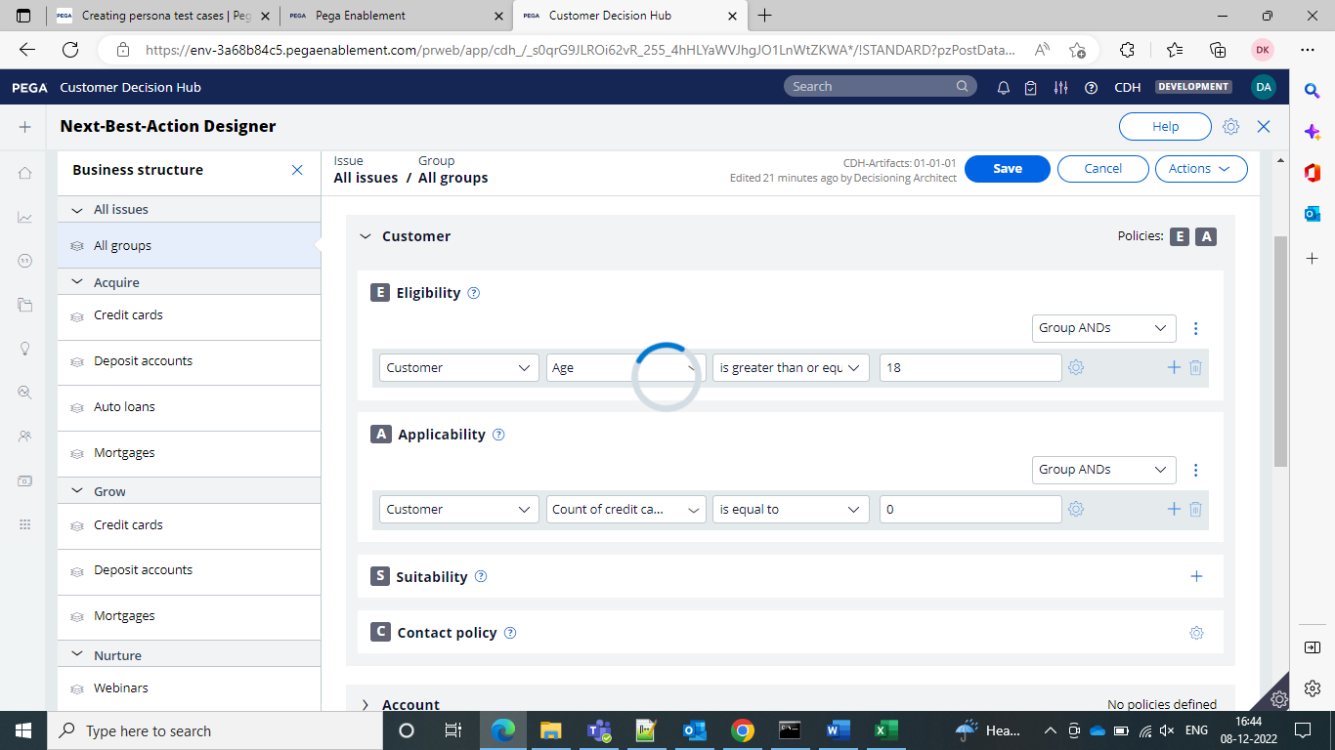

We can find the on the top right of the portal for CDH

And then click on the profile viewer and then select the persona as Troy and go for the

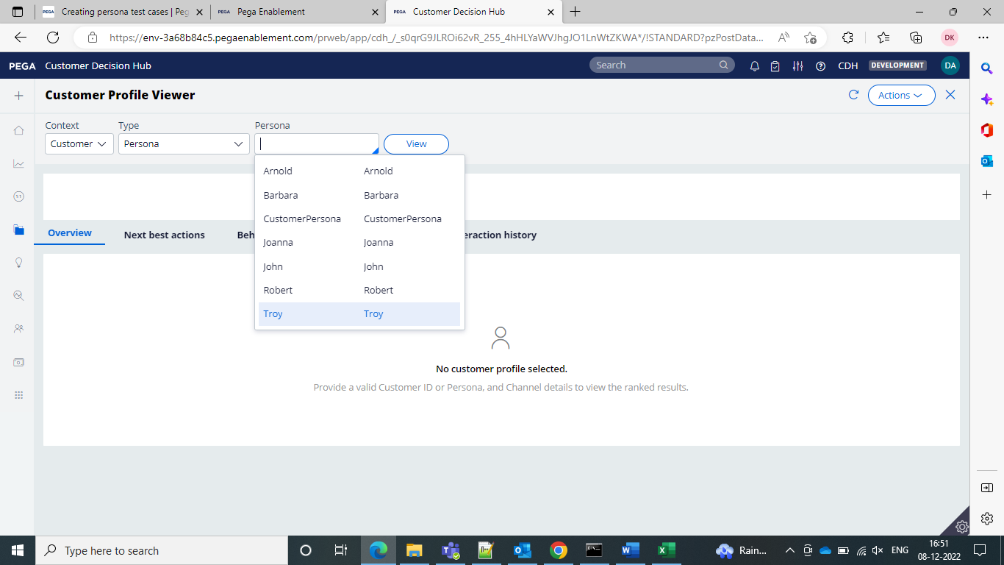



And inside that we can see the profiles and can view it and can go for his overview next best action history etc..

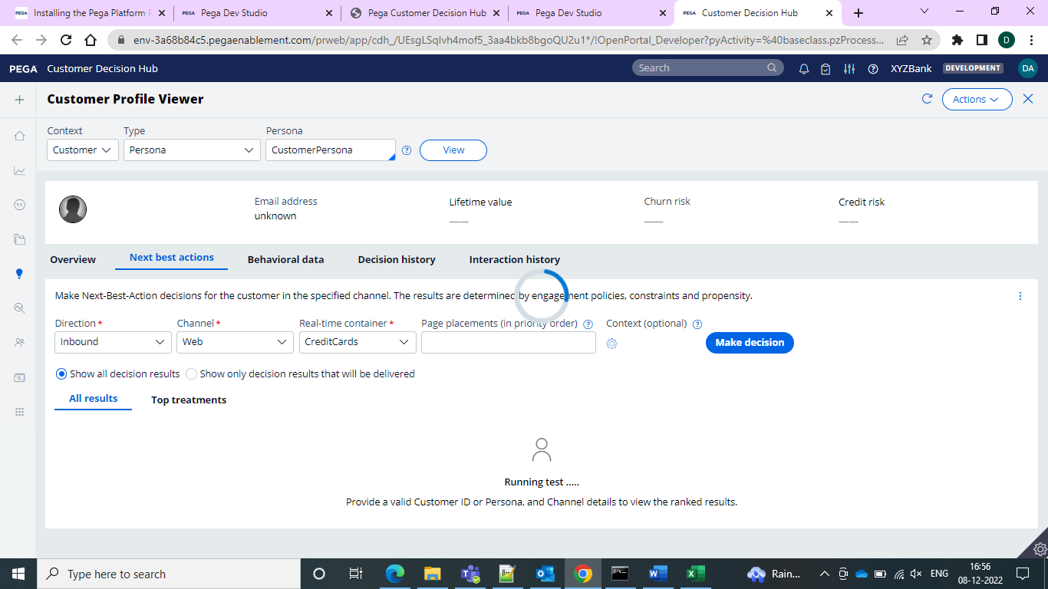

Avoiding Overexposure of Actions

In CDH contact policies allow you to suppress actions after a specific number of outcomes.

Customer Journeys means like case life cycle

Creating a contact policy from the next best action designer then go to the constraints tab we can define the suppression rules by creating contact policy rules

**Volume constraints**

It limits of the actions delivered to the customers

They can be set at an action, channel or property level

**Outbound Run Scenario**

In an outbound system considers a segment of audience for outbound communication. When customer is eligible for multiple actions then system will apply the volume constraints across customers to limit actions.

**Decision Stratergies**

Used to create logic that will decide the next best action for a particular customer.

Models- Adaptive, predictive- used to store and analyze the customer previous responses and offers are suggested.

Strategy canvas means in which business users visually design decision strategy on what is known as strategy canvas

**Extension points in the stratergy**

An extension is an empty rule that is intended to be overridden to meet the specific needs of the application.

The decision strategy designers must override the empty activity with a functioning interface to their customer master file.

This is the next best action framework strategy when applied to each of the actions.

We use proposition data component to import actions and comprise a unit of reasoning represent ed by the decisioning components.

We use the proposition data to import actions into a strategy canvas.

The sequence of the components in the canvas determines which actions is selected for a customer.

**Set Property Component**

We use this component to set values of the properties that are output by the strategy.

**Prioritize Component**

It is used to rank actions. It is used to rank based on the highest or lowest priority

Now creating Strategy

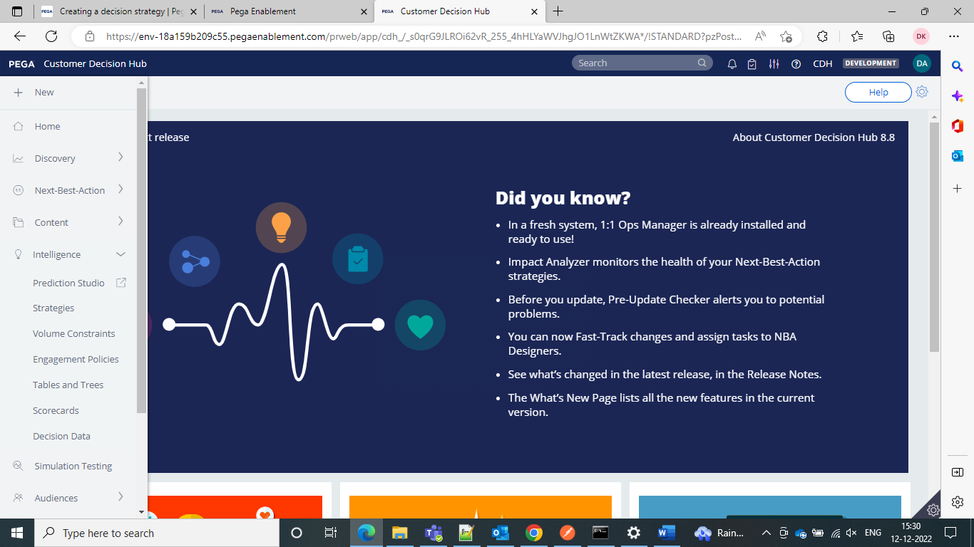

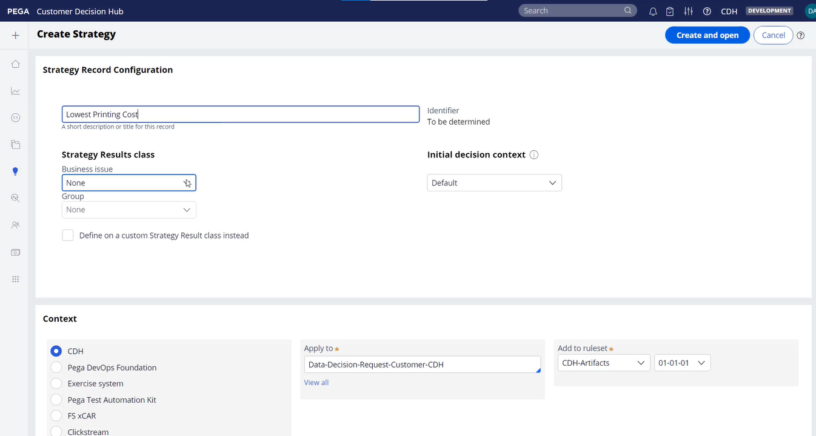



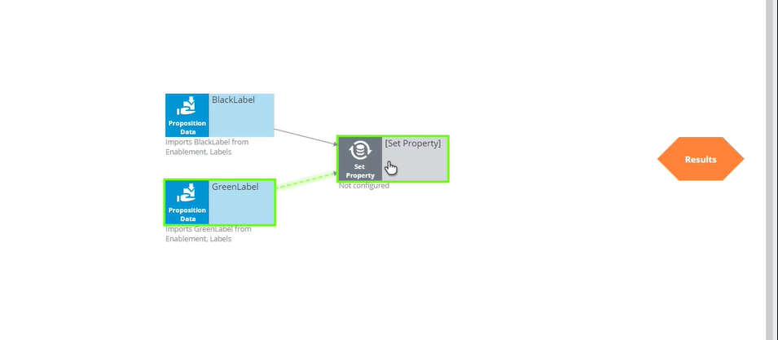

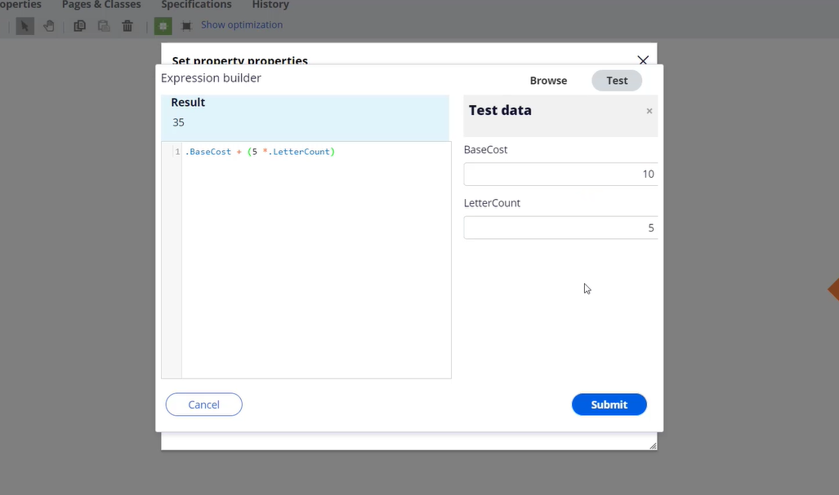

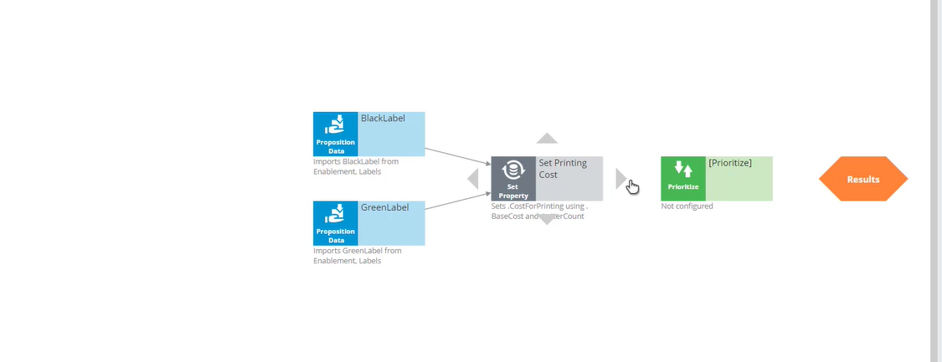

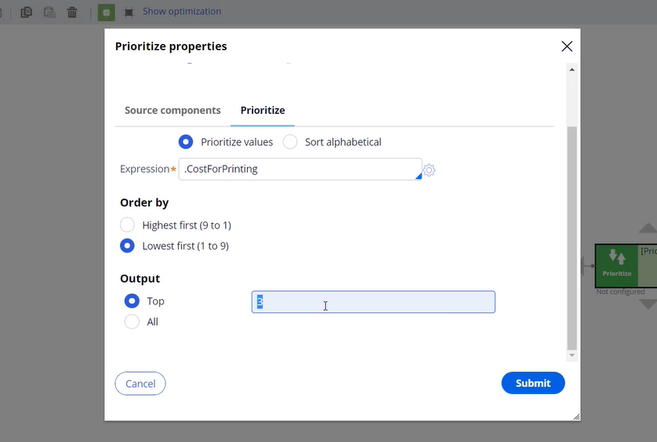

And then go for the test run of the strategy

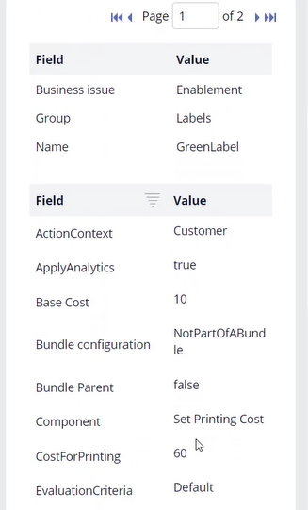

And now the lowest one came first and then we can go for the second one

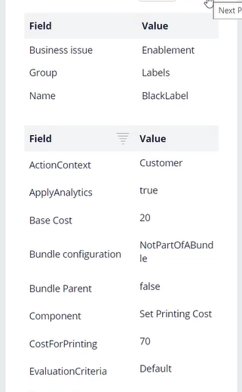

Now the prioritize is working as expected.

Adaptive model determines the Propensity.

Propensity Is always a number between 0 and 1.

Contact Policy

Maximum number of times a customer can be contacted on a particular channel during a time interval

Even though customer is satisfying the suitability applicability eligibility we don’t want to send multiple times the offer. So in order to keep certain limit we will use a contact policy.

Contact policy we would be doing maximum number of times a customer can be contacted on a particular channel during a time interval.

It has 2 components

* Customer contact limit
* Suppression policy

It can be defined under constraints

And this contact policy you will set it only for outbound channels

We will specify channel and what is the limit

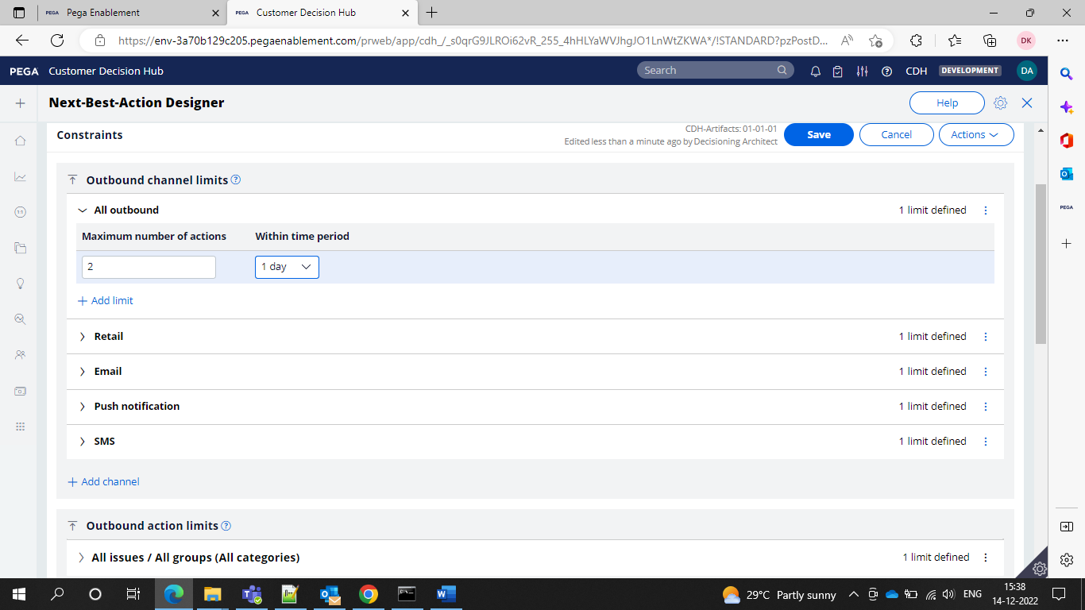

And

Suppression policy means to hide the offer based on the customer behavior.

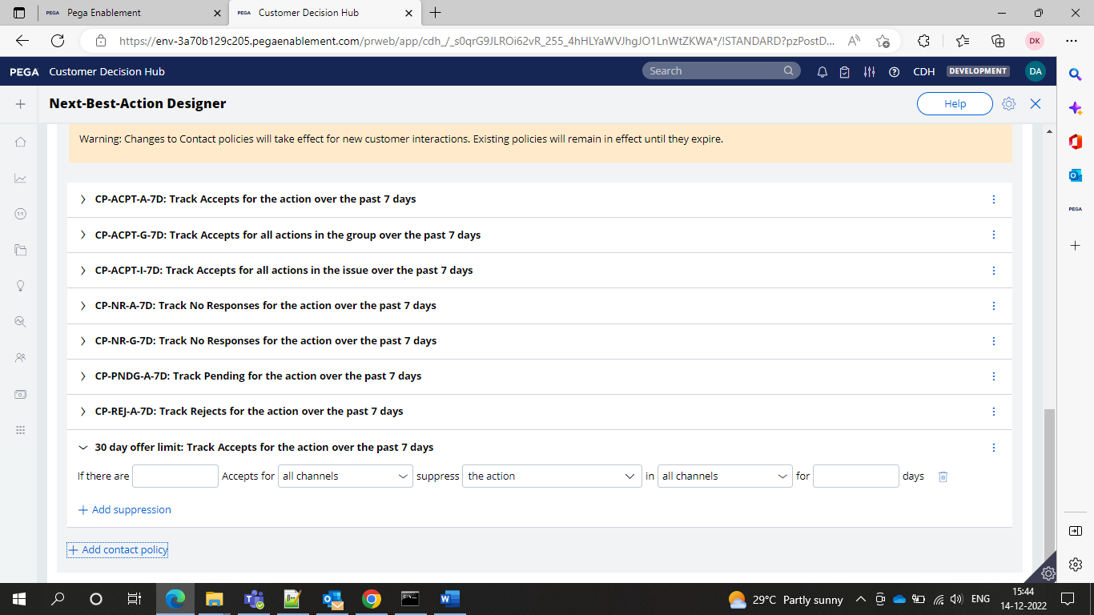

Now you can define here upto how many days you want to suppress the limit.

Depending on how many accepts that means how many customers if one customer also has accepted then please stop showing the offer.

If there are 3 accepts that means except for those 3 customers we will show to everyone else.

It is on the customer level

Suppression means basically to stop the offer for certain period of time

And we can also take for the reject also similar to the acceptance contact policy

When we configure a contact policy it will generate proposition filter which will be used in the Strategy under filter shape.

Volume constraints –

It means that here we can define the minimum and maximum number of offers that can be sent to a customer

Go to the intelligence > volume constraints and create

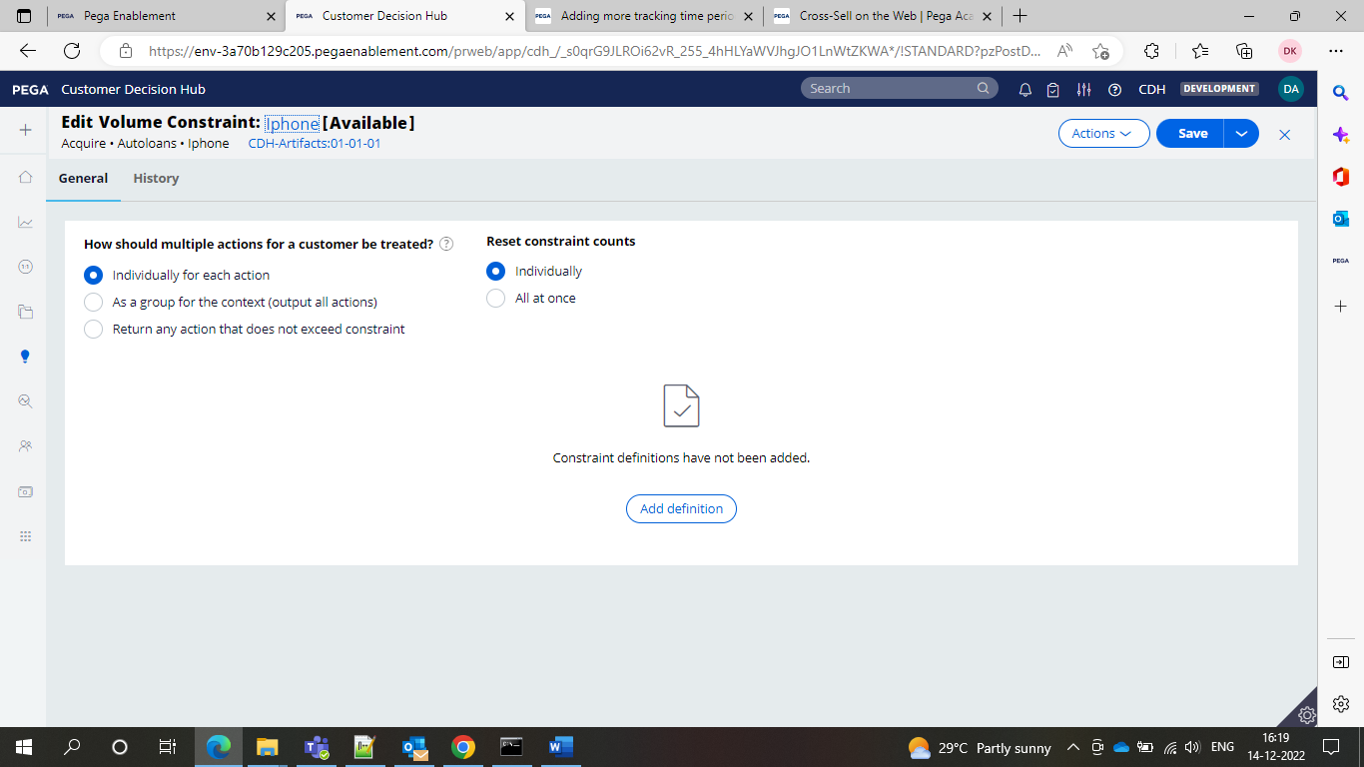

So 100 times it can send the offers for this particular offer.

Volume constraints once we configure we need to apply under the campaigns.

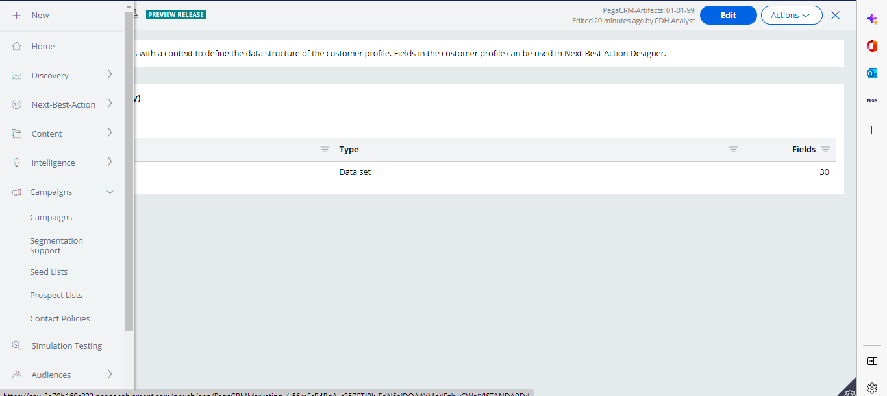

And now under this create multi channel campaign

Under the build tab you can apply your volume constraints

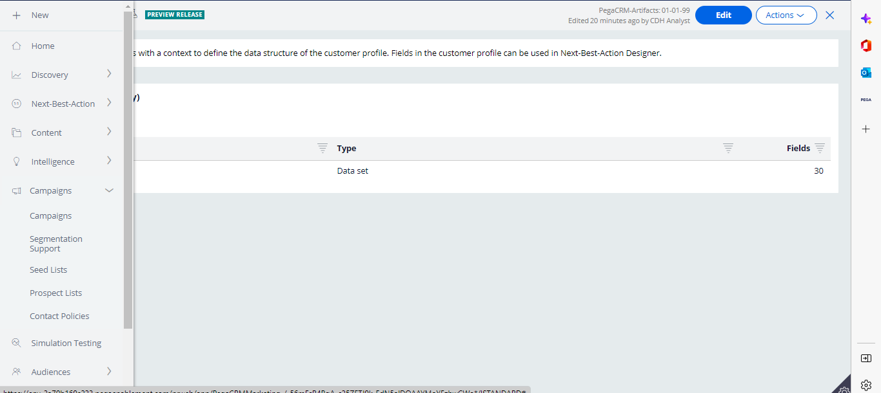

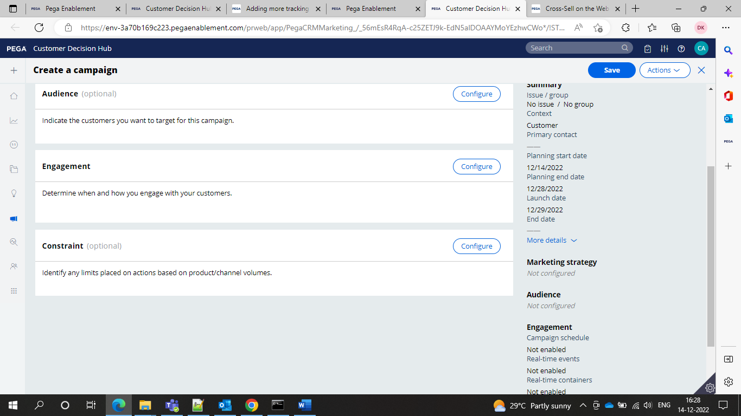

To implement a risk segmentation use a decision table from the business rules category, which outputs customer risk segment.

It can be defied in the SR class or customer class.

SR classes parent will be

Data-pxStratergyResult

BusinessIssue-pyIssue

BusinessGroup-pyGroup

PropositionName-pyName

Customer’s Decision on the Offer- pyOutcome-i.e Accept/reject

Prediction Value – pyPrediction- “Churn” “Risk”

Business Rules Result stored in pxSegment

Time at which outcome has occurred- pyOutcomeTime

Channel used to deliver the proposition -pyChannel

Direction of Offer- inbound or outbound- pyDirection

All these properties will be in the SR class. Main decisioning class that contains all these properties .

**SELLING TERMINOLOGY**

**CROSS- SELL**

It is a business marketing mechanism of selling a new product to an existing customer.

Ex- if you purchased a product in amazon now again amazon is trying to promote another product to you so this mechanism is called as Cross selling.

It means an existing customer who already brought a product we are trying to promote a new product to him that is cross selling.

**UP SELL**

it means it is an add on product and will not be promoted with the existing product and will be sold separately whether it is existing customer or new customer.

Ex- if purchasing laptop along with laptop laptop bag and mouse are not includedbut business will say that we will try to provide the add on Bag and will say to buy that product which will inturn increase more revenue by getting more sales.

In case of rare situations like when revenue is very low in that case only this upsell happens.

**OPTINS-**

It is like agreement and acknowledgment from customers to receive notifications from that particular customer. If we checked the checkbox that means we are acdepting to receive offers.

Ex- we will find checkbox like receive future notifications and push notifications on mail and whatsapp about the products. So generally this is called as OPTINS.

**RETENTION-**

**Churn Rate-**

Churn Rate means percentage of customers who stopped using the service. The process of unsubscribe from the customer.

Churn Rate = percentage of total customers who stopped using divided by total number of customers available at the start of certain time period.

Ex- 500/2000 = 0.25% Churn Rate

The lower the churn rate the higher the sales/ revenue for the business.

It is recommended to have the churn rate decreasing as you do marketing in PEGA below 0.1%.

**Customer Life Time Value-**

It is a prediction of the net profit that is generated as a result of an organization’s entire future relationship with a customer.

**Net Promoter Score-**

Net Promoter Score is the score that indicates how satisfied the customer is with the purchase and the probability of him recommending or promoting the business products to other users.

The range is between -1 to +1

**Strategies**

Now after getting into the strategy rule if we do not specify the issue and the group and we use the proposition filter to get the offers then it will ask to select the issue and group then the strategy results class would be like

Pega-CRM-SR-issue-Group

Pan Mode if we enable then we can go if we want to drag the canvas

We can use the set property from enrichment now this component will set the values

In the property set you will be having access to two types of classes here

One is the SR class and this will be shown if we do not select the issue and group at the creation of the strategy

Another one is the applies to class by using Primary which means on the primary page all the values will come

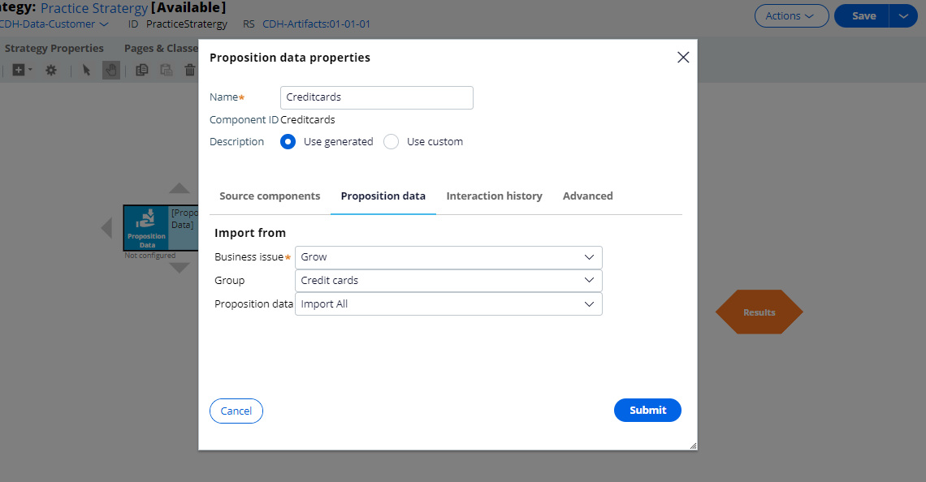

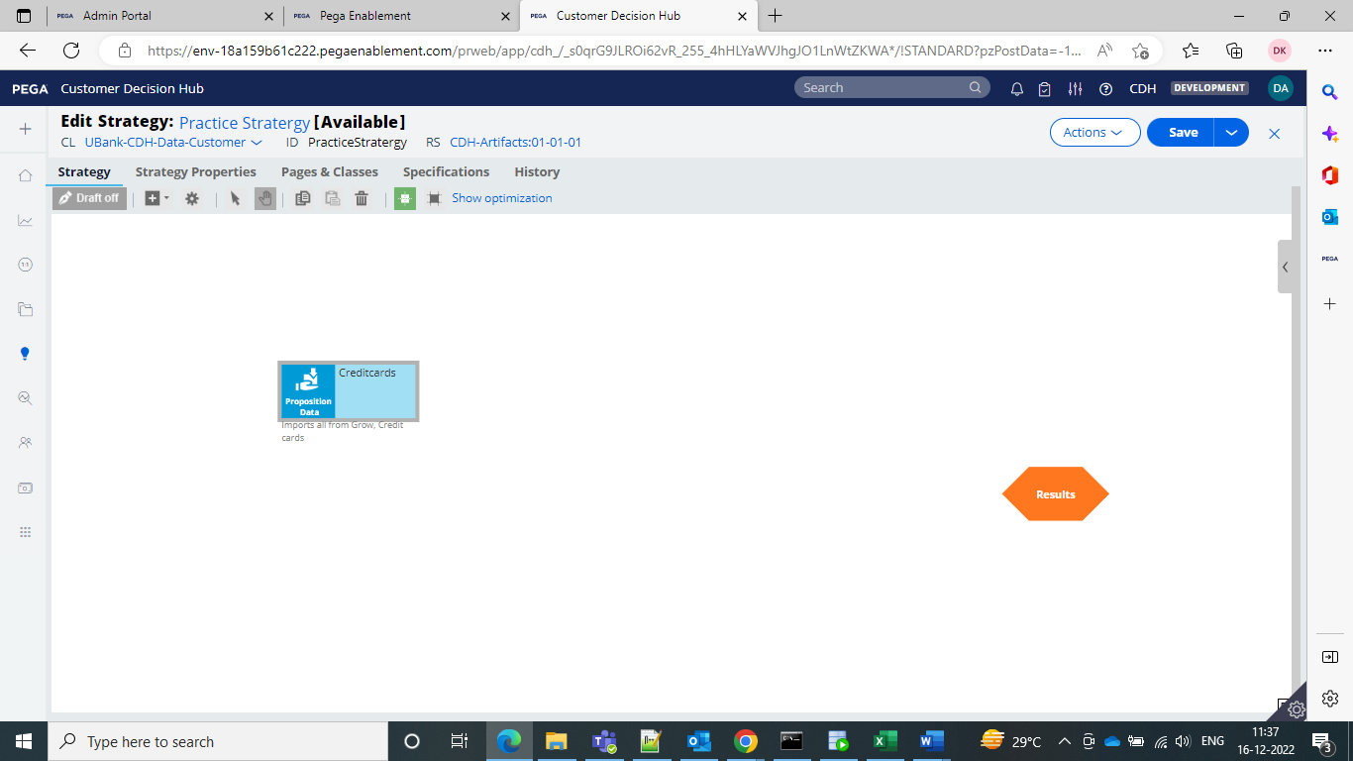

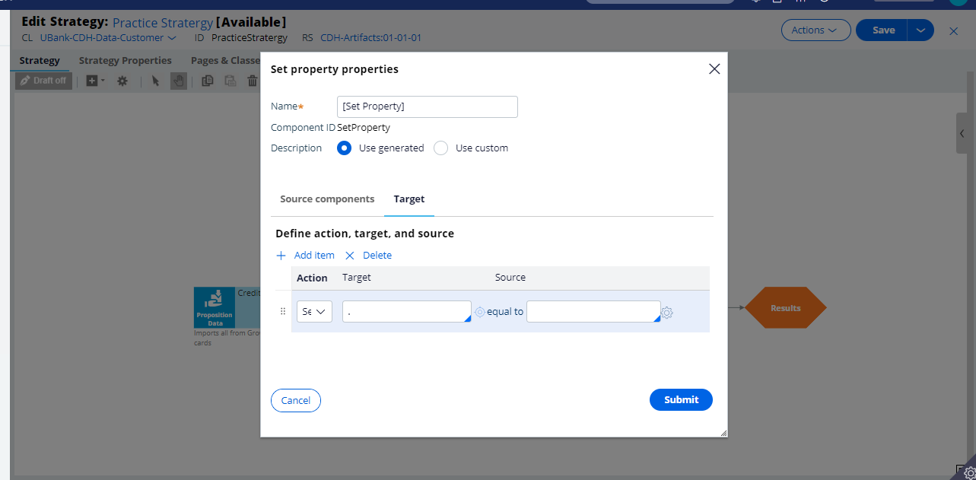

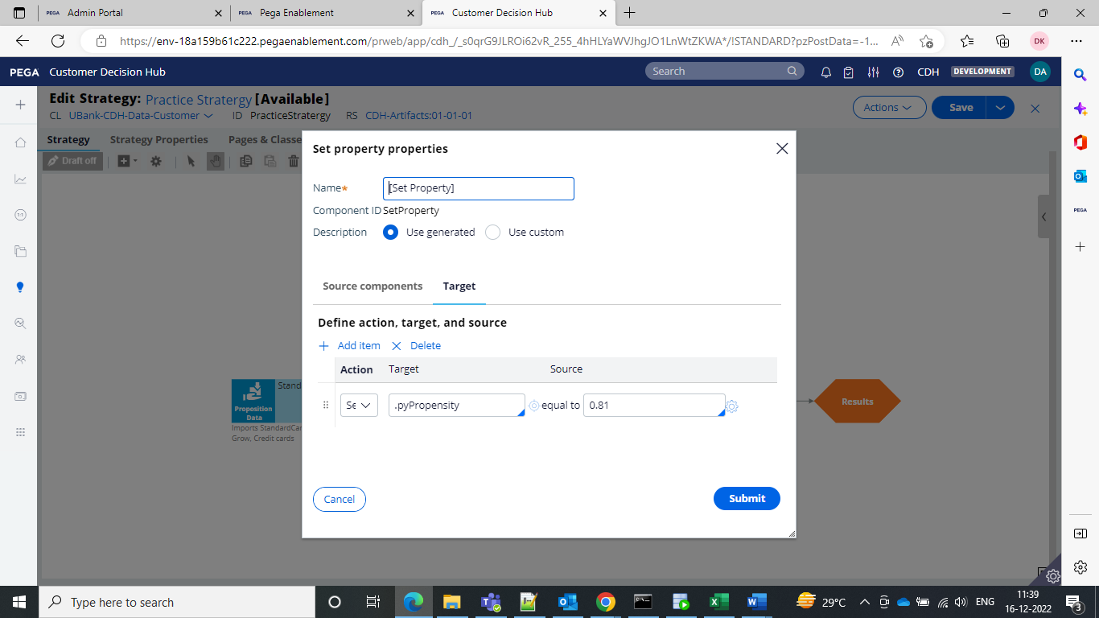

This propensity value will be coming from the adaptive model and predictive model and we do not set it manually.

So here after the results

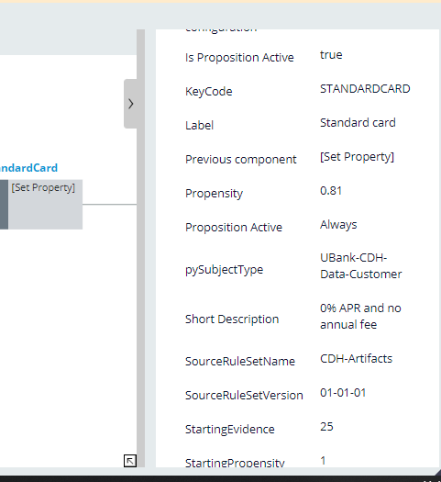

The propensity is applied for the standard card and now the output is coming.

So we are applying set property to set the results for both SR class properties and applies to class properties.

Now we will see what are the prioritize

It means that you can prioritize the results based on a property or alphabetical wise

Here I am prioritizing based on propensity value

Make sure that if on basis of property you are prioritizing then it should already be in the SR results.

If not there set it before and then prioritize

And you cannot use more than one property and we can prioritize only on basis of single propensity.

And before the prioritize I am getting all the 3 results from the strategy.

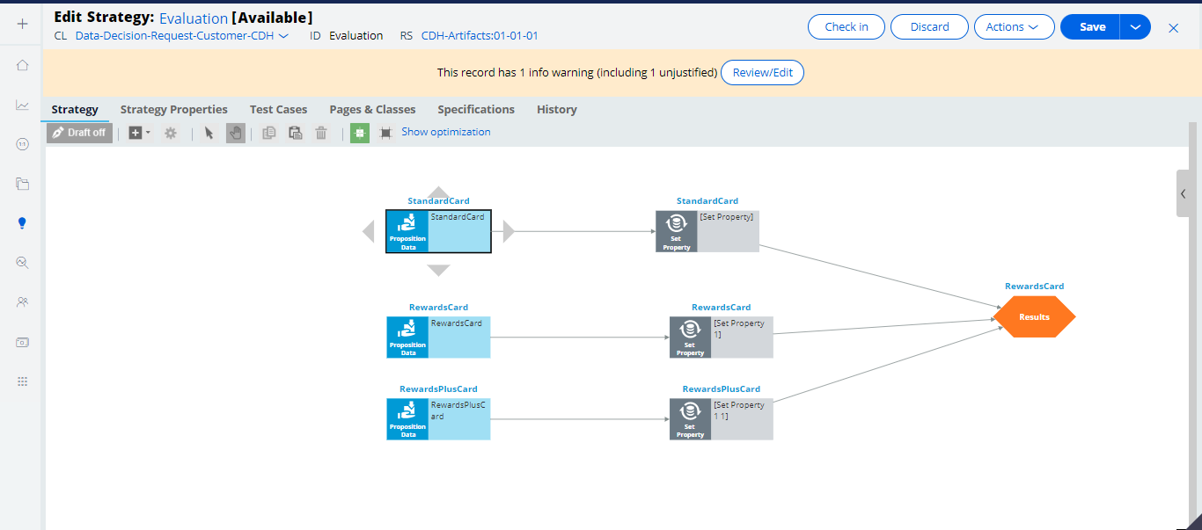

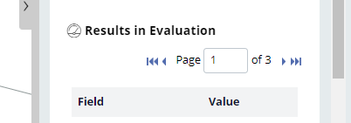

And now after using the prioritize we can sort on basis of propensity value which is higher and also we sre using the output as the top 2 or 3 or 5 etcc.. or all offers.



And after doing this we can see the highest propensity value offer and top 2 offers out of 3 are generated.

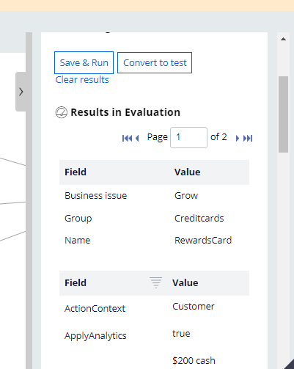

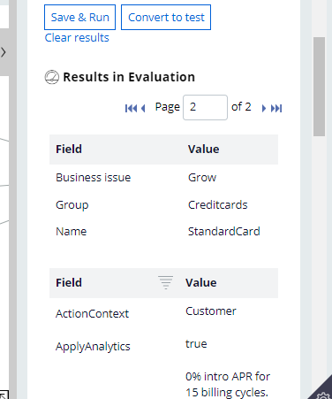

So reward and standard card are displayed and sorted/prioritized on basis of the highest to lowest propensity value which is 0.9, 0.8 and these are the top 2 so only these 2 are considered. So that is the prioritize shape.

Switch shape

It is used to switch between 2 different shapes in the strategy. It can be used not only for offers but also any component in the strategy.

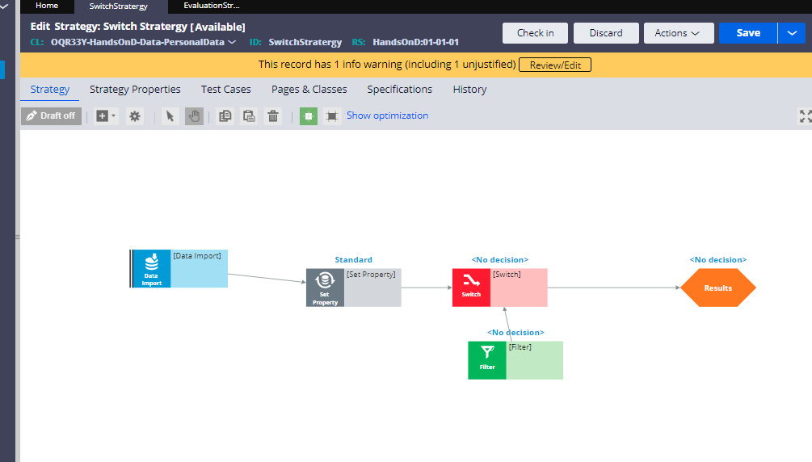

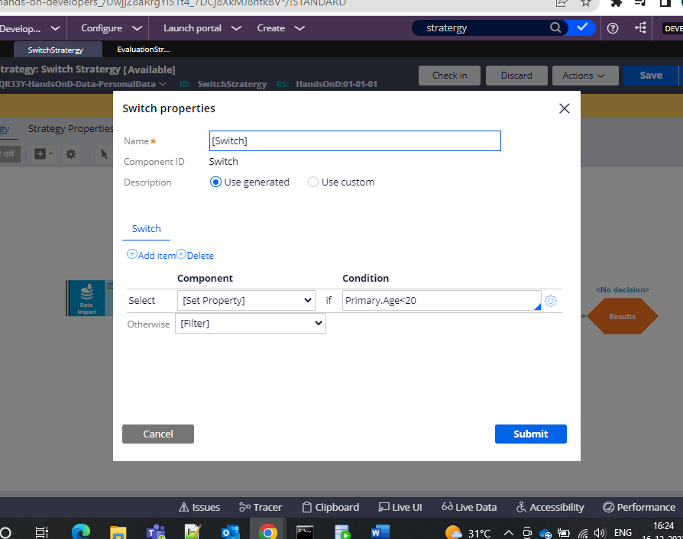

Component level is inbuilt in strategy level only.

Data Flows- sequencing and combining data for large customers.

Campaigns- used to send the offers to the customer.

Treatments- the actual content that is visible to the customers.

Channels- delivery models – email, sms, website etc..

Segments- targeted customers --- 2 crore customers—2GB MOBILE DATA offer. All the customers who are eligible for this offer are called as one segment

External Input component

External input component on the canvas to represent all strategy results(SR) records that are input into the strategy.

Score mapping

Score mapping allows you to map the score value, computed by the scorecard to a property.

Decision Management Capability

Decision strategies are used to improve customer experience and deploy intelligent processes based on behavioral

Data set to read and write the data used in the decision strategies.

Event Strategies is used to detect patterns in data streams.

Data flows as scalable and resilient data pipelines.

A data scientist can create a predictive model in Pega Platform (or) an external environment that can export the model as a PMML (or) H20 file.

(or)

Another option is to connect to a machine learning service such as google ML or AWS

Prediction Studio

Prediction studio is the dedicated, workspace where you manage the lifecycle of predictive models and the predictions they drive.

Customer decision hub predictions can predict customer behavior such as which customer is about to churn(or) predict the likelihood that a customer clicks on a web banner.

Pega adaptive decision manager(ADM) a key component of a decision management capability.

Adaptive models rule typically represents many adaptive model instances because each unique combination of the model content generates a model.

Customer decision hub predictions feature a response timeout setting. After the timeout expires, a negative response is recorded.

A data scientist will create predictions.

There are three types of predictions

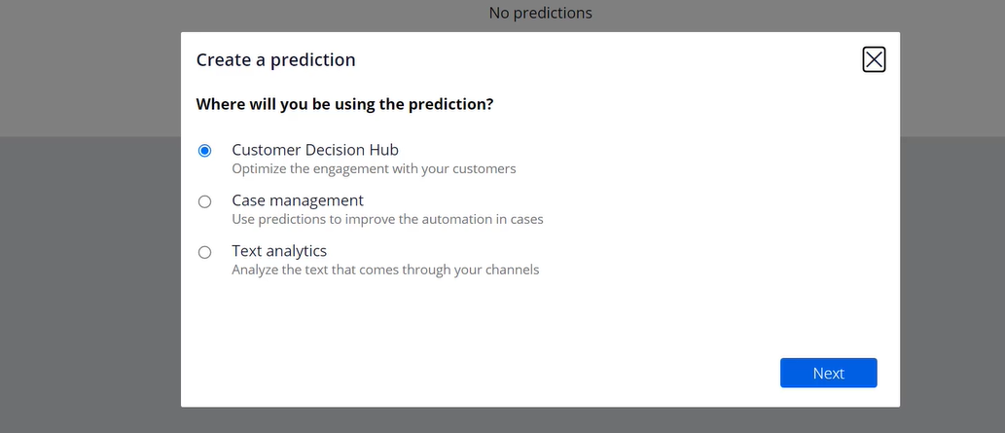

AI will focus on the case management prediction.

Case management prediction are used in case types to support decisions for business process.

A prediction represents an hand off to an application developer.

We can use a prediction in the decision step in the case type.

Can use a prediction outcome instead of the decision step in a business rule

What happens when you use Data Flows to call a Strategy?

You can separate the business process from decision strategies by utilizing a data flow to call them.

An adaptive model rule typically represents many adaptive model instances because each unique combination generates a model.

Predict web propensity prediction that predicts likelihood of a customer action.

They also have a response timeout setting which sets the prediction as negative if the prediction time is reached.

We can use the predictive model as a predictor in the adaptive model.

Pega customer service uses text analytics predictions that are distinctly different from CDH and case management predictions.

Text analytics predictions use predictive models to detect the topic of an incoming message that application can use to optimize the routing of the message.

Text analytics use entity extraction models.

The applicatrion can use this information to fill relevant fields in a case automatically.

They come with the sentiment model to improve the customer experience.

Based on the prediction a segment of customers can be decided and presented with offers.

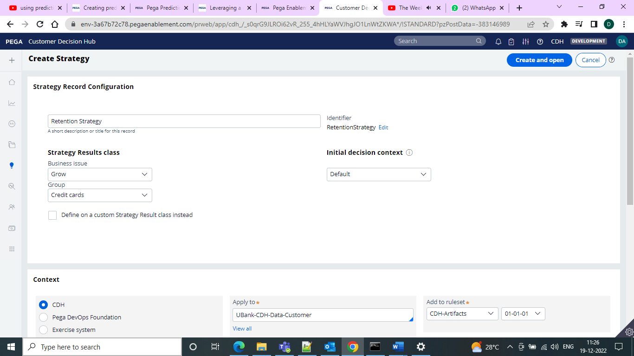

Create one strategy to evaluate the results for the churn customers.

Use the prediction shape to get the results for the prediction and filter them with the customers who have higher churn risk and then go for the results. And after this select the engagement policy to detect the churn risk customers and send the offers and what to show .

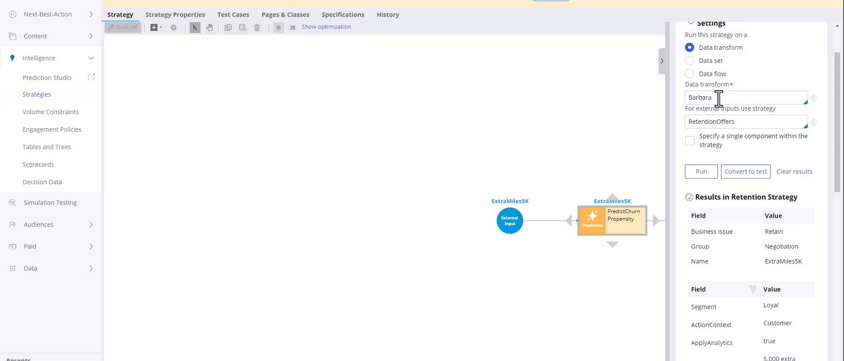

And now for Troy it would be as Churn as to dropping customer for the services

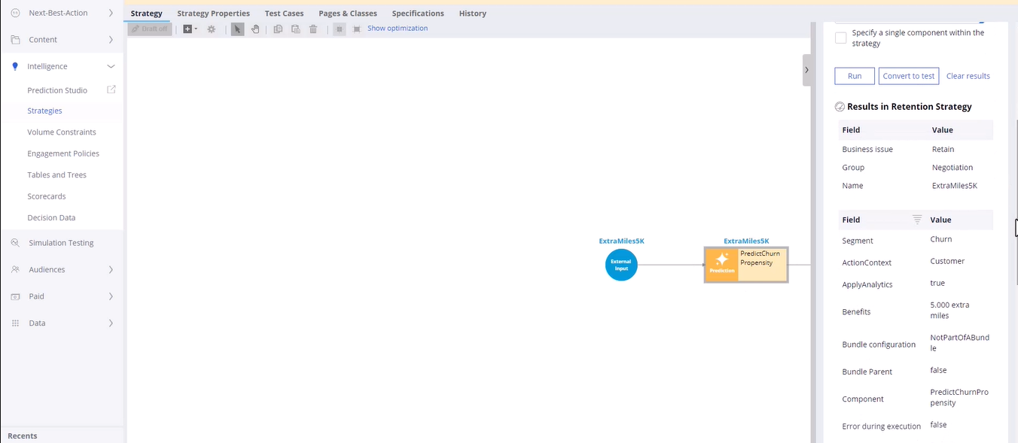

And then in the NBA under the applicability change under the negotiation to show different offer for the churn customer and the main customer

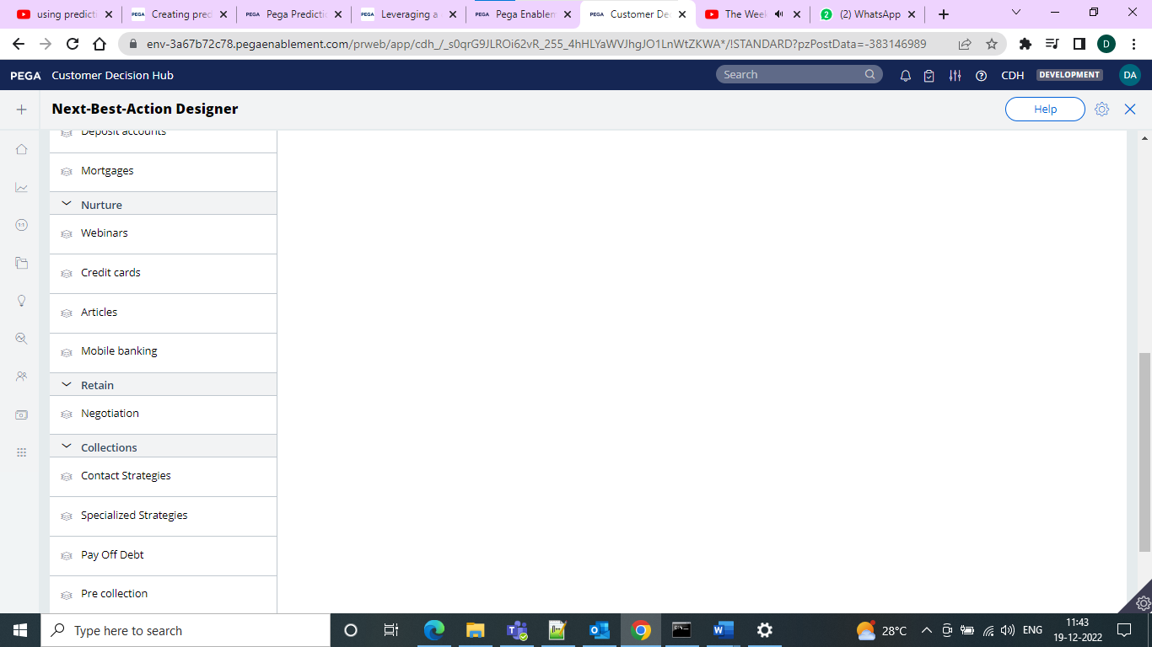

When you mark as relevant you should be able to see the strategy under the conditions to describe it

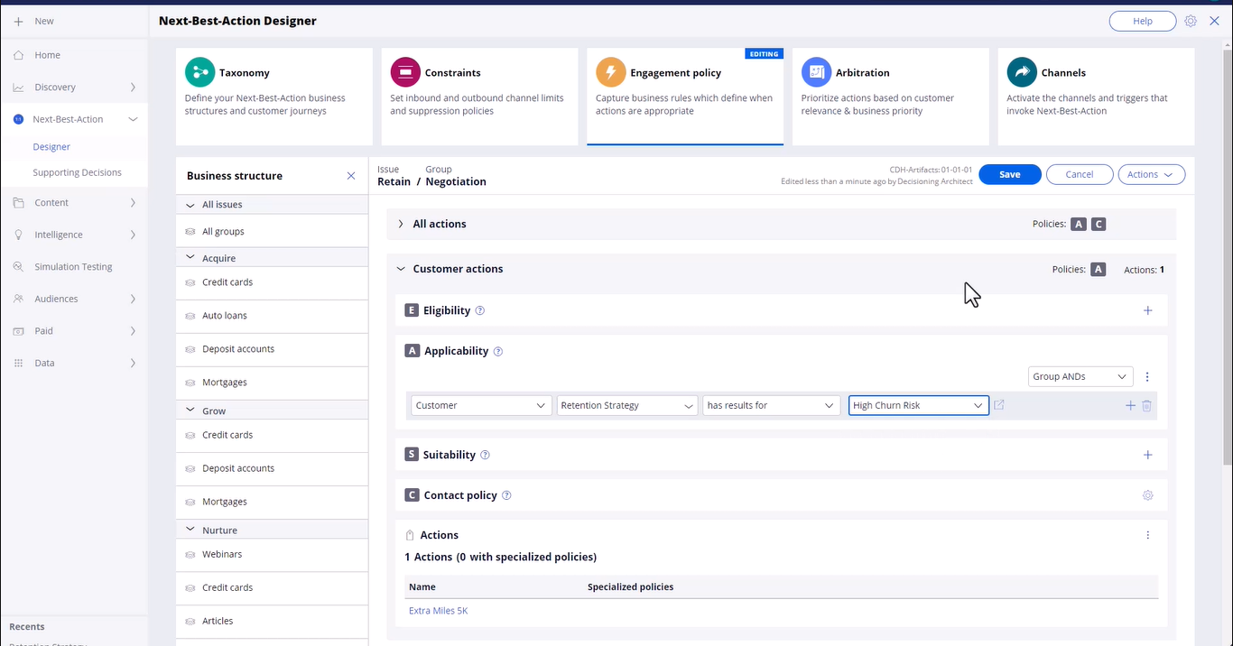

And then go for the declaring in the engagement policy and you will find different offers for the churn customer and normal customer and also define that if the customer is not equal to high churn so that churn offer won’t display. And in the channels select to which group or business you want to see the result.

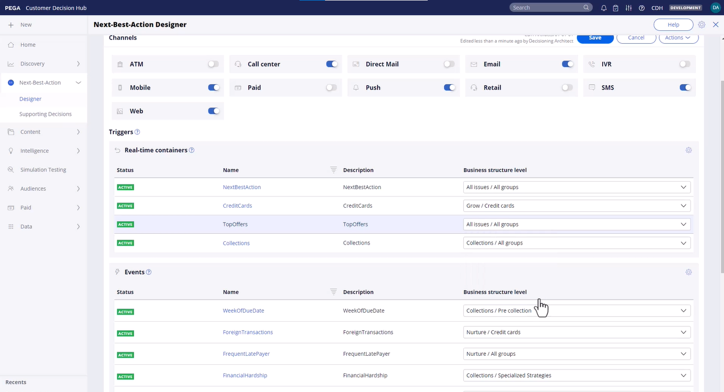

Input fields that are not accessible to the customer data can be made accessible by defining these fields as parameterized predictors.

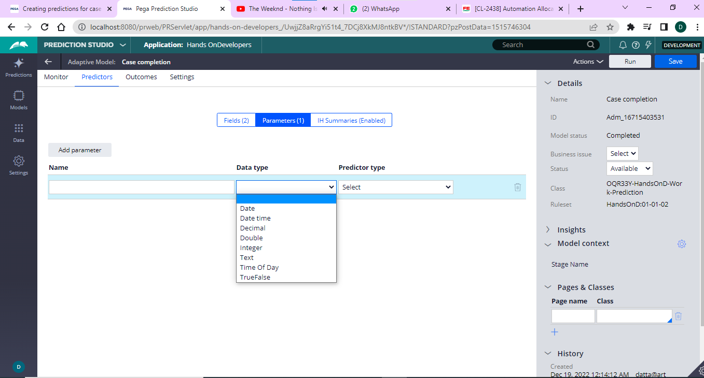

And fields we can declare in the parameters and some data types also available.

Instead of the scripting of the entire customer journey for every offer by offer you can add multiple journeys and stages with actions to your system and let the AI which action/journey is suitable for the customer at that time.

We can define a customer through the NBA where we define issue and business groups and then it will inherit the engagement policies.

And n the taxonomy we can define the customer journeys

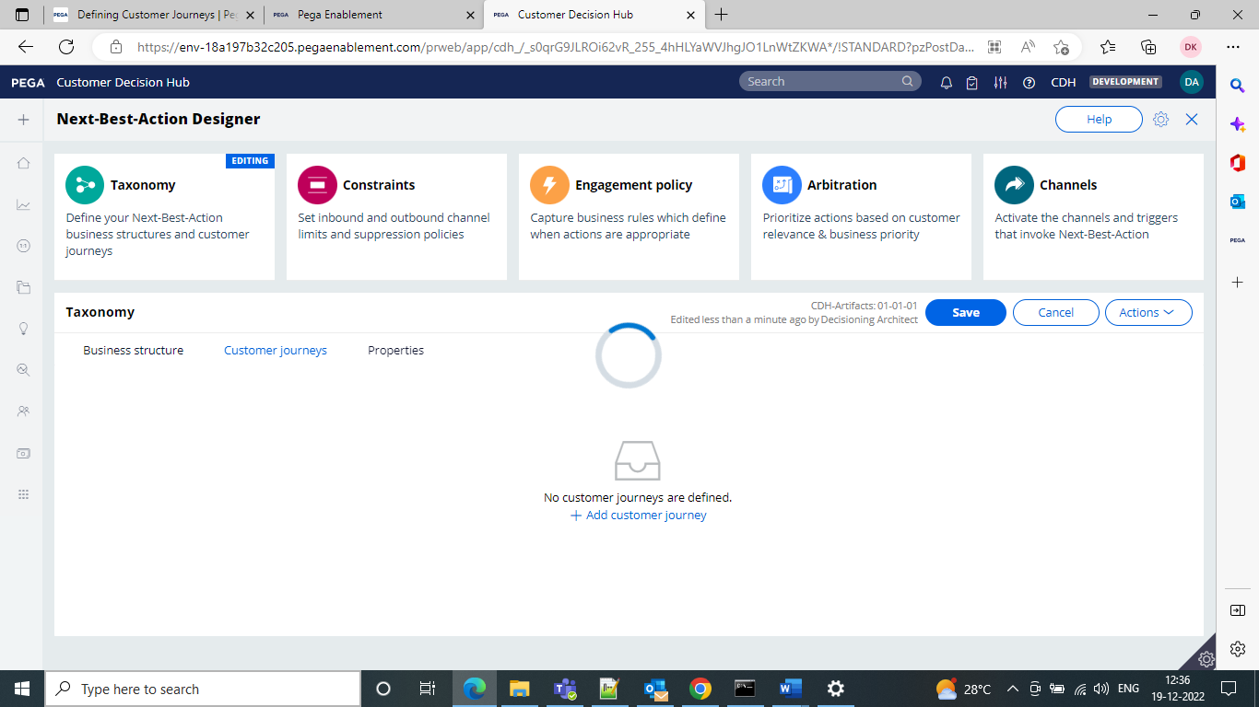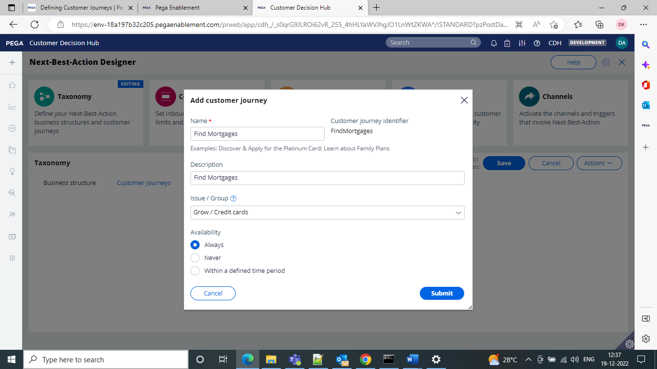

When you add actions to each stage it adds the application adds all their available treatments

**Always On Outbound Customer Engagement**

Always On means the brain constantly monitors each customer’s context across channels.

The brain will include the data about the customer including past profile information and contextual information.

Customer interaction happens in many channels which can be classified as Owned and Paid

Owned channels are owned by the business.

Paid channels are owned by third party for exzmple google sms facebook business has to pay for these

Owned can be classified as inbound channels

**Outbound Channels**

Outbound interactions

It means the brain sends outbound messages when it is appropriate.

It will happen in 3 ways

1-Scheduled Update

When customers respond the responses are recorded and used for the next best action evaluation.

It is configured to send messages and notifications on a scheduled basis when require/relevant.

**Scheduled Update-**

When customer is using inbound then brain will analyze the NBA and sends result back to the same channel in real time.

**Customer event-**

When an event is detected then NBA sends appropriate notification. Like if the customer searched for product and added to cart but did not place order. Like that in such scenario

**Priority Communication**

When a situation comes where you wat send notifications to all your customers but this won’t be repeated by the system again and again

The email offer sending has 2 schedule types

Recurrence

Starting population

First we need to set the required recurrence frequency and we can then refresh the audience check box

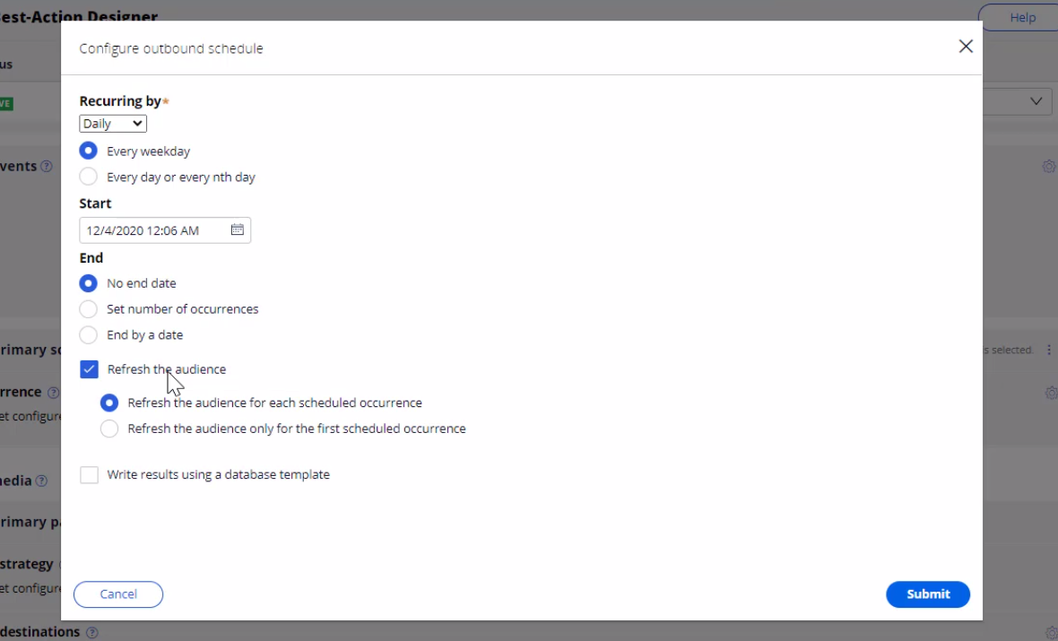

Next select the segments in the volume constraints

Once the run completes we can see the results.

**Adaptive model**

Whenever we use the adaptive model we must use 5 mandatory parameters.

It is important to use the following

pyIssue

pyGroup

pyDirection

pyChannel

pyName

In the monitoring the bubbles shown for each and every proposition which got responses from the customers. And those will be displayed as bubbles. The smaller the size of the bubble the less number of the bubbles recieeved responses.

The successs rate here can be defined as the total no of positive responses/total no of responses

And here the performance is nothing but area under the curve. It will be calculated by machine learning there is no specific formula

And the range for AUC will be 50 to 100.

By default it will be 50

Performance will increase when success rate and propensity varies.

If you have four propositions you will have 4 adaptive models.

When we open the model we would be seeing the information about that particular instance.

In order to achieve the success rate what are the contributing predictors.

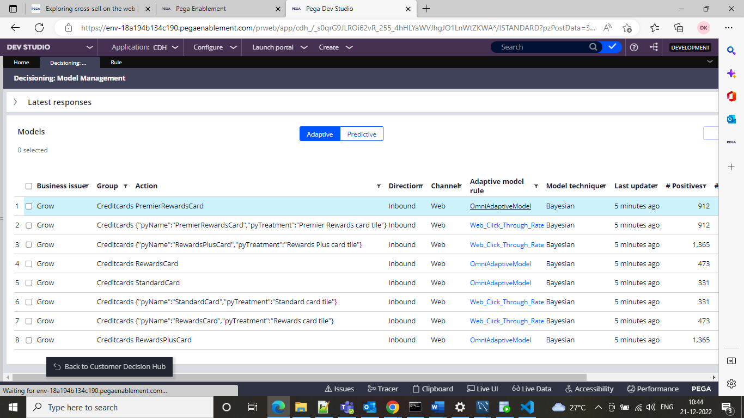

Under arbitration we have business value and business levers and if we turn on propensity and the offers which come from the strategy will be prioritized on the basis of propensity.

**Context weighting means based upon some scenario we can carry forward the offer.**

**Technical Terms it allows Pega Customer Decision Hub to consider situational context for each action.**

**Ex-if customer contacts banck to close an account their immediate action is to retain the customer**

**Action Value- enables to assign a financial value to an action and prioritize high value actions over low value actions. So priority of an action is increased by a specified value when context is detected.**

If we give the business value for all the offers then the value which is higher that offer will be shown first and the least one will come last. All offers will come but ordering will be done on the basis of business value.

In the business group whatever we specify those group offers will come first and be shown on issue and group level and which issue group has highest those offers will come.

In action weighing we will come to the business weight in a particular action and which action has more business weight it will be shown first.

And based on certain segments issue/groups if the offer comes it is called business levers.

Business value and business levers if given then system will evaluate itself and send it.

In the business levers we have something to calculate but in the business value we have nothing to alter everything is evaluated with the strategy itself which is by default provided named as calculate business value.

**Segmentation**

A particular target set of customers are called as segments.

It is best to use eligibility, applicability, suitability rules to configure in NBA to set the criteria correct for your population

A segment can reference a parent segment enabling you to create a hierarchy of the segments.

That means one strategy must be a starting point for processing.

Define an action for an outbound

Email Treatments can be internal or external

**C:\PRPCPersonalEdition**CDH provides two common patterns for designing an internal treatment

It is not a best practice. Use this only when context is simple and does not require any complex HTML design.

Marketing department can outsource email content designs to professional designing will design HTML and give the access and we can import it into the email treatment

Your CDH server requires SMTP server to send the emails

**External treatments**

in this there will be no direct contact and no SMTP server and then only external service providers will handles the service.

These will be either mapped to file or Database table.

It is good to create email trewamment under the same issue and group which will make it easier to access and manage

We can Avoid sending the same action for a time period

We can do this by the constraints and edit it under it go for the outbound limits for a particular limits

On the engagement policy tab you can associate contact policy with an issue and group.

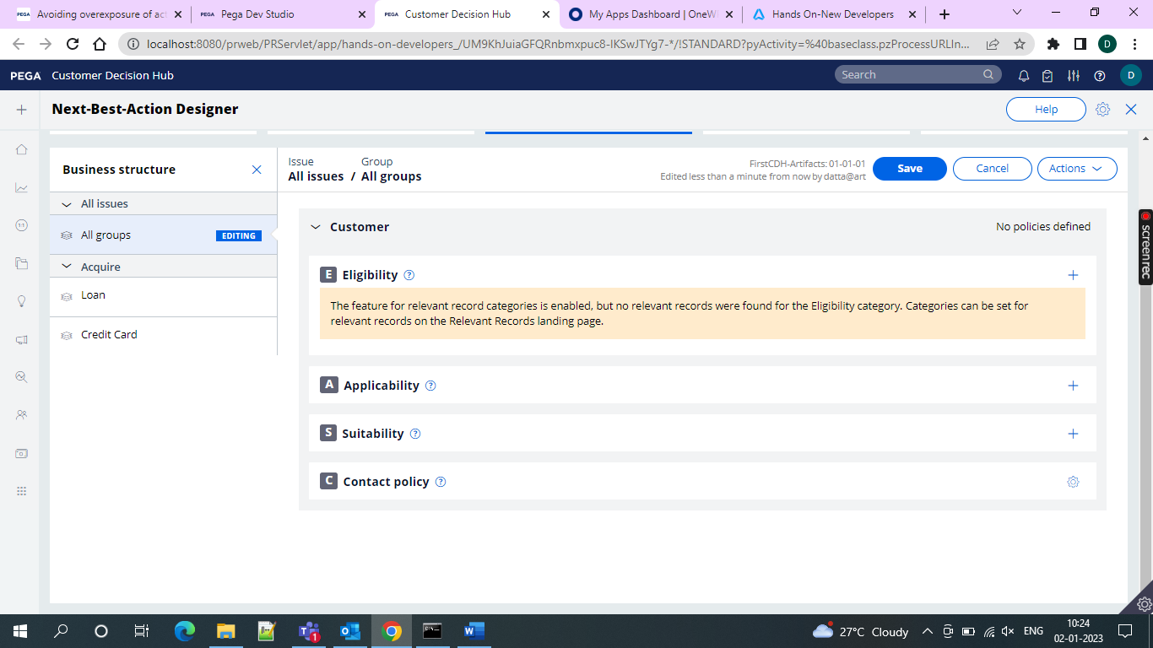

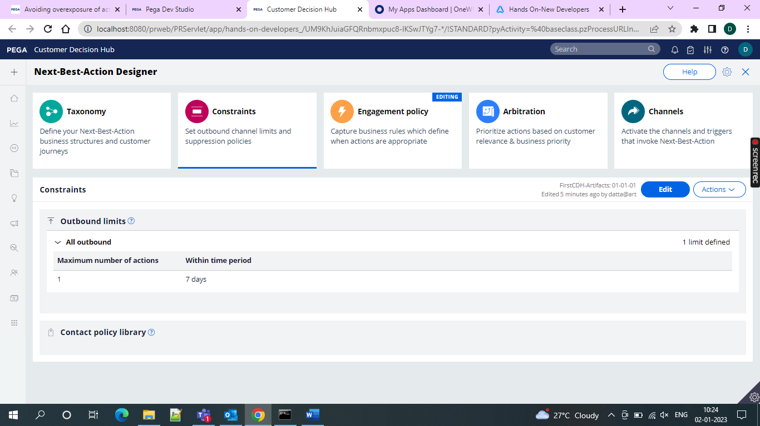

If we apply individually for an action if the customer qualifies for an action then he will pass theough the set of defined volume constraints and system validates each constraint type.

Volume constraints types

They fall into 3 types

Action- it will limit the volume of actions that system can send to the customer

Channel-it will limit amount of actions sent to a particular channel

Property- by using this one you can limit upto a set of the actions across different issues and groups by using a property value.

Pega CDH enables you to write the files in one of the following cloud based destinations as well as local file system

* JFrog Artifactory
* Amazon S3
* Microsoft Azure

To write and read the details for any local or third party vendor or application for distribution we need to configure an action flow to include a send shape where database/file template option must be enabled.

There are 4 shapes that can be used for this purpose

Send email

Send SMS

Send Multi

Send Generic

If we are unaware of the communication channel we can simply use the Send Generic Shape.

To use the multiple Action details in a single location which could be useful when the Next-Best Action Outbound schedule includes multiple action.

We need to create one file template to in order to share oinfo with databadse or third party service provider

To achieve this go to content> treatments

Then we can go for the creation of the repository as the ocsal file system since I want to use that

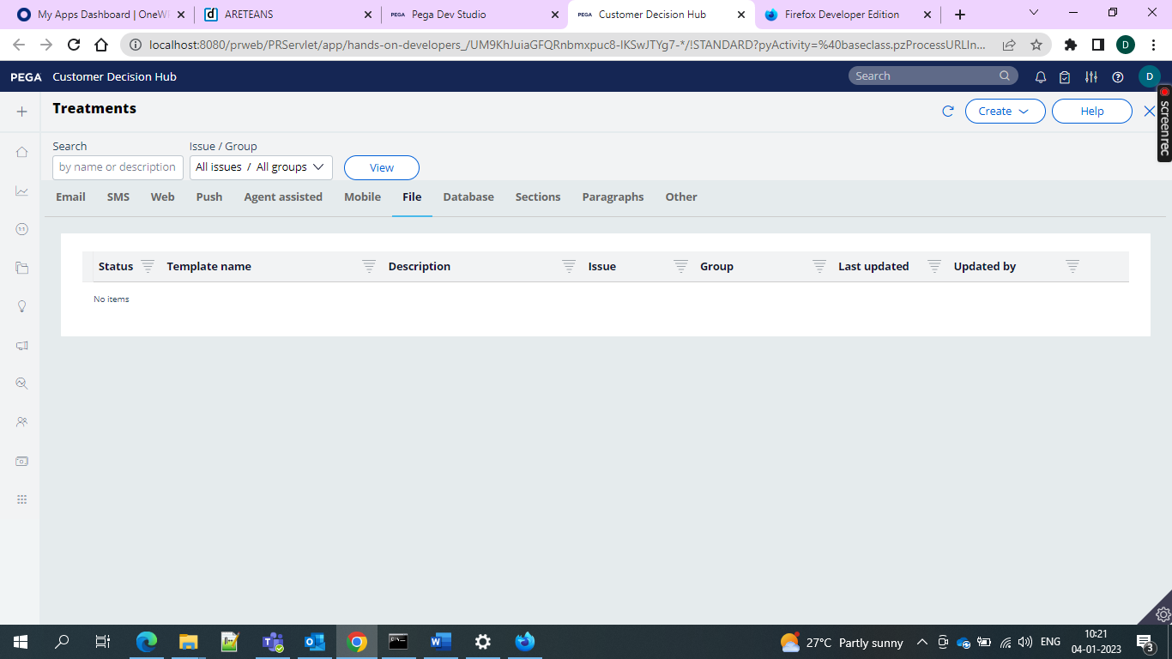

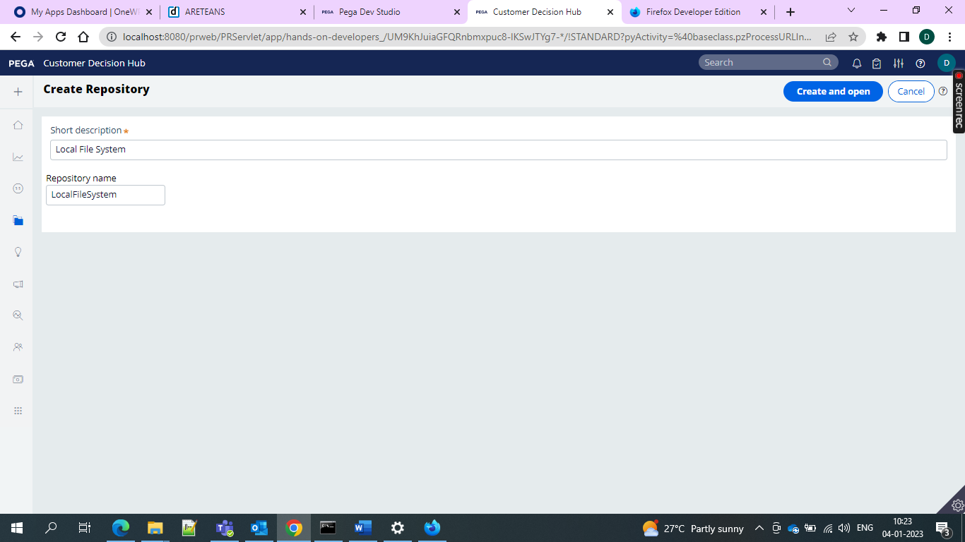

And while we select the reporsitory then the following options are displayed

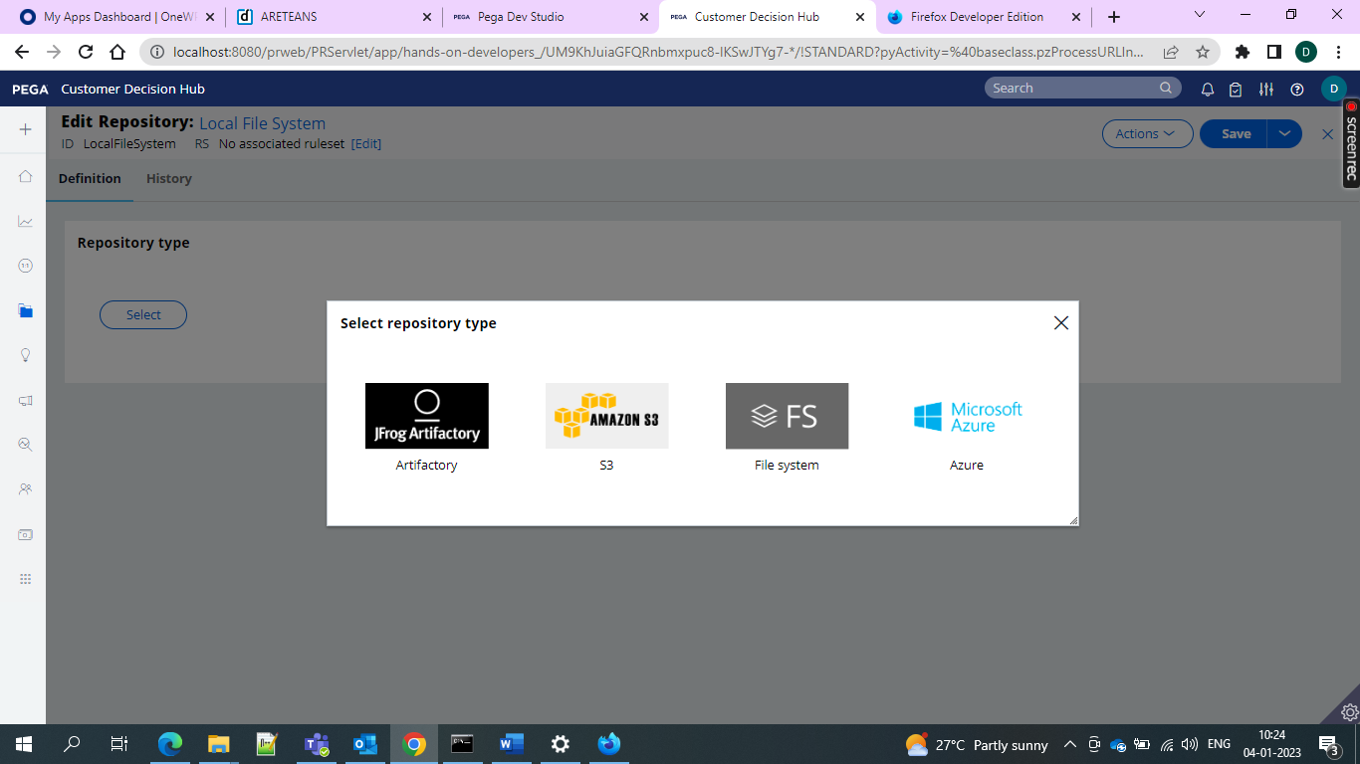

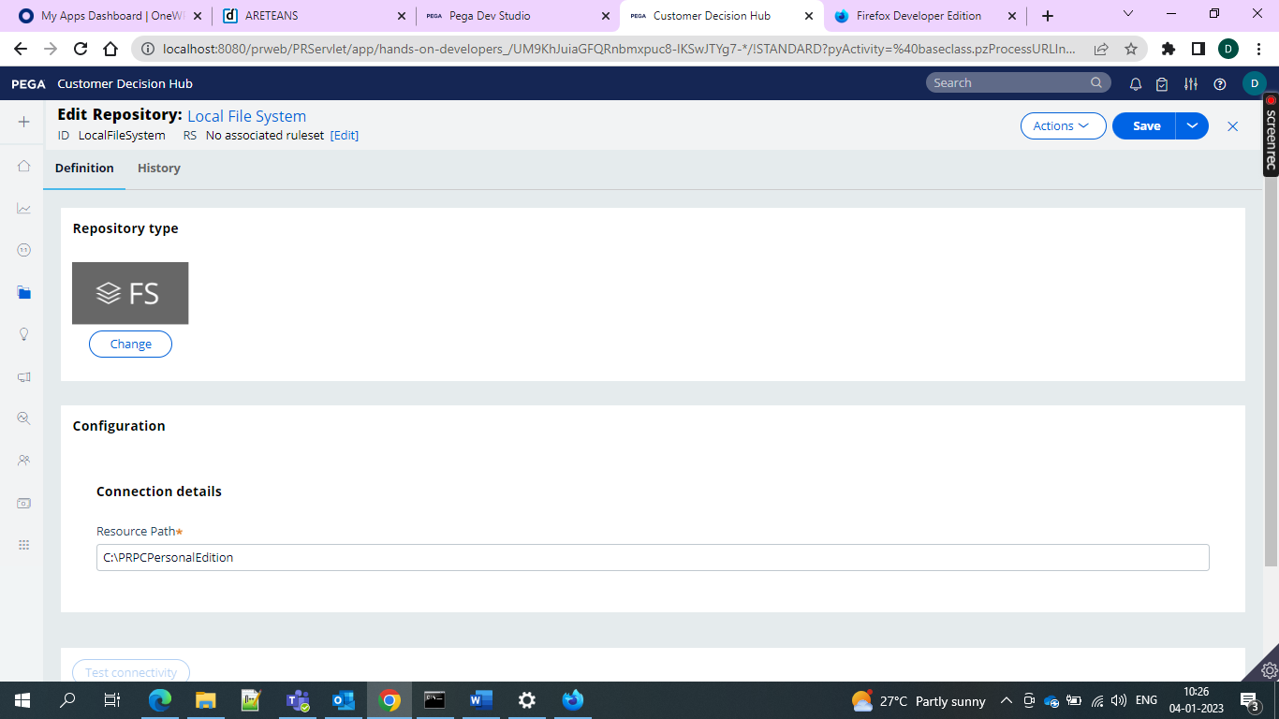

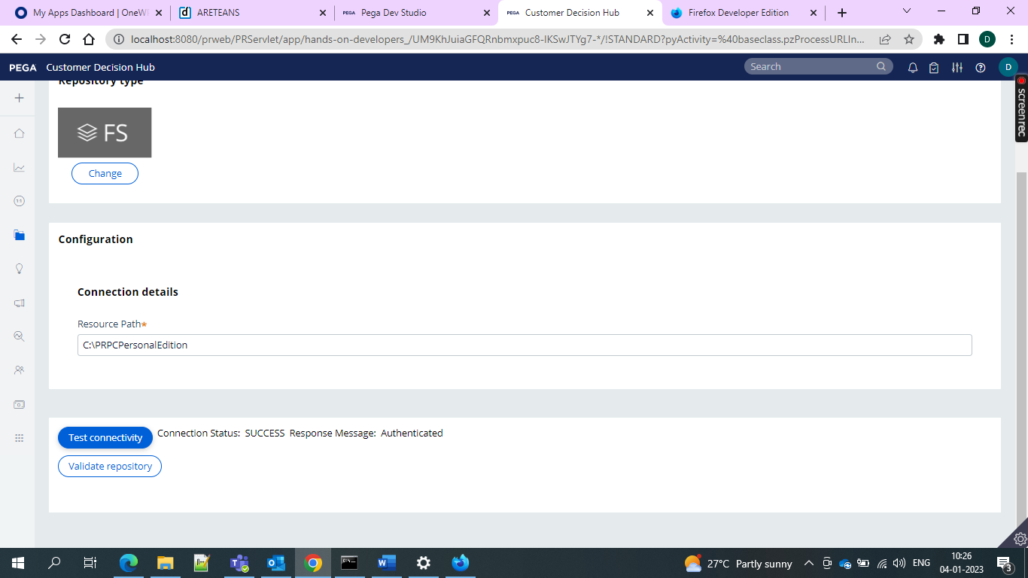and then it is authenticated

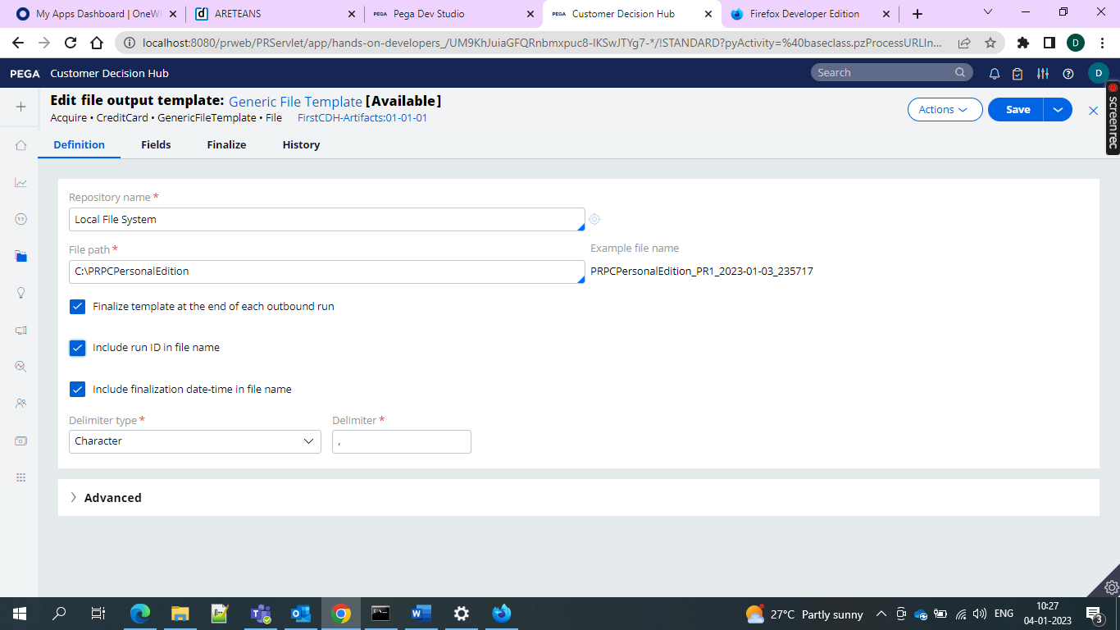

and after we create and then we can finalize anything if we want and finally it will get saved and then we would be seeing as running and online status

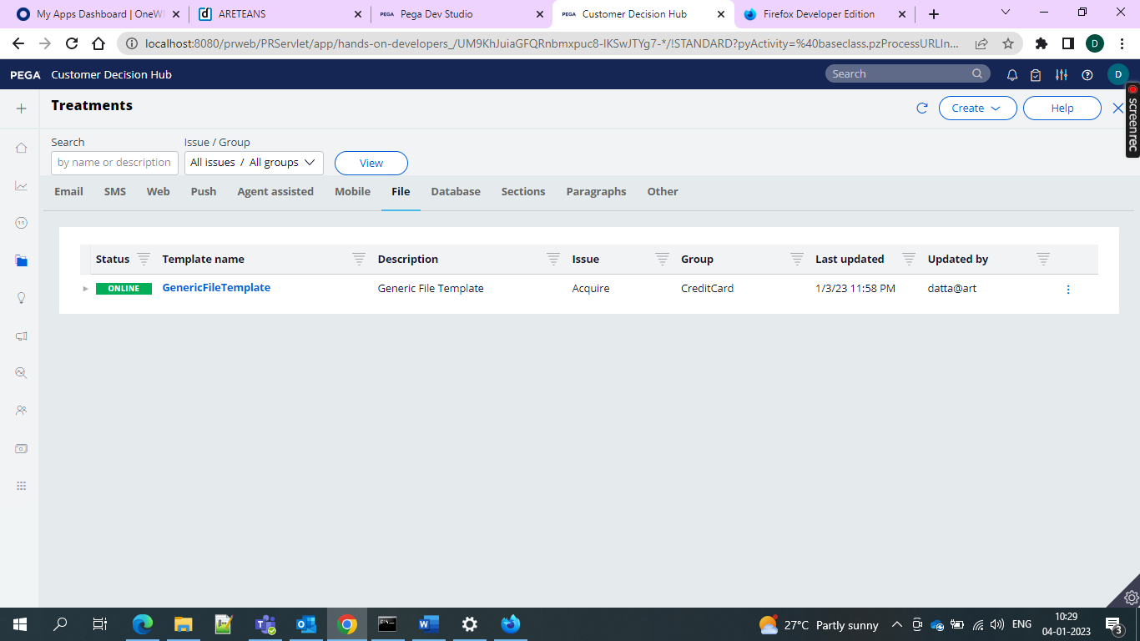

Now we can invoke in the action flow

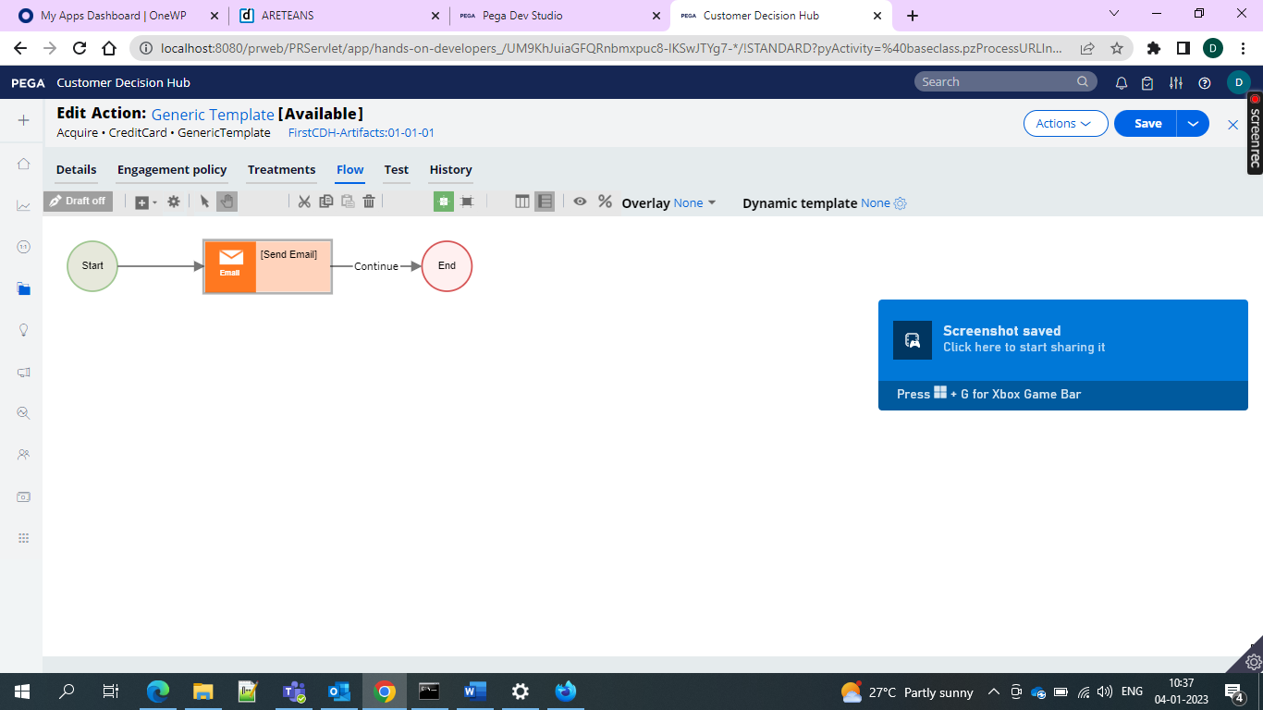

And now we can go for the flow in an action and then go for the email treatment invoking

Create In the treatment tab of the action add email channel and then create external treatment and write to the file and then get the results.

**Business Agility in 1:1 customer engagement overview**

Agility means that yourorganiation is able to react quickly to changes in the marketplace and Pega 1:1 customer operations manager increases your agility in digital channels giving business users what they need

Basically sometimes business users want to make changes which will again be costly and then we can overcome the cost by using the 1:1 Operations Manager

Business changes are small and day to day changes

Ex- changes

* Adding a new Action (such as offer or message) with treatments to production
* Removing or disabling an Action in production
* Modifying a group-level Engagement Policy
* Enabling an integrated channel
* Fixing a typo in a call center message provided by Pega Customer Decision Hub™

Enterprise changes tend to require larger pieces of the stratergic development work and usually disrupt the normal operations. These may introduce something new or implement a change

* Adding new data attributes to the customer profile
* Integrating a new channel
* Implementing an approval flow for change requests

Pega 1;1 operation management

Team involved in business operations

Business Users

Team Lead

NBA Specialists

**Business Users**

Planning customer engagement

Reviewing and approving content and offer distribution

**Team Lead**

He does run daily stand up show and tell and sprint retrospective meetings

Remove blockers

Ensure best practices are followed

Work with IT on deployment

**NBA Specialist**

Supporting the definition and assessment of the requirement

Translating business needs into NBA strategy and artifacts

Lifecycle of the change request

Plan

Build

Test

Deploy

There are 3 categories in the update existing actions

Create new action

Update existing action

Not sure

We can request one or more changes in action level

Add new treatment

Remove existing treatment

Edit existing treatment

Edit engagement policy

Edit action details

**CDH setup Wizard**

During CDH setup Wizard we need four inputs from the user

1. Name of the org
2. Name of the application
3. Template of the domain/industry
4. Repository

Overlay Standard Overlay fast release

CDH Implementation 1:1 Operations manager

Pega CDH Devops Pega 1:1 Operations Manager

Pega Platform

Context Dictionary it is best practice to always generate the context dictionary in the RULES ruleset.

Agent is an internal background process operating on the server that runs activities periodically. On top of pega platform agents a set of other agents manage different aspect of Pega CDH.

Depending on scope you can enable or disable the agents

We are adding a property to the existing data model and creating

Use base 64 images in email treatment to show in the mail we should use Base 64 images

For Adding a new entity you need to go to your Data Type and then edit your columns and can add the required new fields and you must specify them in the External Class Mapping and add your property and then add them and can check in the data tab In the portal.

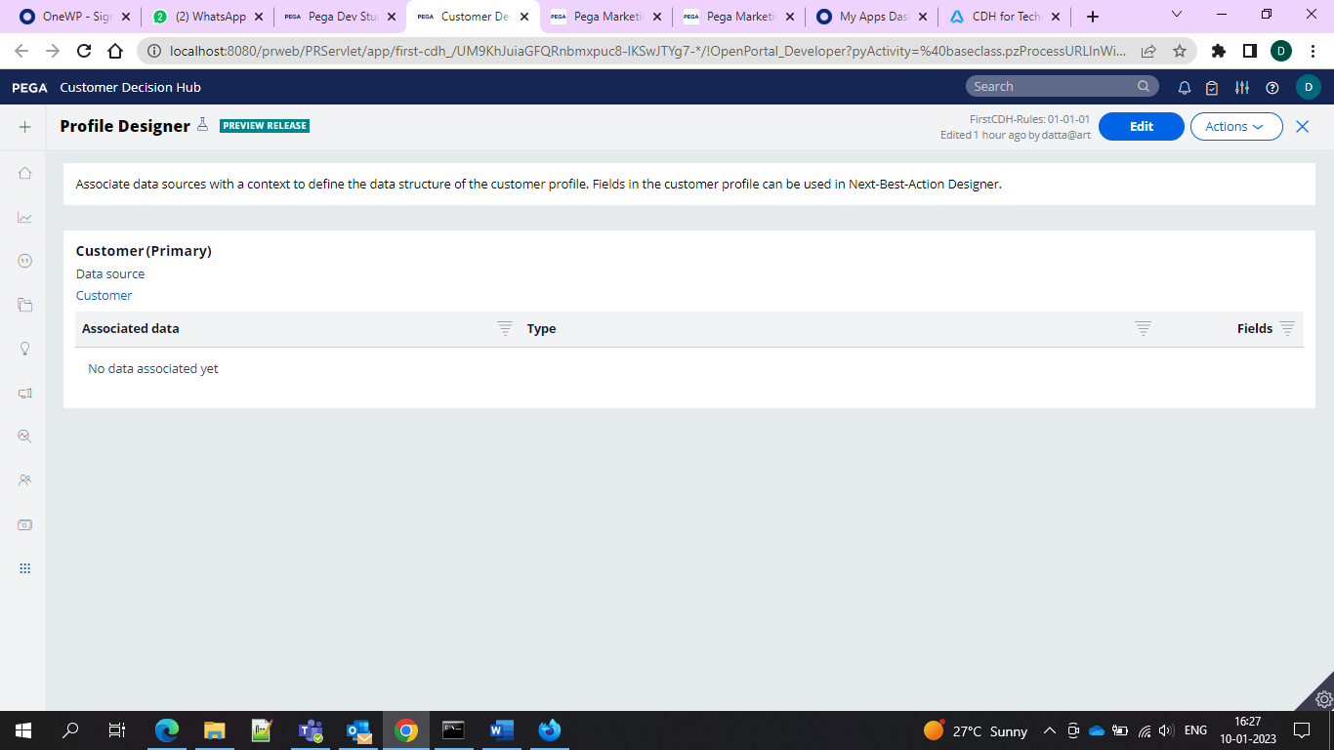

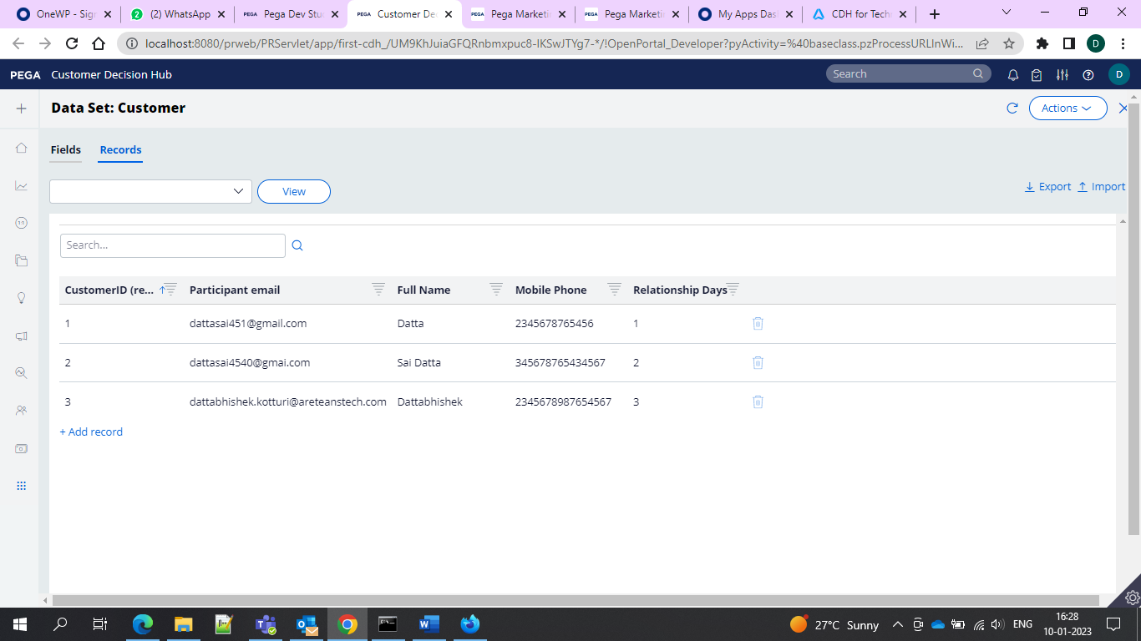

So 3 records that means 3 customers and added relationship days as a field and gave external mapping

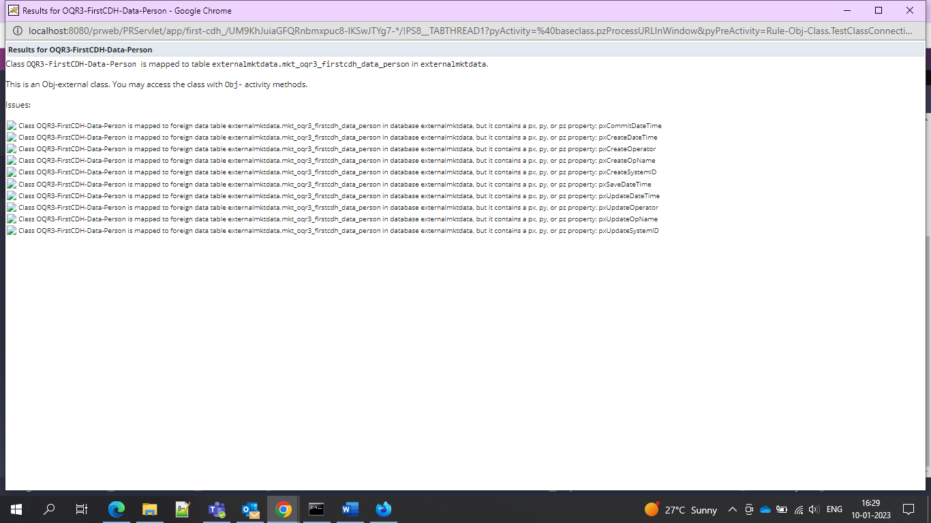

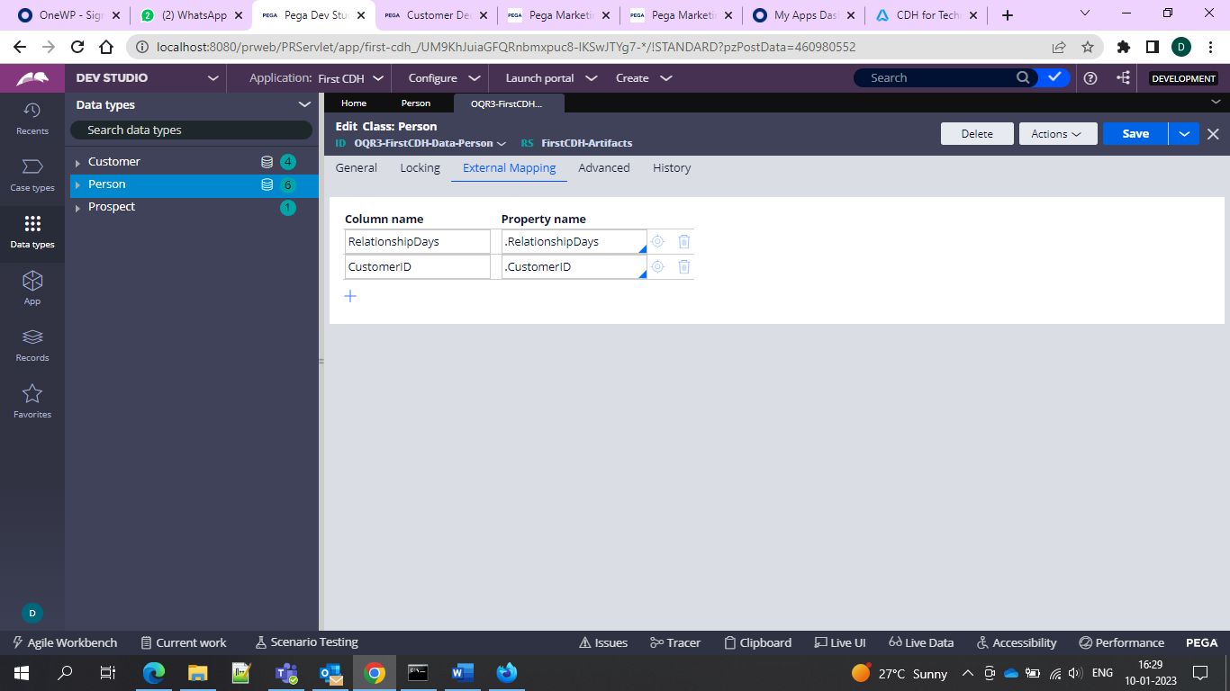

And added the property here

And you can also see in the data set

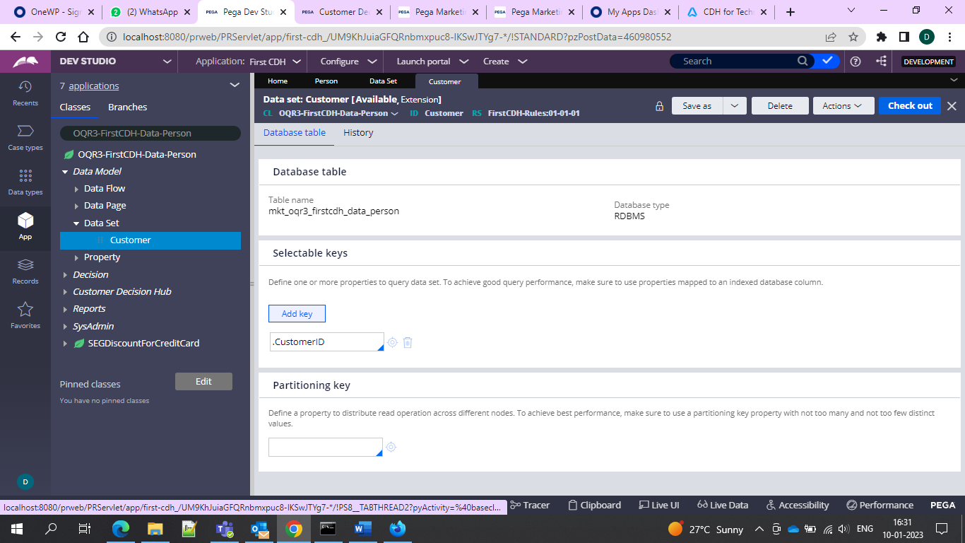

Customer Data Set we can check whether our data is there or not.

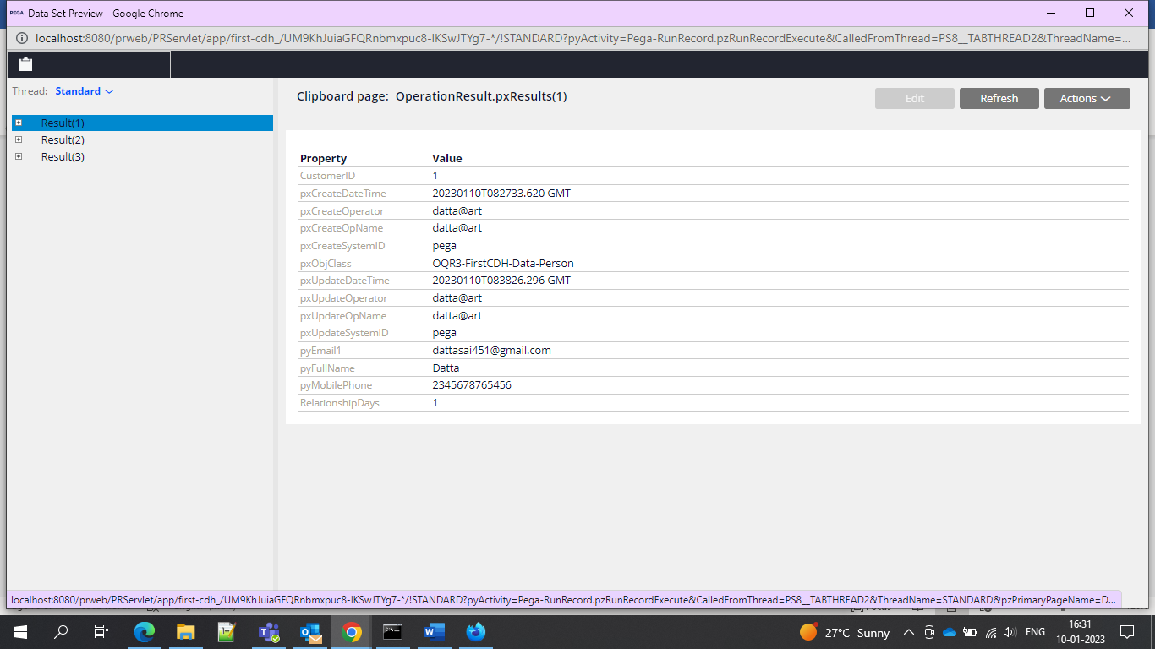

And after that we can see the AGENTS are running or not from pxAdminStudio

All agents under running schedule if anything missed offers are not generated

Data Sets are kept in CDH-Rules ruleset

Campaigns can be triggered in 2 ways: 1. Schedule, 2. Event Trigger

Event Trigger: When a Realtime event is triggered, it will check for a active campaign (running) and it will be executed.

Real time events are one to one engagement

We can create one Repository in the SysAdmin>Repository

In order to import the data jobs we need to add the following privilege to our access roles

CanUpdateJobConfiguration  privilege in your access group.

In the App Studio you can define the general settings for the data import

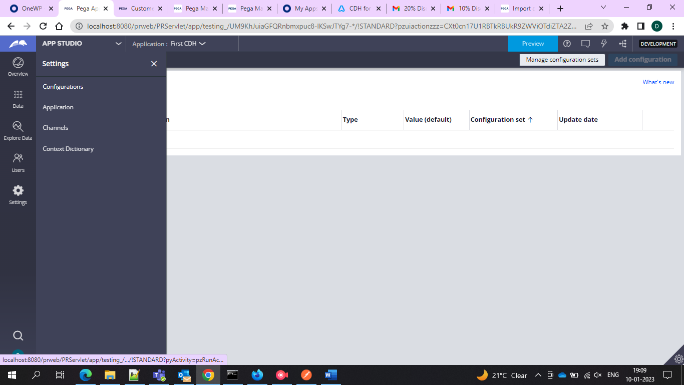

**If we want propensity we must use the top level and trigger top level strategies.**

**If we use issue group level strategies only offers will be generated not the propensity**

**Business Value means what will be the use and profit for the company if it will promote/sell a particular offer**

**Business Levers-What are the offers that are least accepted by the customer and what it should concentrate on that offer to make it valuable.**

**PNG images are accepted in the email when you select a**

**Deployment Manager for 1:1 Customer Engagement**

Different teams involved in the delivery of the applications typically involve the following

1. Product development
2. Testing
3. Operations

Time to market/Lead Time- Time taken from the stage of requirement/user request to till it is finally Delivered to the target customer.

DevOps is fundamentally about increasing the speed of delivery to reduce the time to market.

Operation team is completely dependent on the maintenance and meeting the SLA. Mostly worried about the customer experience.

Pipelines are those which is a gate that would be of high quality and only those are delivered.

Release Frequency would be Yearly, Quarterly, Monthly, Once a Sprint, weekly, daily, multiple times a day.

3 thing are there

Continuous Deployment- where developers get feedback on the quality of the changes

Continuous Delivery- It is the process of validating an application in short incremental cycles.

Continuous Deployment- it is automated validation and deployment

Continuous Integration

Code or change review

Unit test execution

Code or change analysis

Smoke test execution- Here it will be made sure that the most important functionality is working or not

Key Benefits- Smooth Integration, Detect problems early, Solve problems early

Continuous delivery means application changes run through automated regression testing and are deployed to staging.

Pega Pipeline Overview

Submit change

Integrate change

Ready to accept

Ready to deploy

Deploy

Key components

Development Team-

Artifact

Environment

Testing strategy

Automation or orchestration

Application repository

Building Effective automated unit tests for the application changes help you to stop the leakage of the defects in the later phases of the release cycles.

In order to implement this Dev Ops we need to know the main components in the architecture

1. Orchestration- it will demonstrate the workflow involved in DevOps release process.
2. Development Framework- The technology and related functionality is defined.
3. Source Control Management System- The repository that holds the functionality of the application.
4. Build Management System- The capabilities which packages the application from dev to other env in a releasable package.
5. Artifact Repository- The storage location or repository that stores the generated application package to make the package available for the higher environments.
6. Test Framework- Capabilities that help validate the functional correctness of the application logic.
7. Quality Inspection System- The capabilities that validate he qualitative dimensions of an application mainly by the test coverages and guardrails.

Key Feature areas available on Deployment Manager

* Pipeline Overview
* Pipeline
* Deployment
* Users
* Roles
* Settings

Deployment Manager will have different environments

Orchestrator

Deployment SOR(deployment environment is referred to as the SOR

Staging

Business Operations Environment

Production

To use the deployment manager you need supported artifact repository Deployment process automatically versions application artifacts.

The development and Business Operations team work on these artifacts to keep them up to date

There are 3 applications that will leverage with the devops best practices for CDH implementation

Enterprise capability changes require

* Creating new customer property
* Integrating an additional channel
* Creating a new service to gather additional customer data

The updates are maintained for a CDH application and are maintained in Rules ruleset and any other client specific rulesets \

The business content team and the enterprise capabilities team make business changes in the BOE.

BOE(Busines Operations Environment) is used to test the configurations.

**You can make two types of changes to the customer decision hub application from the BOE.**

**The first one is the Change Request that is initiated in the 1:1 Operations Manager Application.**

**Examples can be creating an action, creating a treatment, updating action level eligibility condition.**

**The second type are the changes that are not managed by 1:1 Operations Manager but completed using revision management capabilities in CDH portal on BOE.**

**Low volume business changes would be like**

**Modifying a score card**

**Updating decision strategy with the elgibility conditions**

**And we can deploy both these changes as part of single revision.**

**We can deploy both these changes from the BOE to all other environments.**

**After the deployment from the BOE is initiated, the artifacts related are merged in to the branch After the branch is merged to the enterprose application a new version of the enterprise application is created.**

**Simulation testing is required you to provide with the insight as to how your changes are affecting the decision logic affect the results that your strsatergy produce.**

**To summarize, successfully setting up Deployment Manager to conduct proper change management and provide sampled production data for simulations enables businesses to seamlessly deploy revisions and test how decision strategy changes affect real-life scenarios.**

5 environments

Development environm- to develop the enterprises features or the system of record

UAT/Staging environment to test the changes and analyze the technical impact,

BOE environment to make business changes

Production system to serve customers with the most recent artifacts

Orchestrator to manage and automate deployment artifacts from one environment to another.

When the setup wizard is run it will generate two different applications and those two are

1:1 Operations Management. The overlay application, built on CDH.

1:1 Operatoons Manager extension with the predefined configuration to set the stage for the change management.

Operation manager extn iks built on the pega 1:1 Operations Manager.

The staging, BOE and production environment must have Pega Platform, CDH, DevOps installed. They must have access to the repository.

Should also have deployment manager features during migration.

Deployment manager looks like this

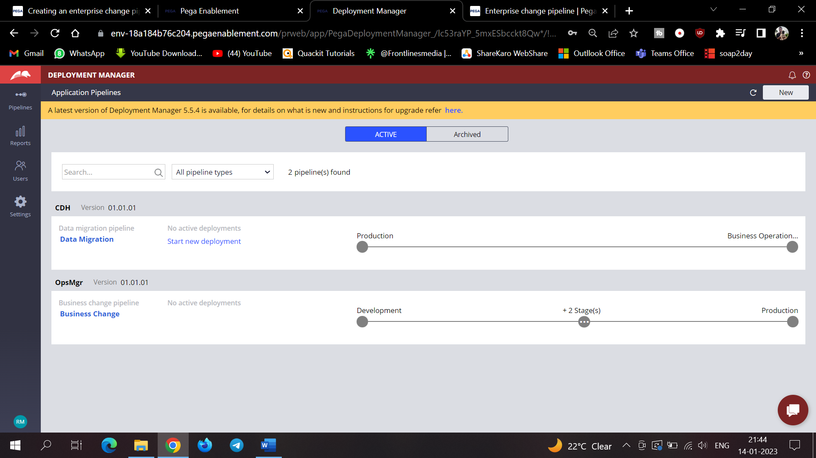

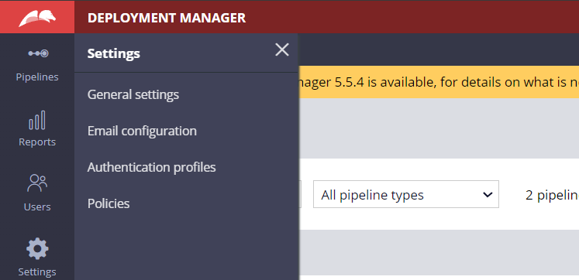

And here we will have the Orchestrator URL when we click on the General settings

The URL is environment specific and automatically updates for you.

If we want to deploy any changes click on New on the top right and then click on pipeline and then it will ask for application details

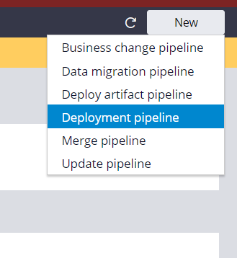

And in the next give the orchestrator URL and authentication profile the admin access group

And in the next step give the application Name and version and the product rule name pipeline name and acces group and product rule version as shown below

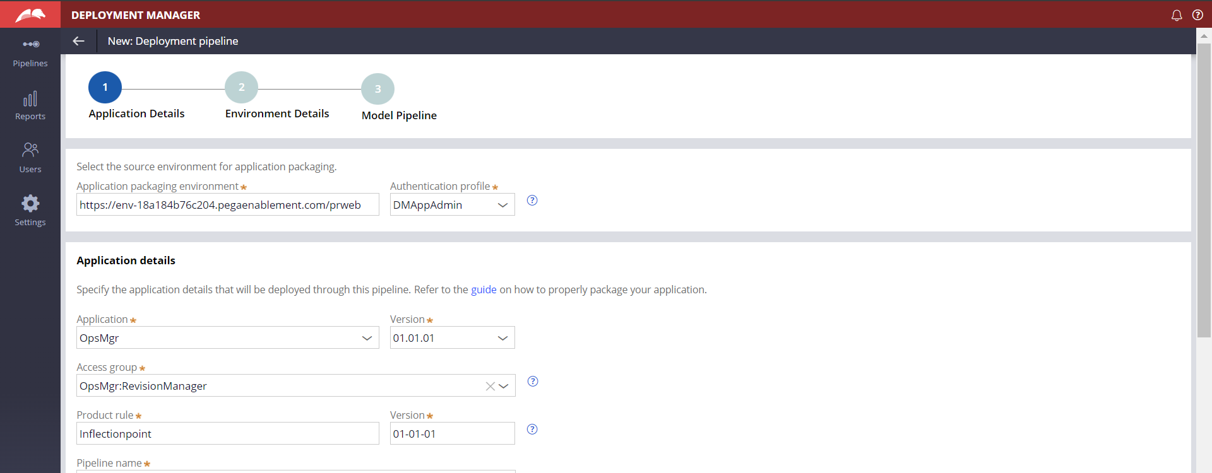

And after that in the environment details update the environment details for development staging production and QA and access group of the admin

And then give the repository for the changes from the dev to the production

And after giving all these model pipeline page is opened

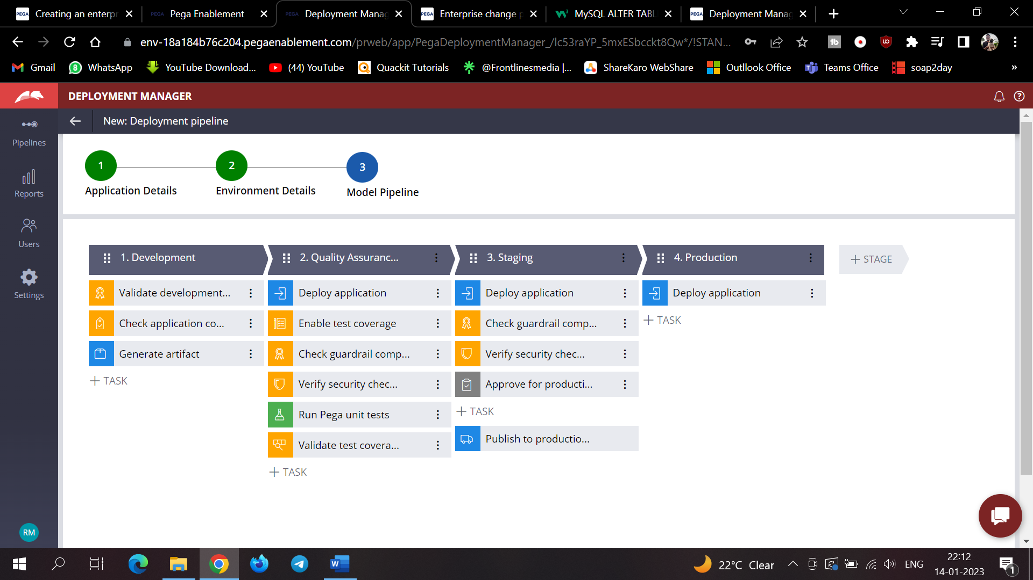

In the Development stage click the check application Compliance step

And in the staging environment click the guardrail compliance step 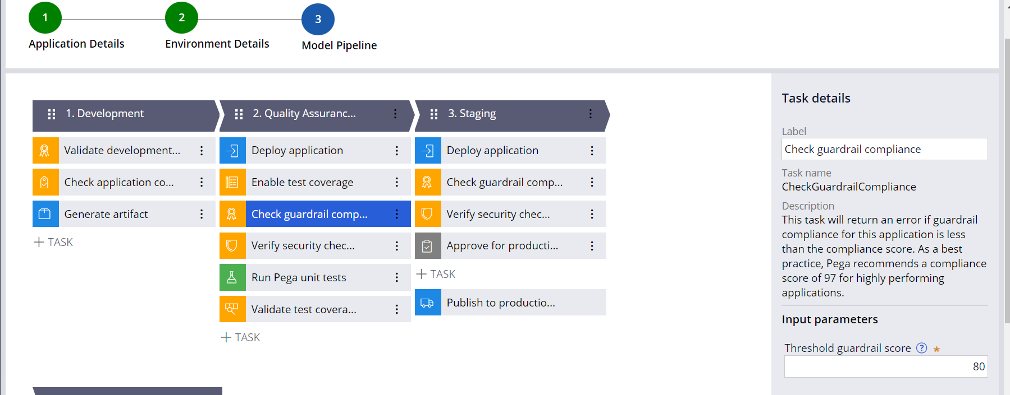

And now can validate the

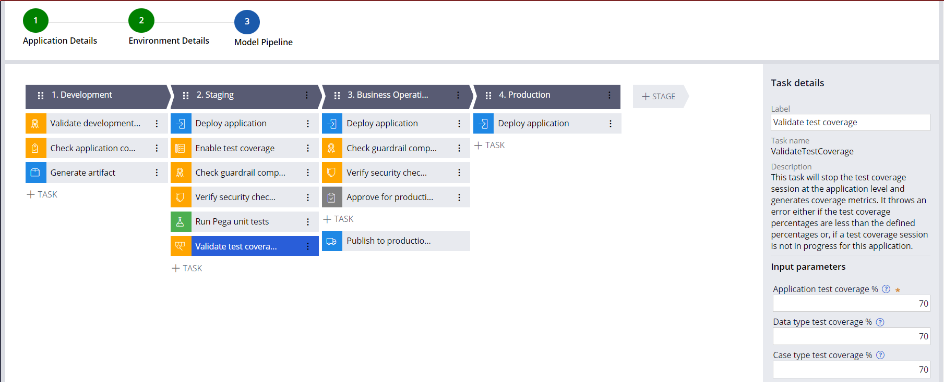

And after that business operations tab check the guardrail compliance score and set the thresholds and then create the pipeline

Now after that run the diagnostics to ensure that pipeline is configured successfully and the Orchestrator can communicate with the candidate/other environments

And now you can check the status of the environments by running the diagnostics

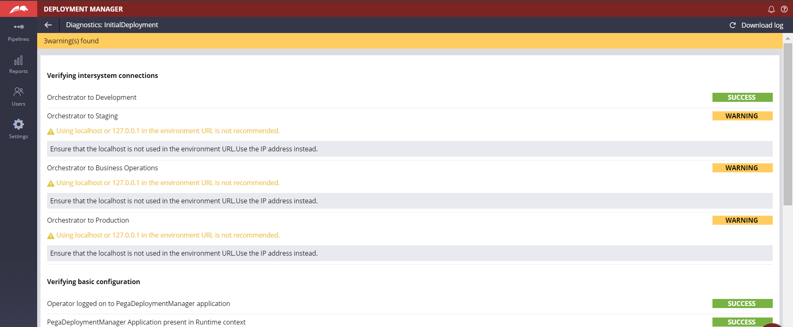

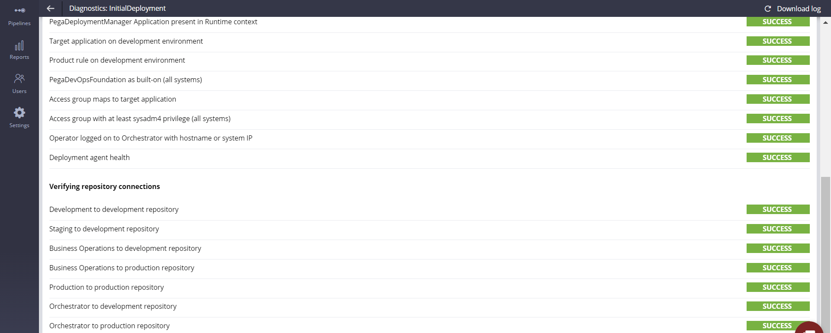

And after all these in the upper left column you can view the pipelines created.

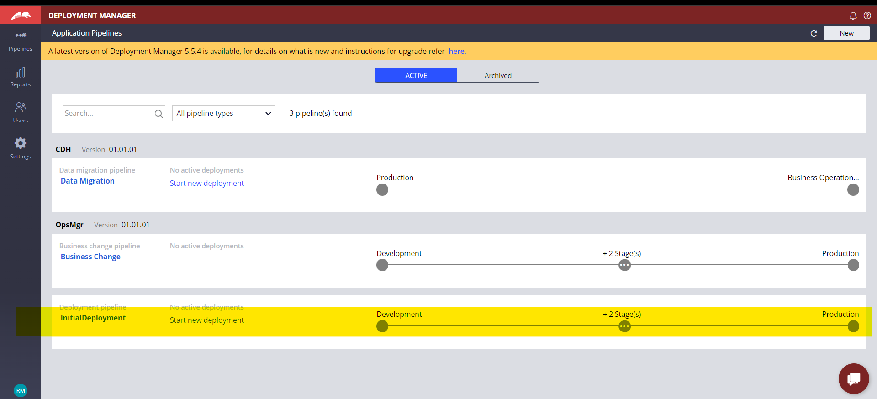

And now

After the post deployment your application would be under change management.

The business teams can perform business changes through the change request process from the business operations environment.

After the initial deployment you enhance CDH in an ongoing basis In the development environment.

When the enterprise changes are deployed only then the rulesets of the implementation and application and the data instances are deployed.

In summary, you start with the development in the development environment after running the CDH setup wizard.

After development process is matured and is ready for change management, use the enterprise change pipeline to deploy all development changes as part of the initial development.

After that use the enterprise change pipeline to deploy all the changes as part of the initial deployment.

From this point you can use the enterprise change pipeline to deploy ongoing application enhancements to higher environments to meet business objectives

Next use business operations environment to deploy the business changes to all other environments.

And also we should migrate data to the business operations environment through the data migration pipeline to simulate the results of business changes to understand the business outcomes are as expected.

The changes are managed through the revisions and are packaged automatically for you when you use the 1:1 Operations Manager and Revision Management.

In the development environment note that the business change is the overlay application.

It is built on the enterprise application with the business change ruleset and Artifacts Ruleset.

The branches created are a part of the Business Change ruleset. The branch is where you mergr business changes. At this point staging, BOE, and production are in sync.

After the initial deployment is complete the change management starts and the changes are stored in BusinessChangeRM in the BOE.

When the revision manager deploys the changes to the business change pipeline, the rules in the branch are packaged and moved to the repository to which all the environments have access.

When revision maanger deploys the change, the rules from the branch are packaged and moved to the repository.

Then the artifacts related to revision are merged into the development system.

Then a new version if enterprise application is created with the merged rules.

A new package is created and sent back to the repository.

This package is created from a pre defined product rule, which is configured as a part of the business change pipeline.

And as a next step application is deployed from the repository to the staging environment, and the enterprise and the overlay application versions are updated.

Then it is deployed from the repository to the BOE, and the enterprise and the overlay application versions are updated.

Finally application package is deployed from the repository to the production env and the enterprise and the overlay are updated.

In the production environment the change is activated in 2 stages. In the first stage, the production environment application ruleset stack version is updated, but a user action is required before the change can be deployed.

The revision manager logs in to the BOE to enable a set of users who can view business changes.

If the users confirm that the changes are fine then they are made available to the users.There are two sets of access groups rollback and the original access groups and the rollback access groups is prefixed.

Once the deployment is done through the business change pipeline is successful, the new version of the enterprise applications with the new version of overlay application ruleset is available in environments.

Practical-Business Deployment Pipeline

In the same deployment manager we have a business change pipeline where we would specify environments and access groups and product rule for the deployment

Go to the pipelines and select data igration pipeline

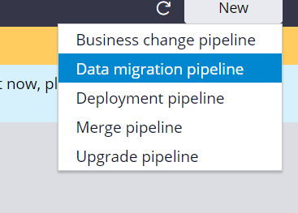

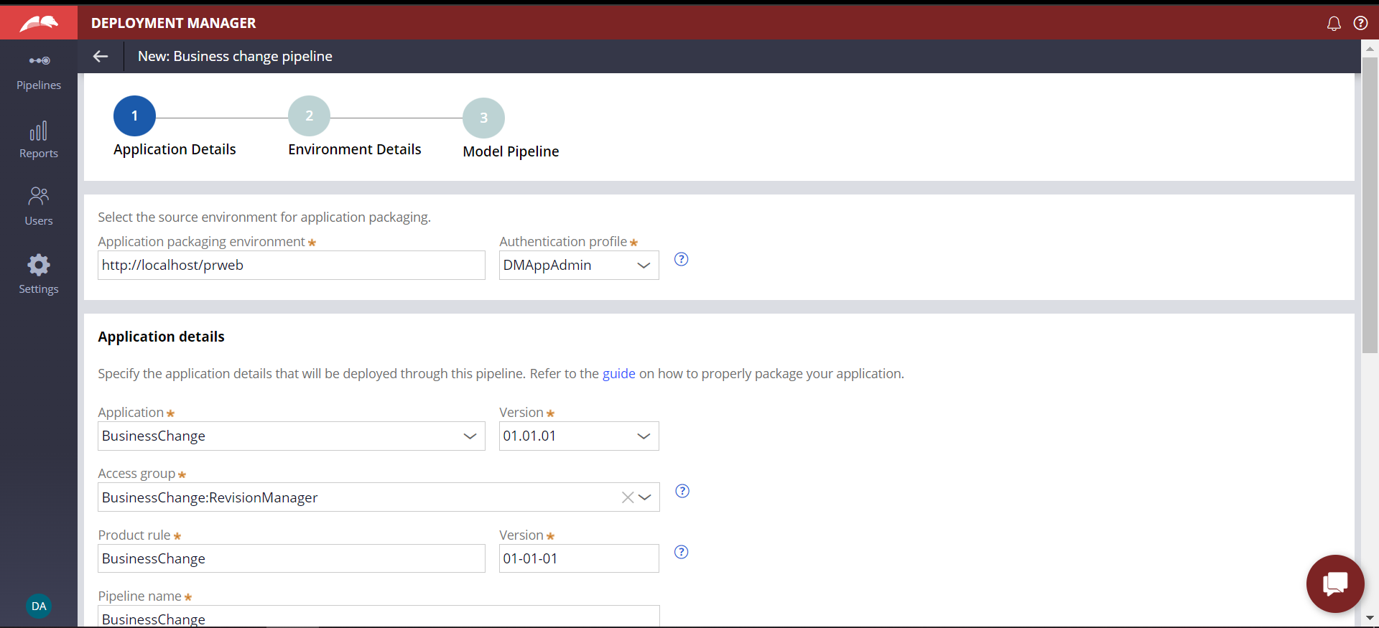

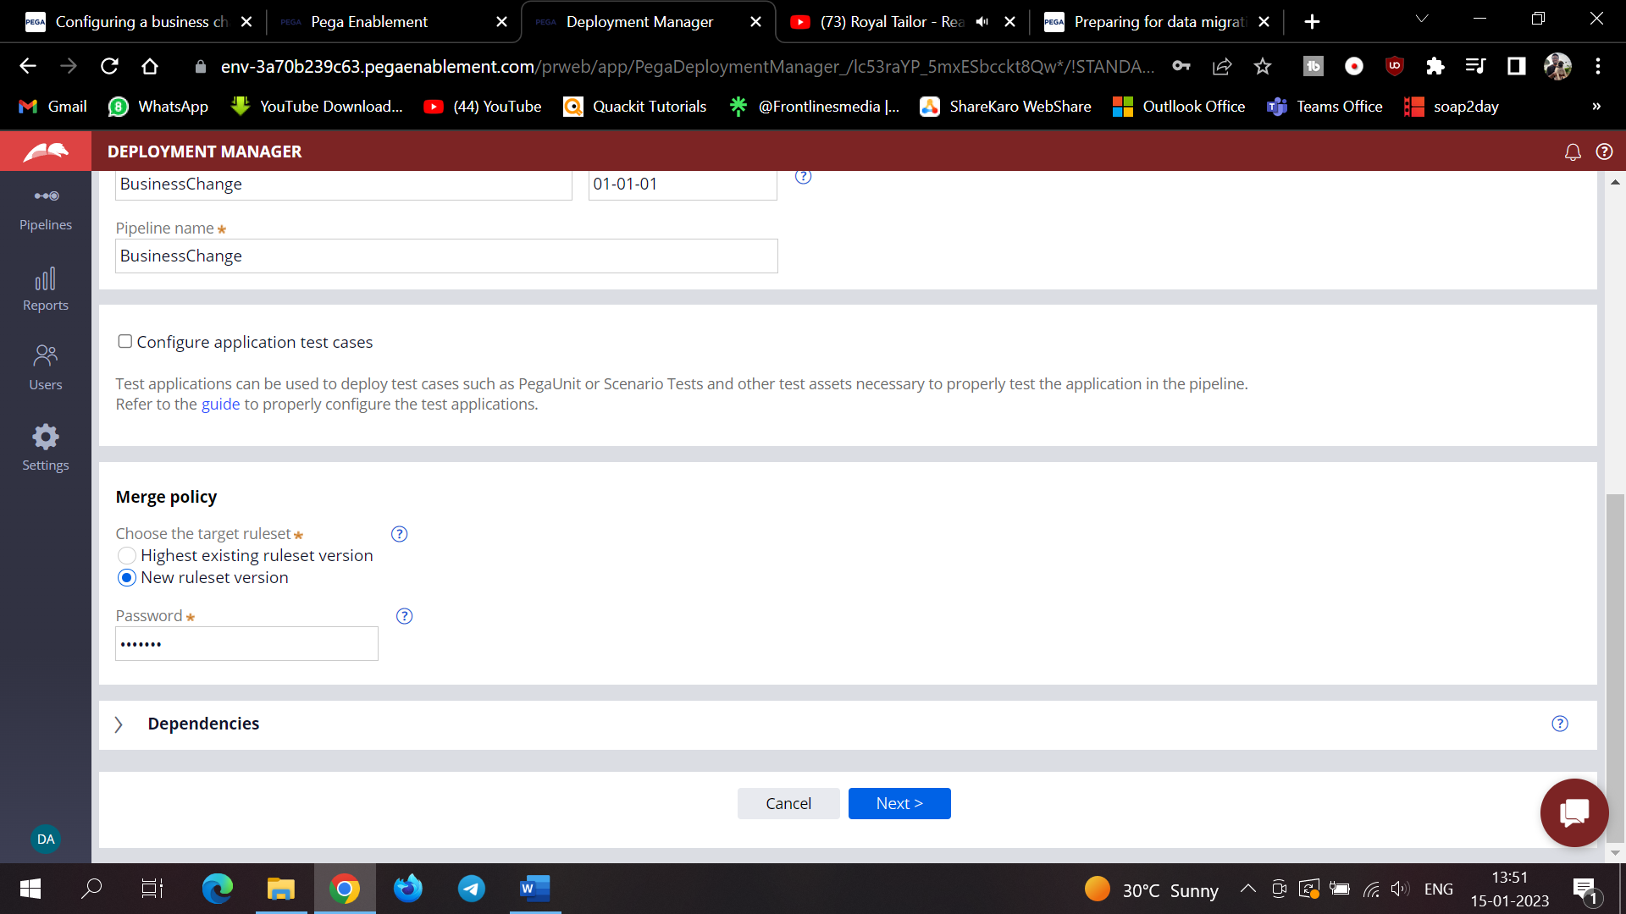

And after that we need to get the specify specific URL for the environments and related admins and then create and then create the pipeline and In that stages are shown already and now in the 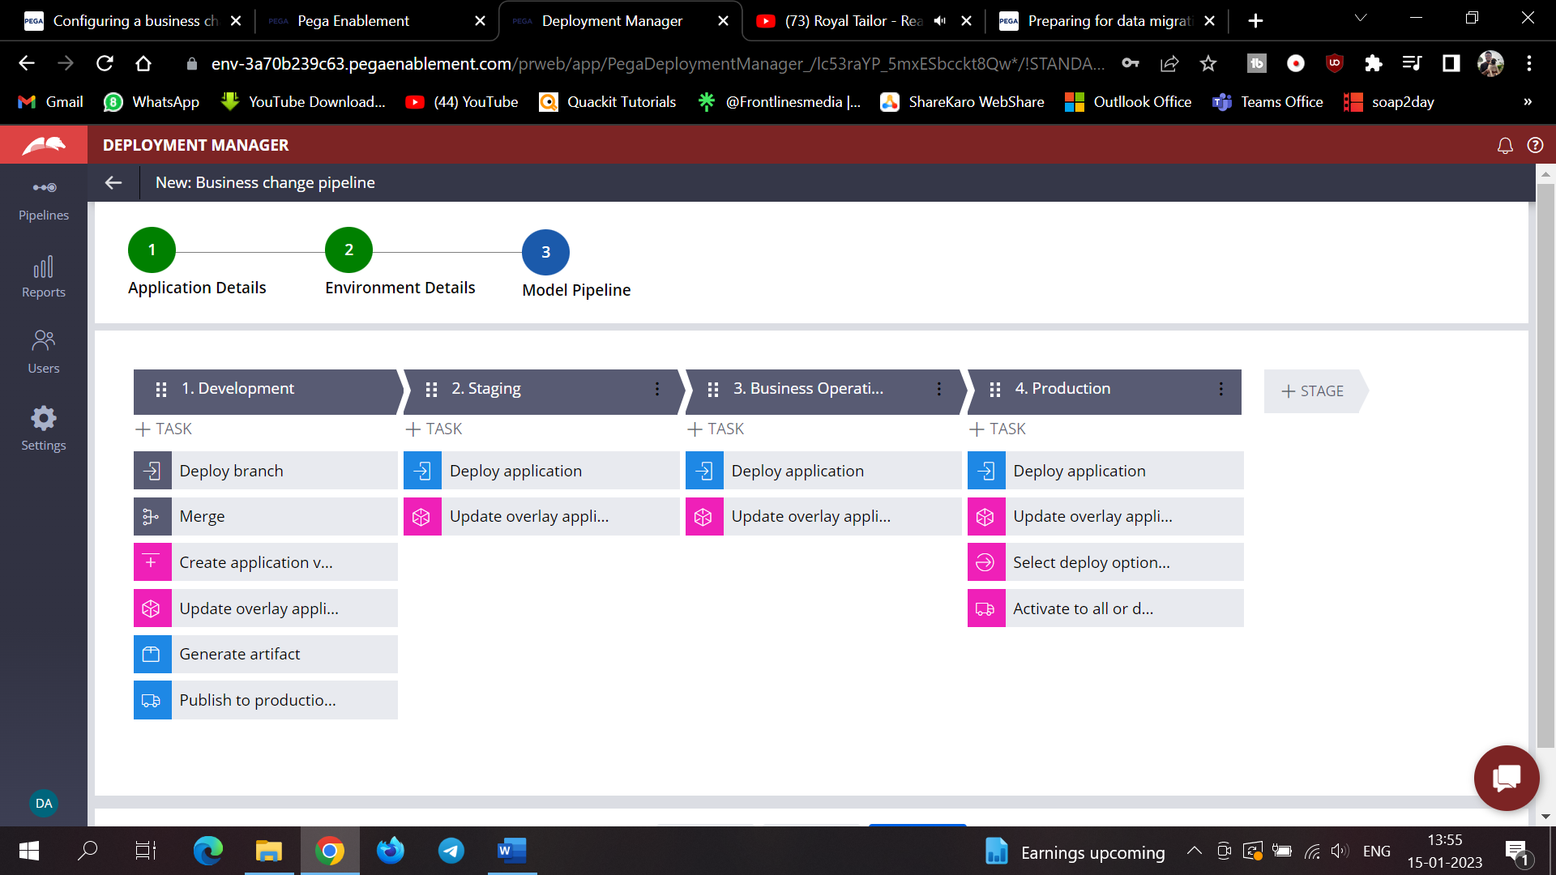

And then we need to select the application version under the create application version give the application name

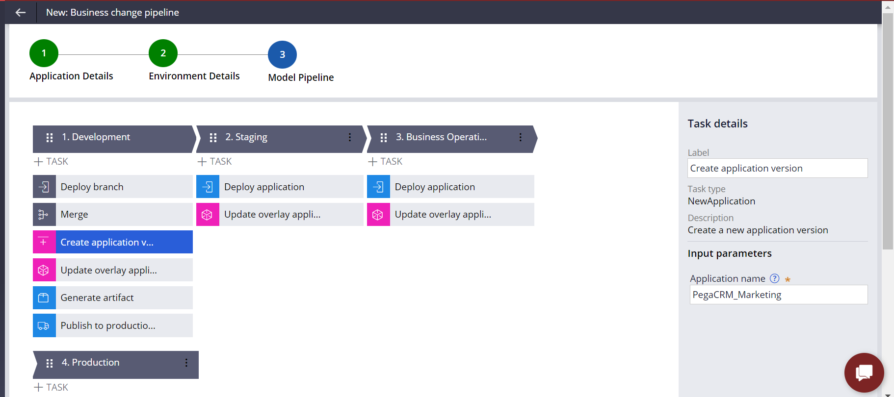

And now we need to run the diagnostics to check the sync and healthiness of the deployment.

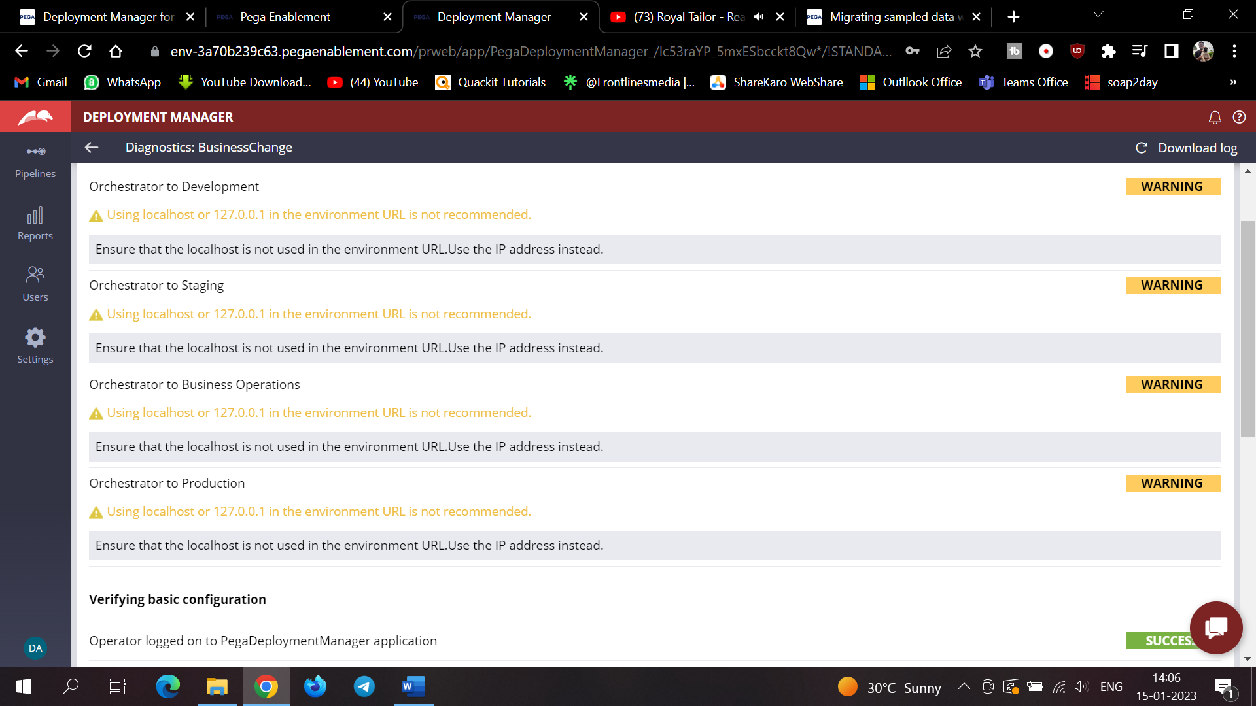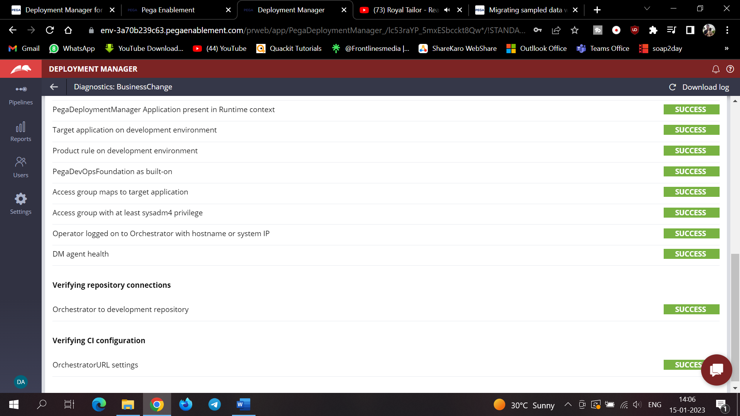

Data Migration pipeline enhances the process of automatically moving sample production data into the business operations environment(BOE).

Pega CDH will provide you with the sample inbound outbound data for your production customer data that you can use as an audience input for simulation.

By using this data migration you can export an inbound outbound sample data set which will include the interaction history and adaptive models from production environment and then import data into BOE.

You can schedule the refreshes of sample datasets in the BOE at specific intervals.

To migrate the sample production data you need to complete the one time configuration in dev environment to generate artifacts and then move them to production environment.

And when the data migration pipeline is generated you can move the simulation data.

The pipeline will provide with the means to simulate what-if scenarios on sample production data without affecting production environment.

How can we prepare for Data Migration

As a best practice start creating a new ruleset to host all systems generated artifacts such as data set and data flows. It would be helpful when you package the artifacts.

So create ruleset from Sysadmin>ruleset

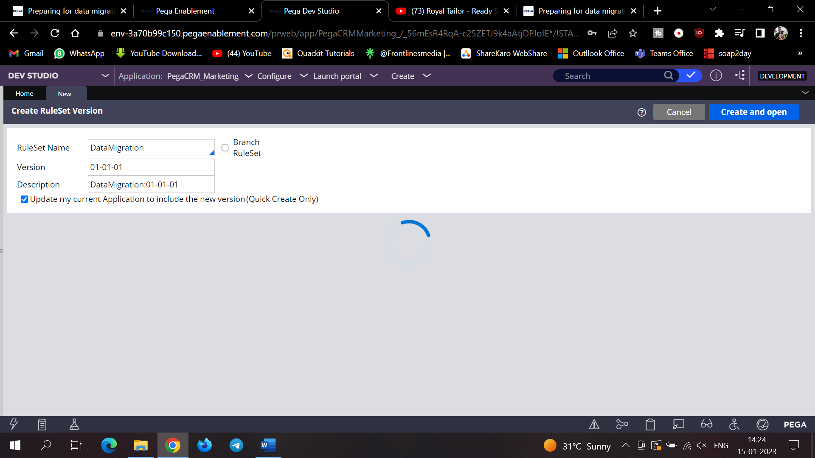

And add this in your application ruleset

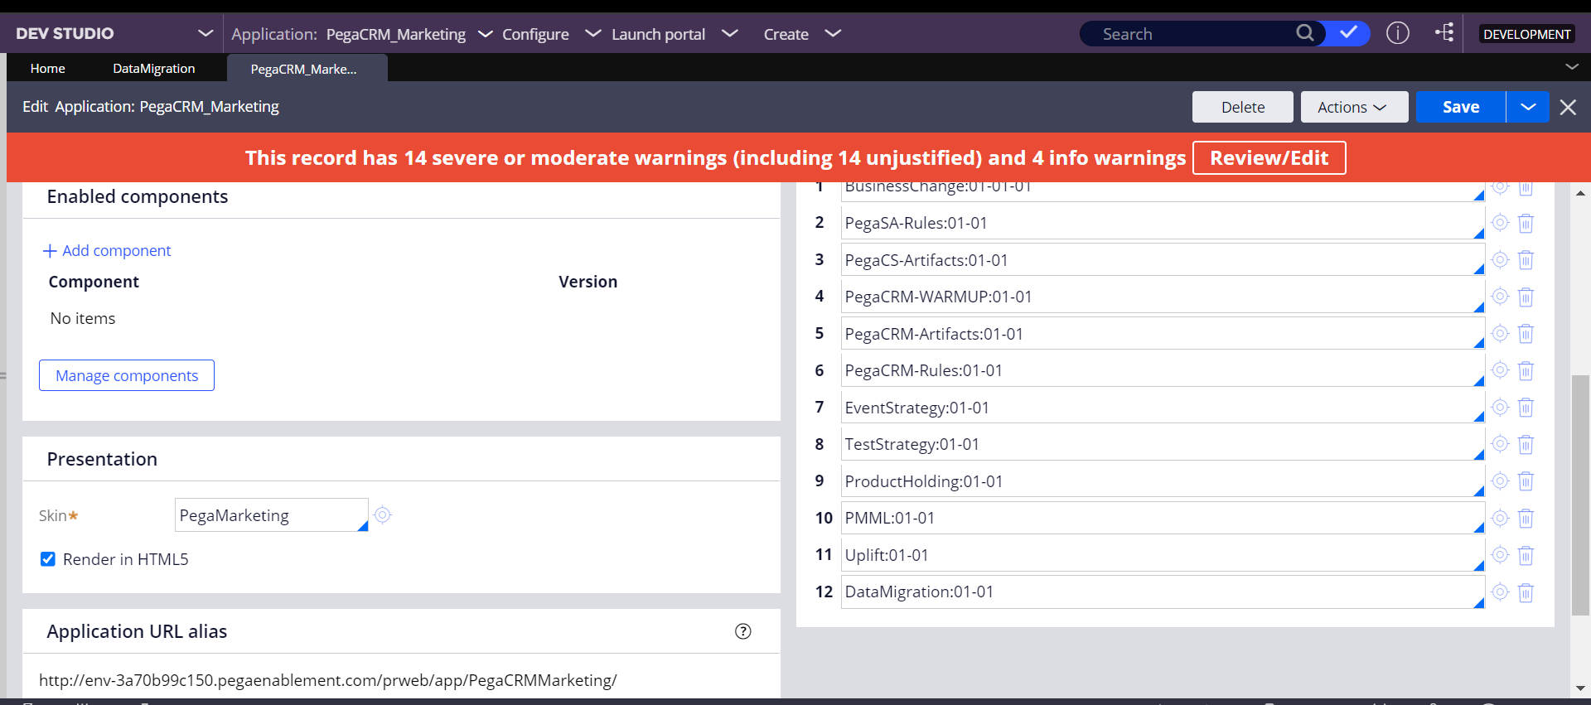

Next configure> infrastructure>Data Migration

Outbound and inbound sample data customer is 20% for the Max and you can specify your Data To Transfer

And then give the repository

And under the supporting artifacts give the ruleset version and the name and click on the supporting artifacts

Now enable the inbound outbound sampling in the DSS and then create the product rule 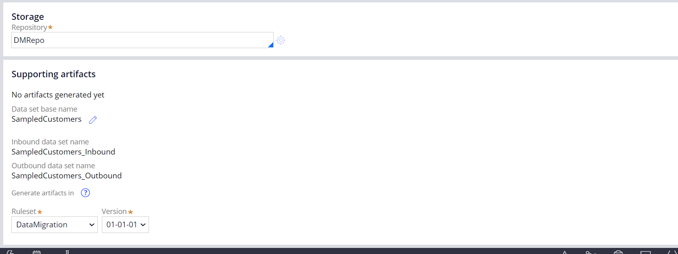

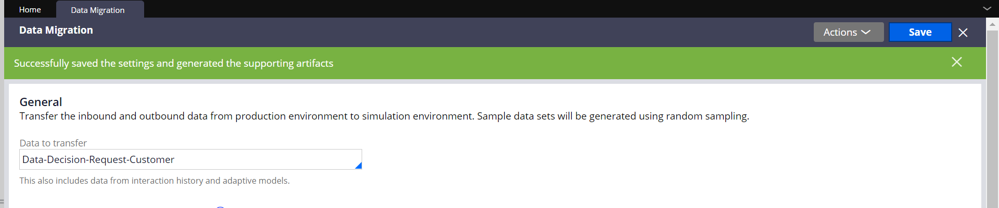’and we can see the artifacts ‘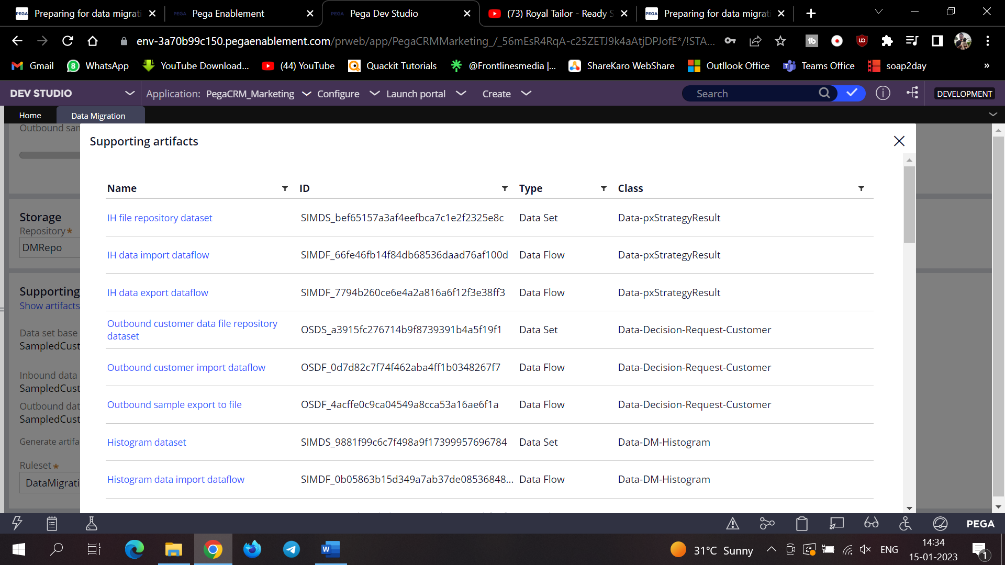

And then enable DSS (Sampling)

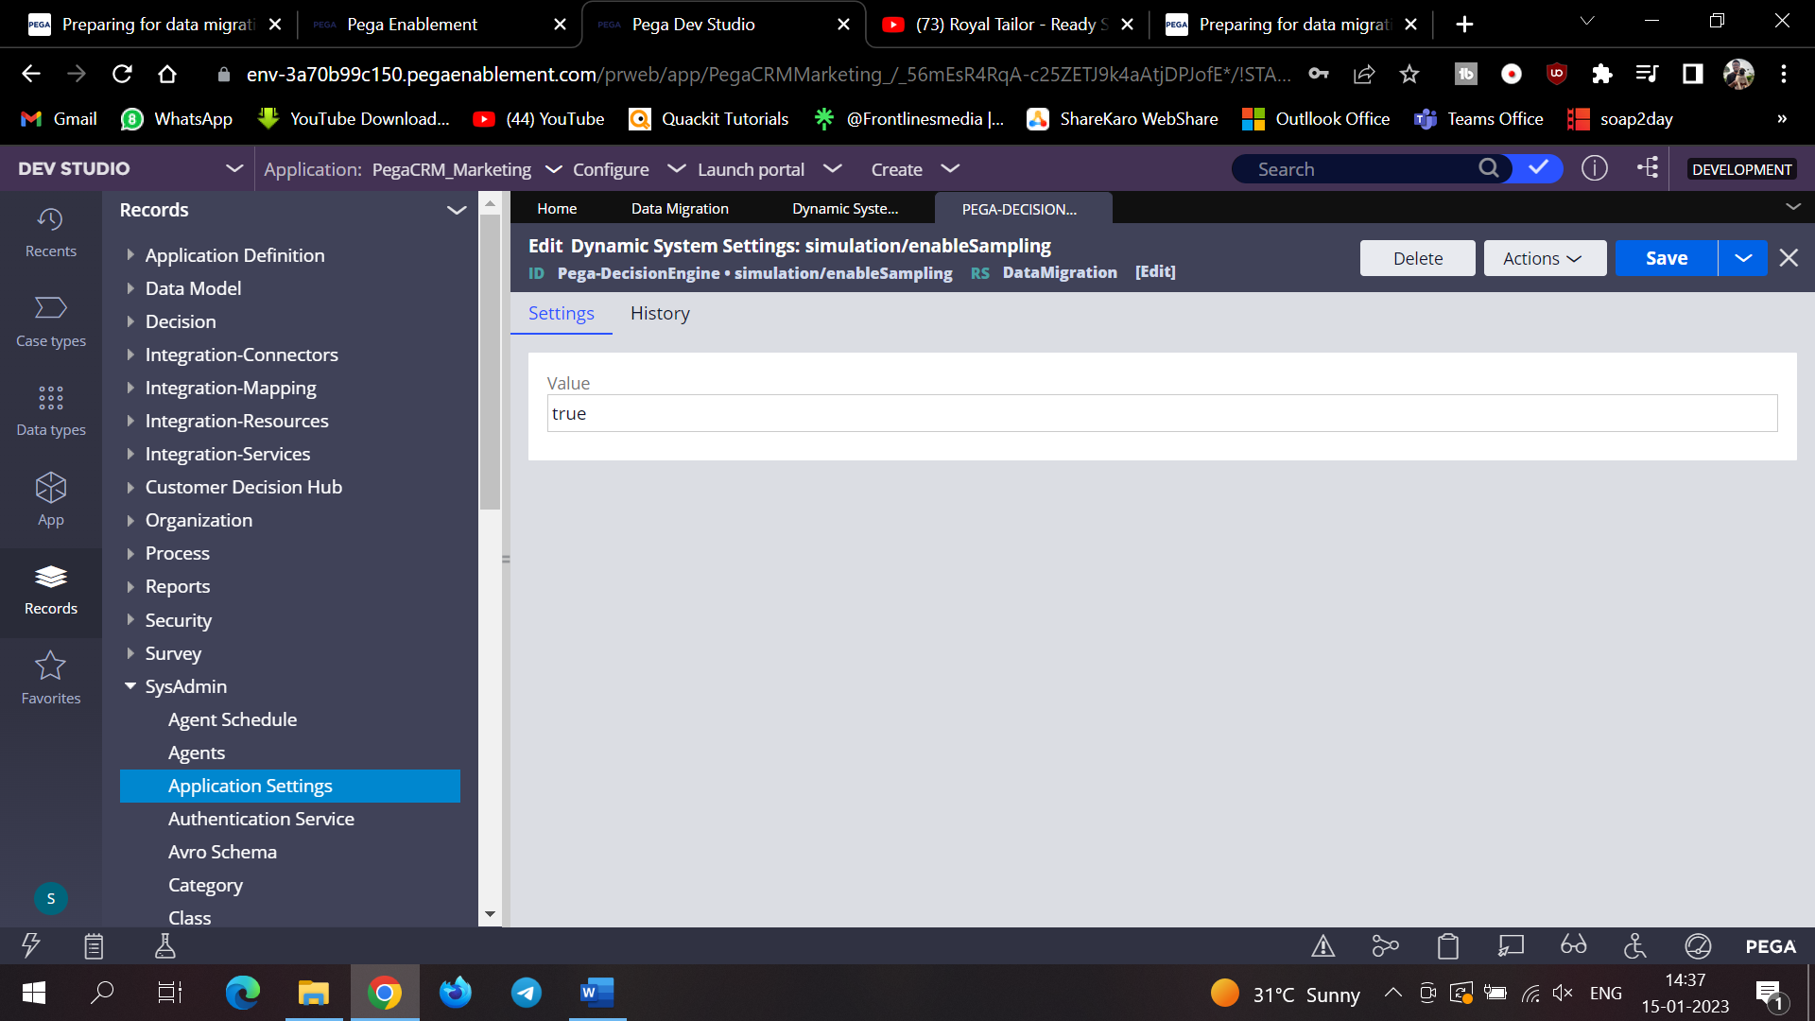

And also CDH outbound Sample

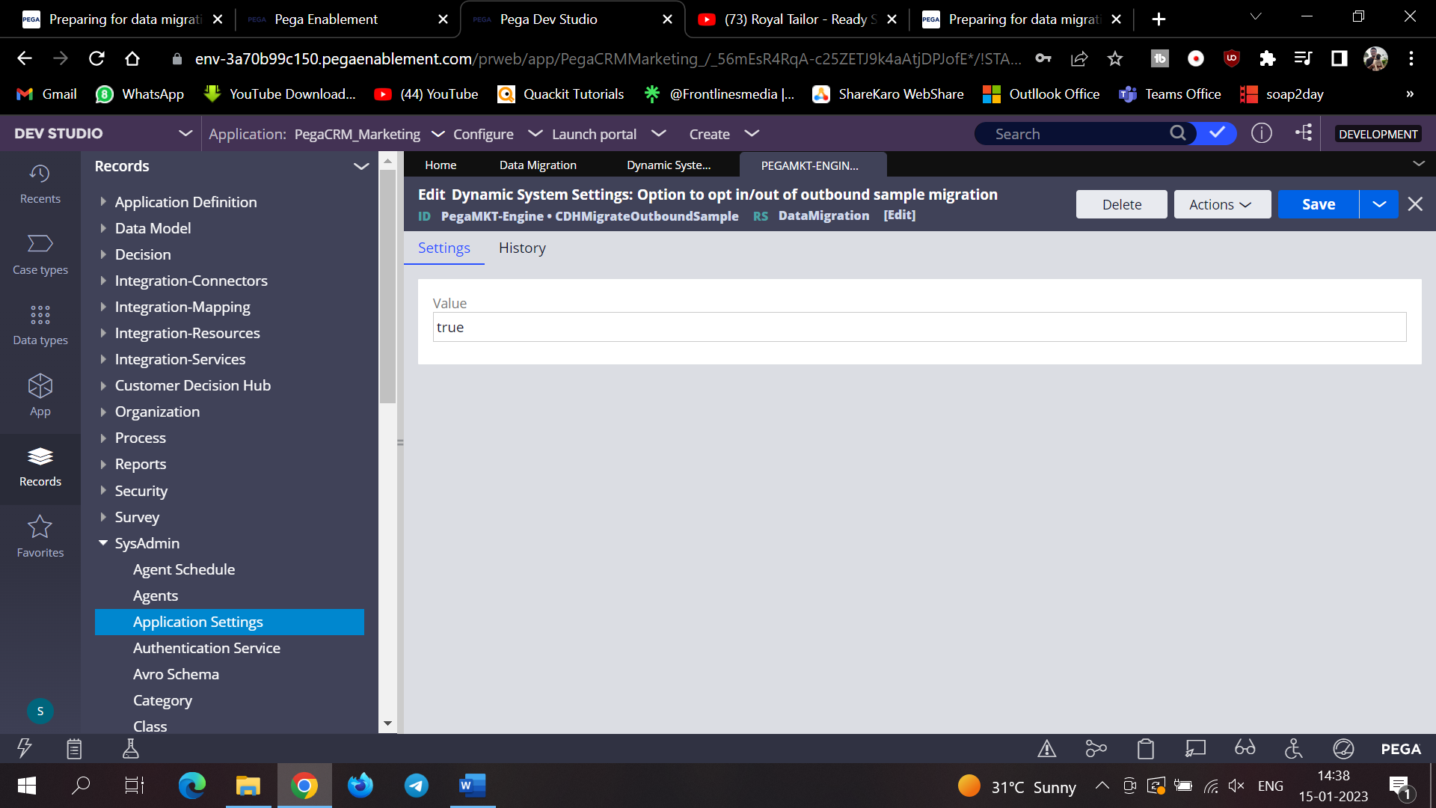

MigrationScenarioActual Planner also to be enabled

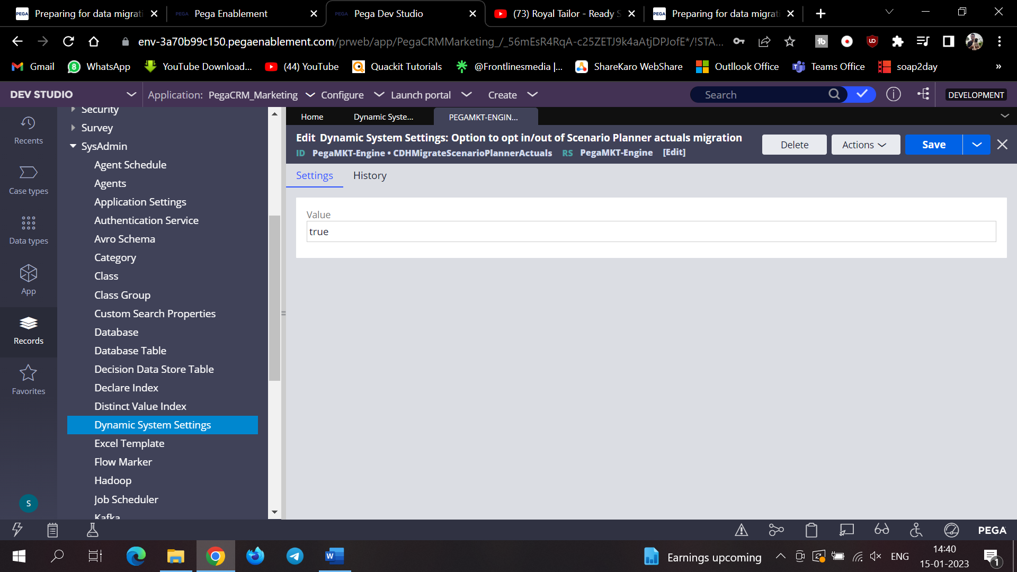

And then you have to create one product

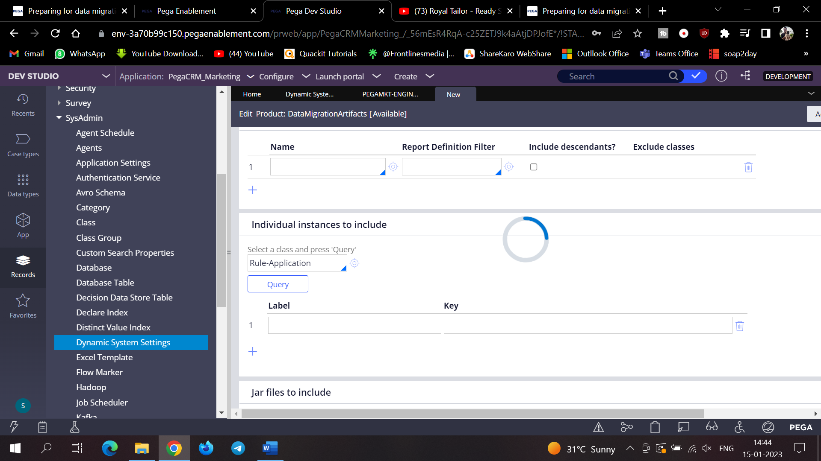

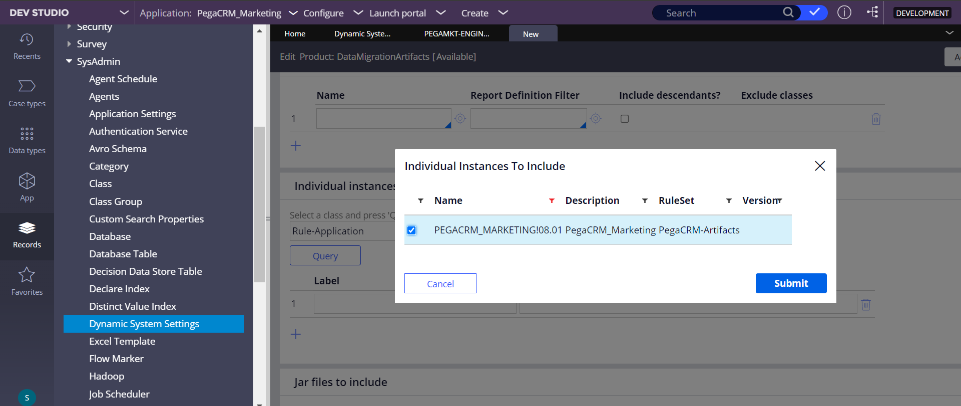

And after thesaving of product file and if ok lock the version and then we need to do the creation of the product file

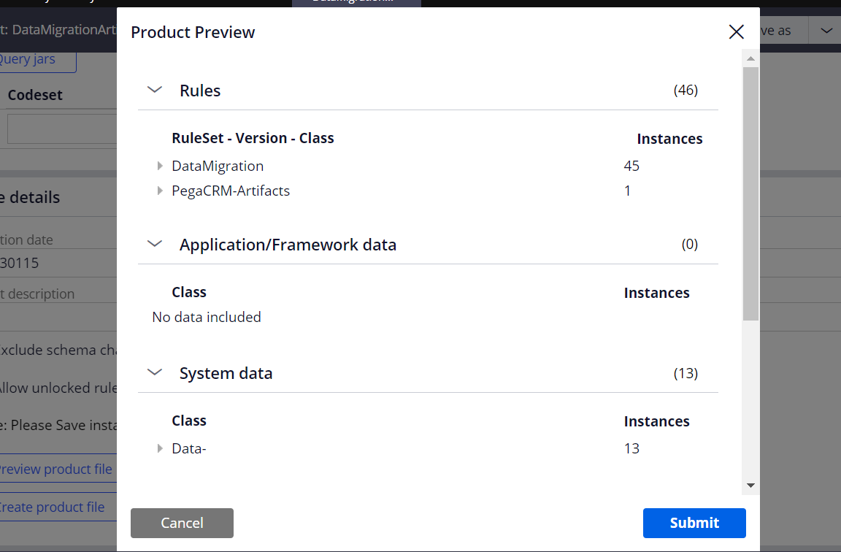

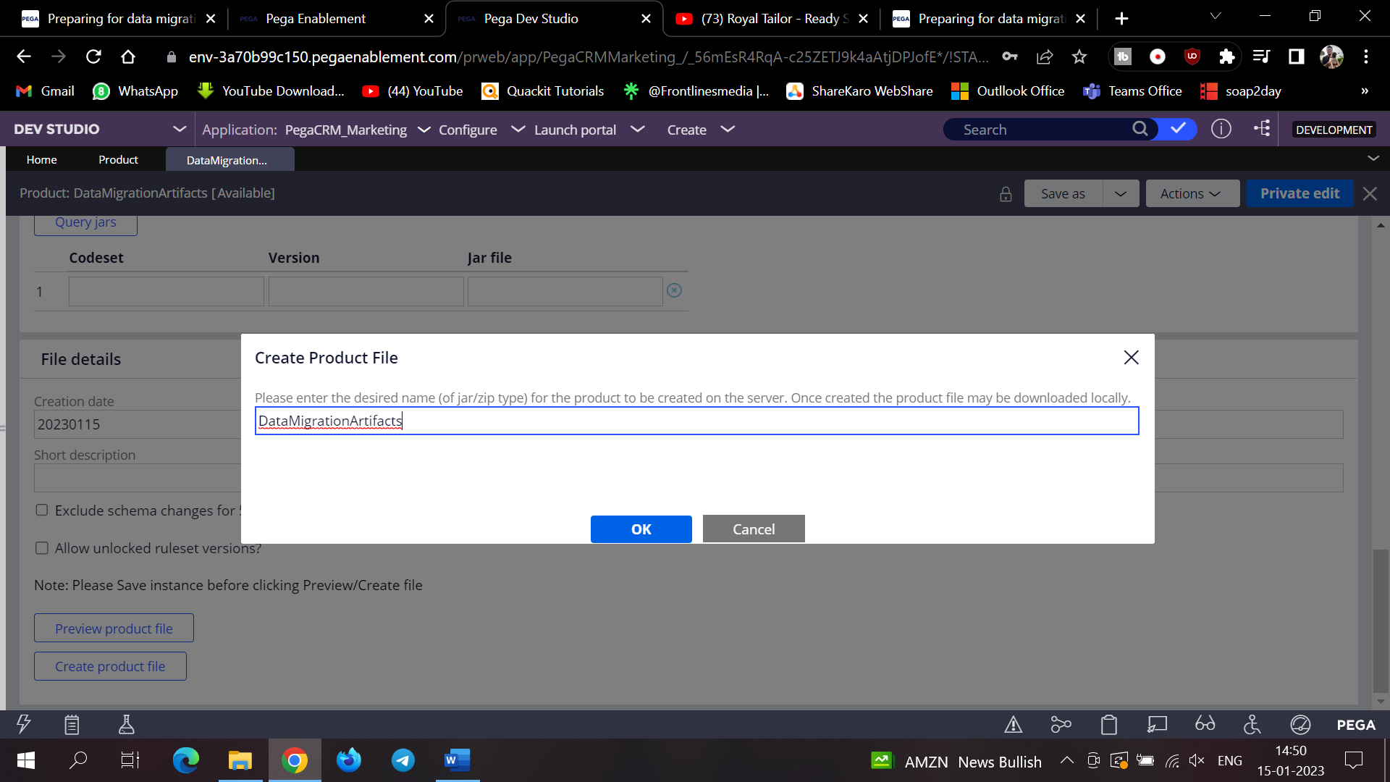

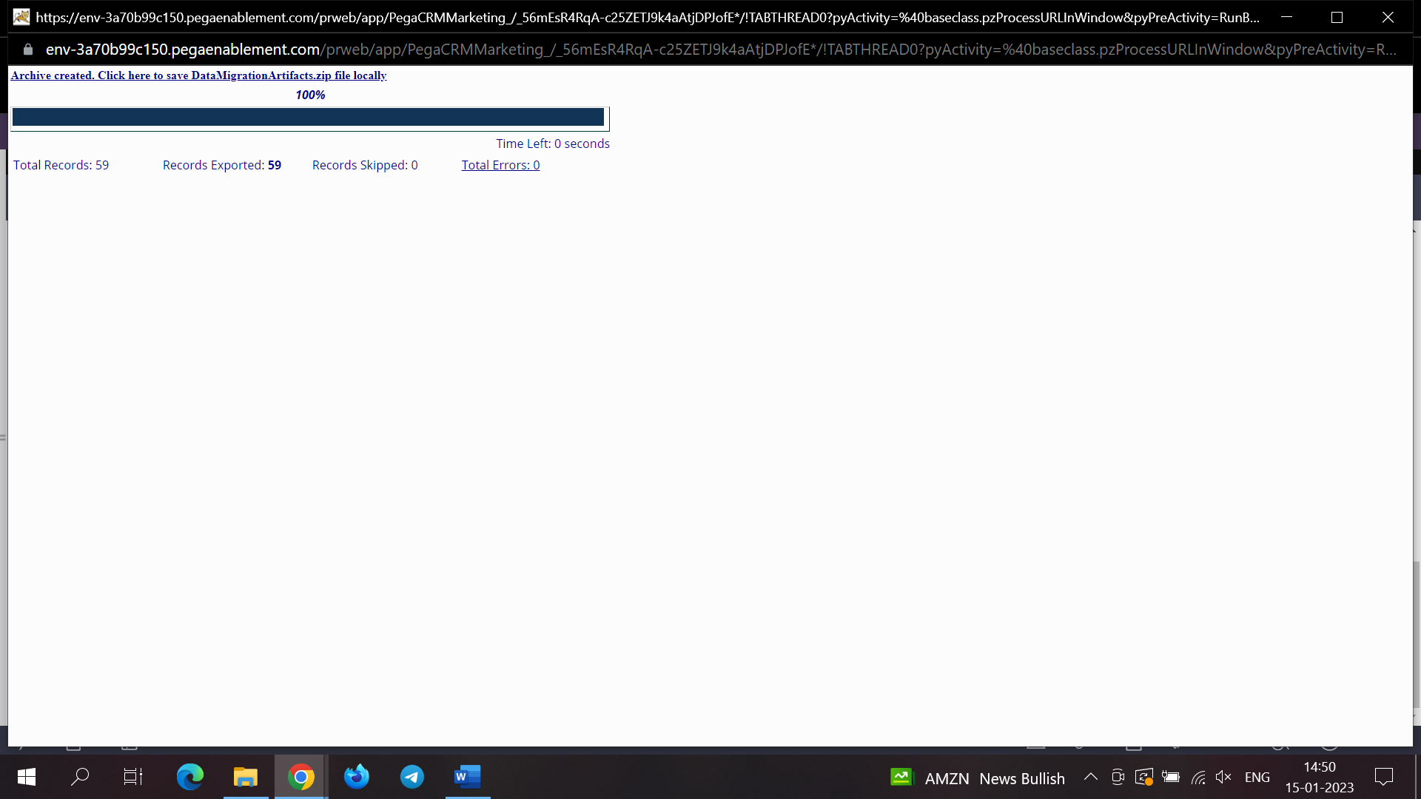

And ensure that under the service packages mentioned below

1. **DataSyncPipeline**
2. **MigrateSimulationData**
3. **Api**
4. Cicd

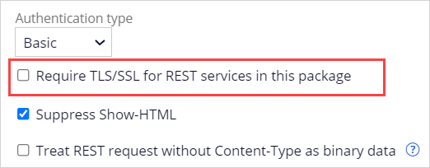

The following checkbox is unchecked.

And done

**CDH Configurations**

Now let us see some configurations

How to configure one Campaign in CDH Before this we need to configure Segments. In order to do that we need to first add some records in our data model and give the external mapping of the properties.

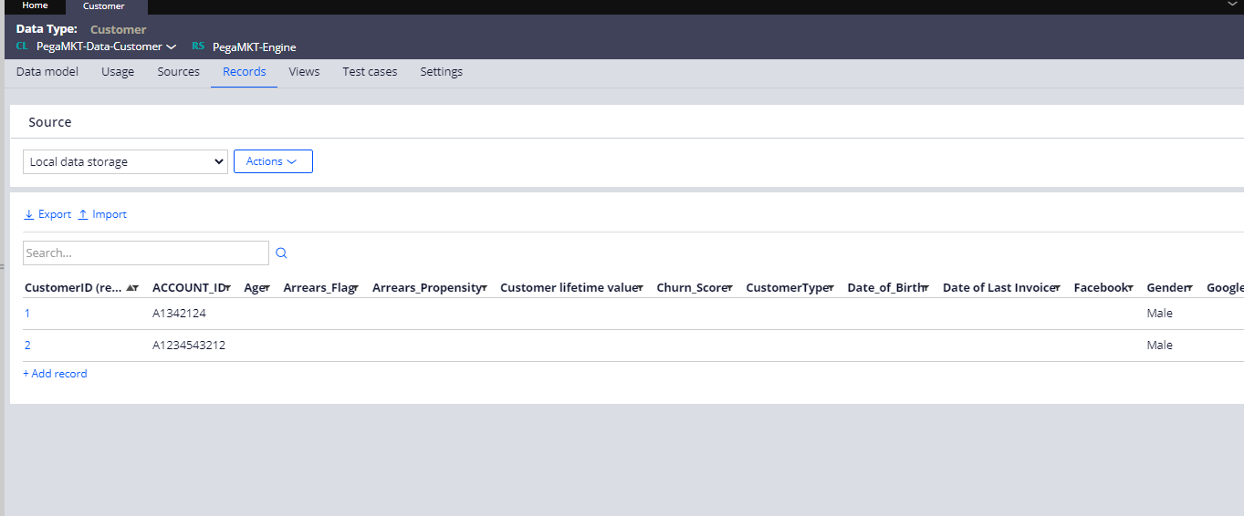

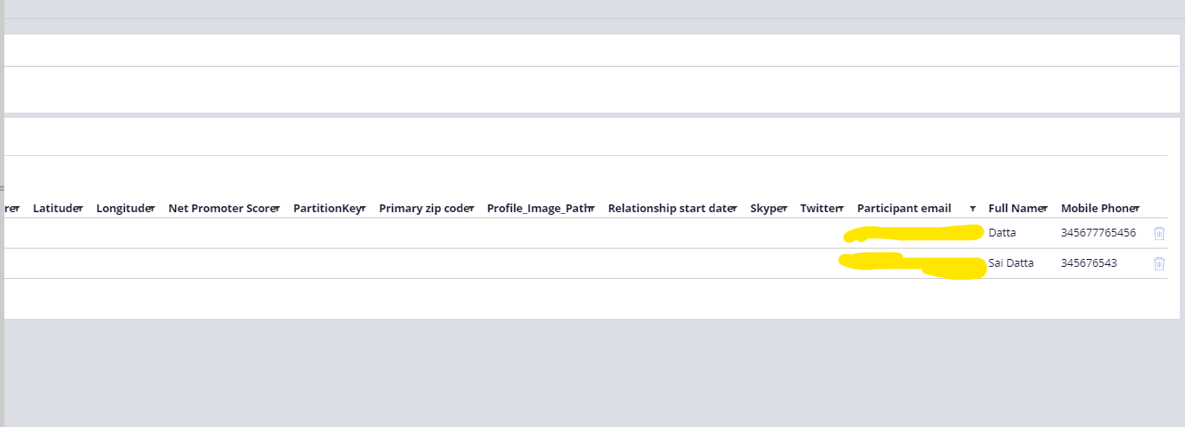

And after this we need to go for the external mapping in class for the properties which you want to see in the portal

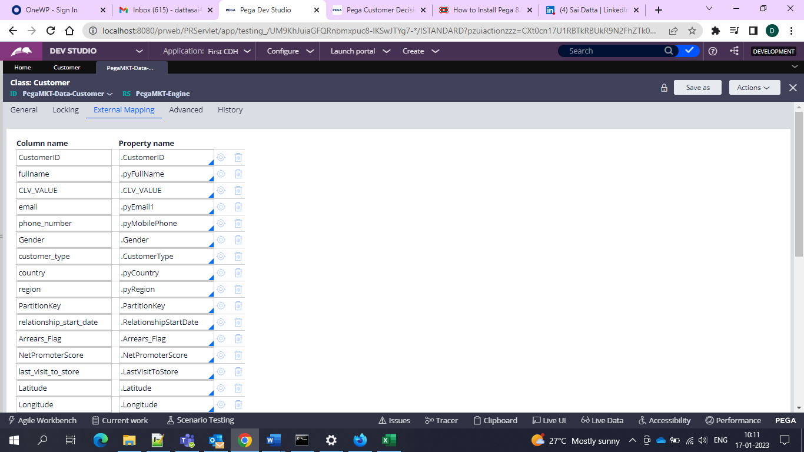

So after this when you go and see in the portal under data you would be having them

So in the profile designer you would be having these 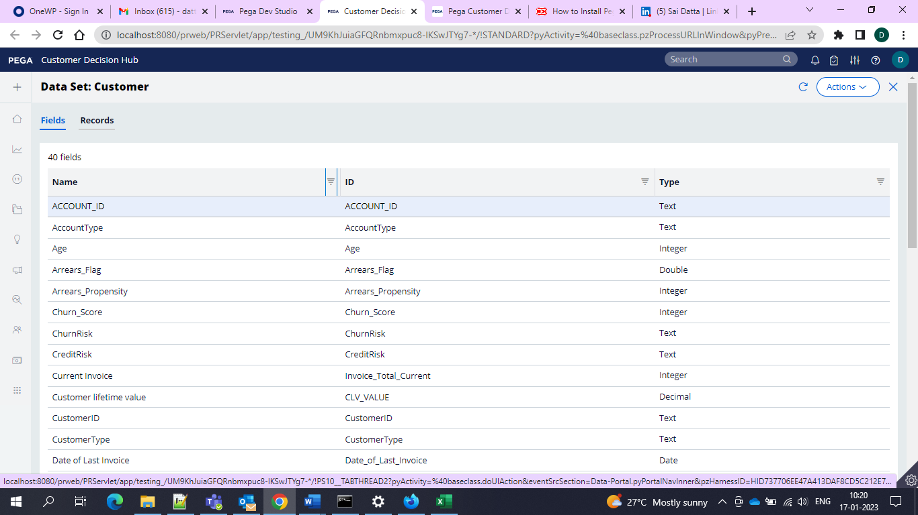

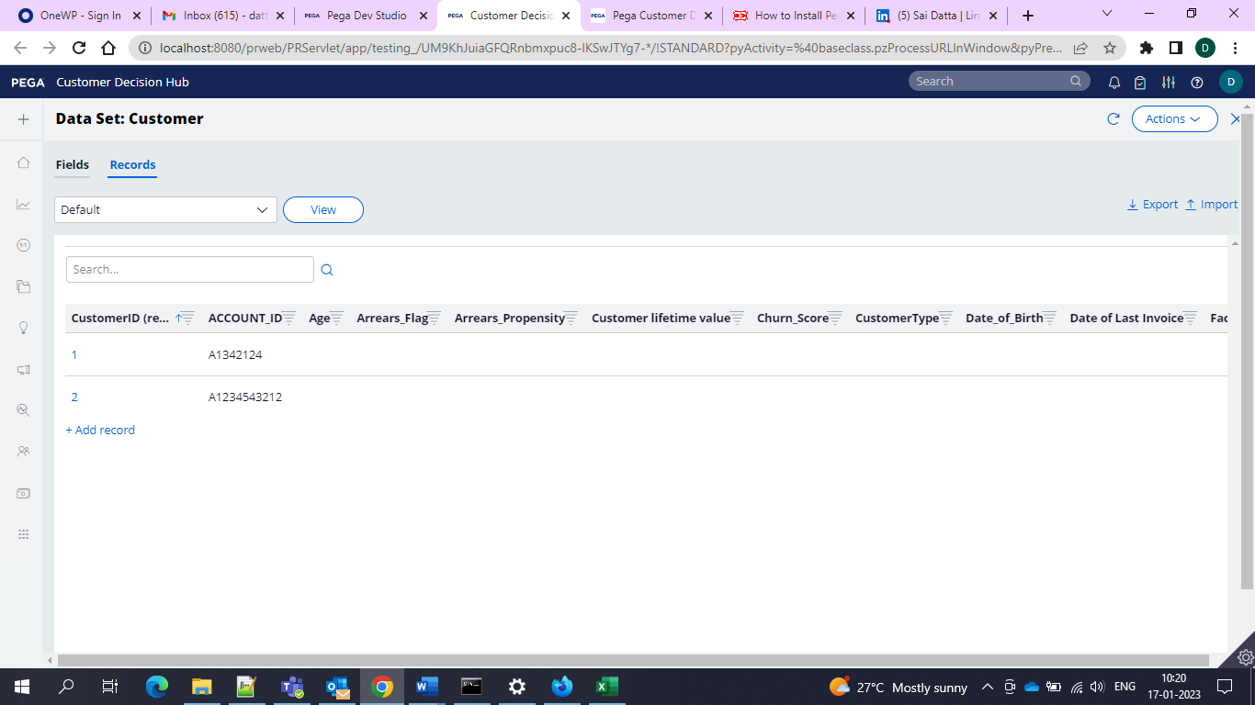and these all are available now.

And then we have to go for the segment creation with this customer data to run the campaign

So we can navigate to the Audiences> Segments

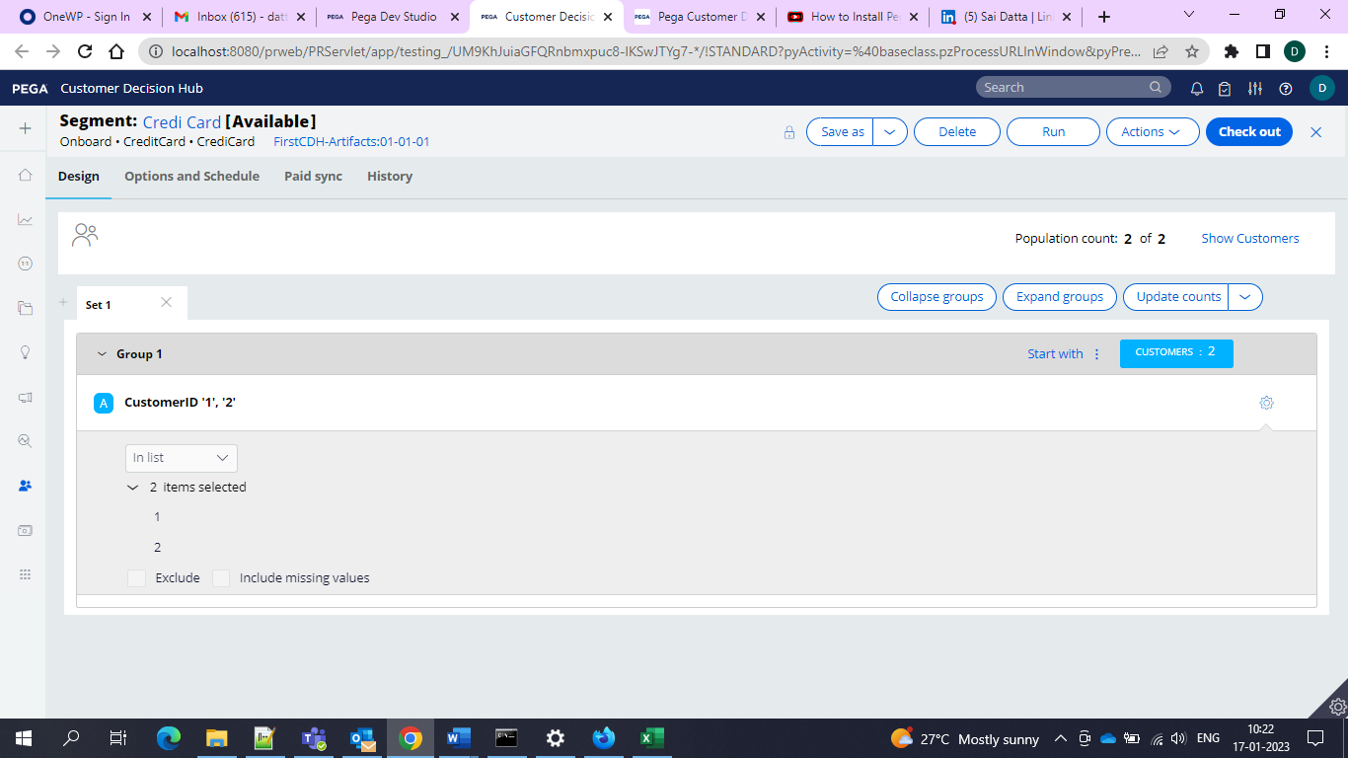

While creating we need to configure with atleast one group and add the criteria and under that we can add one property

And then select the following options

We would be using InList

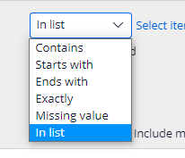

To capture all the customers

And then we can save and run to update the counts but this limited to count of 500 only.

And now we need to use campaign in order to send offers to these particular set of customers.

And then we would be configuring the Campaigns.

Interface would be like this

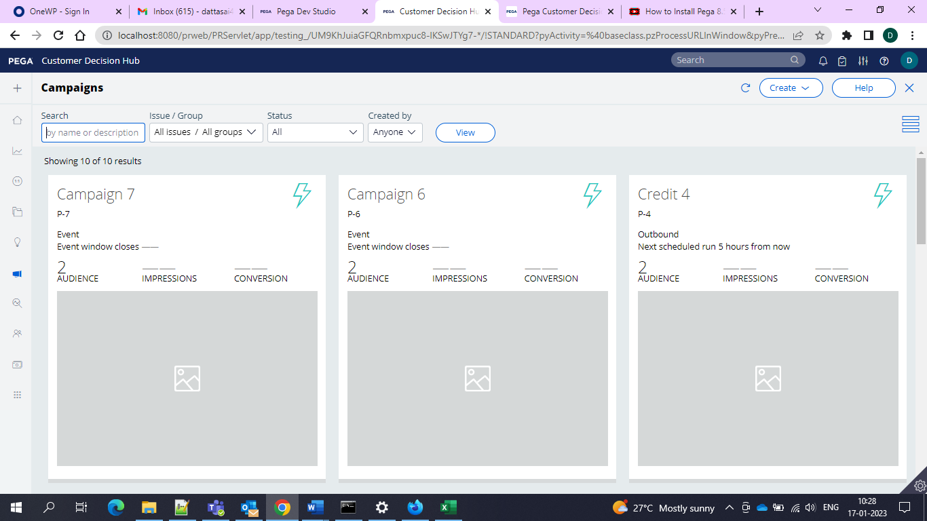

And now we would be having 2 types of Campaigns

1-Outbound Campaigns

2-Multi Channel Campaigns

And outbound means only once we can use it.

And Multi Channel means we can use it multiple times.

And in the outbound campaign the interface would be like this

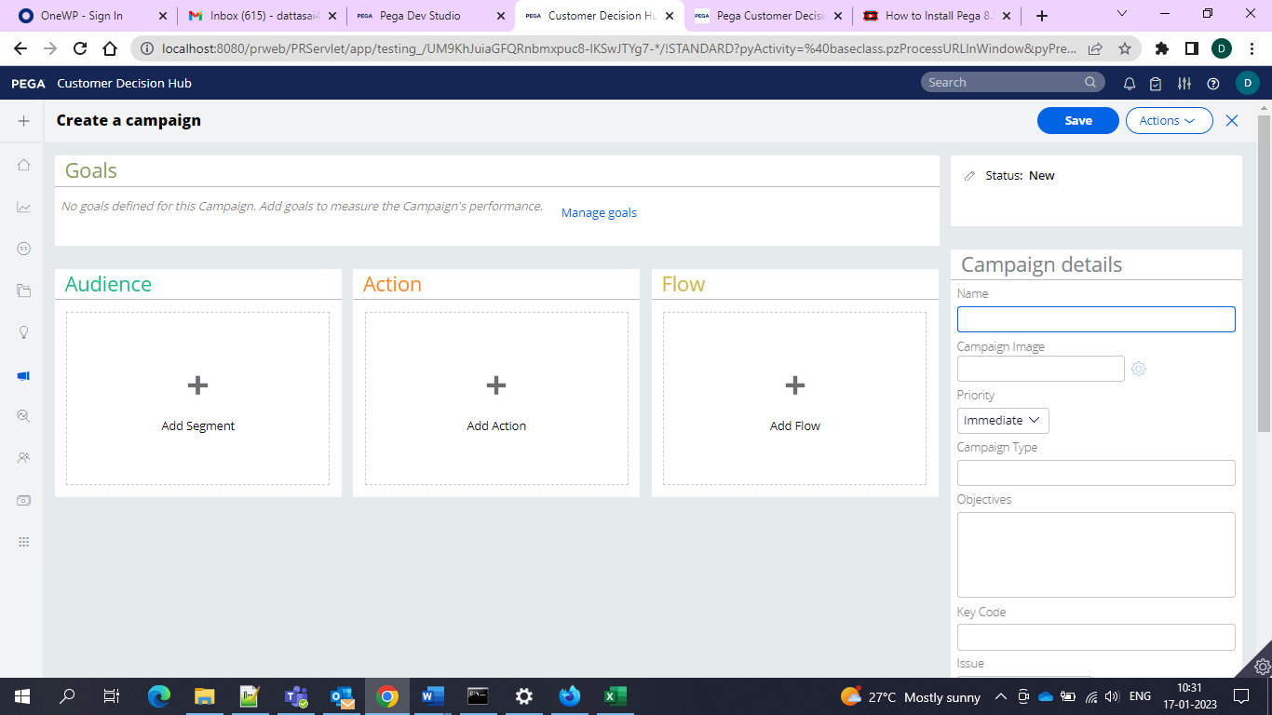

‘and now in that we would be having the